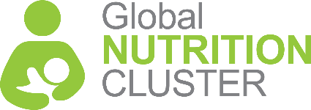
Humanitarian Coordination and the

Cluster Approach
a guide for local and national organizations

This guide is designed to help you understand the humanitarian cluster approach. It provides an overview of what it is and why your organization should get involved.

This GNC guide is based on a similar guide developed by Translators without Borders, Save the Children and the Global Education Cluster

What is the cluster approach?

The cluster approach is a set of structures, processes, principles and commitments to coordinate humanitarian action when a national government requests international support. The goal is to better organize the humanitarian community and make it more accountable to crisis-affected people.

What are clusters?

Clusters are groups of humanitarian organizations working
in specific technical sectors of humanitarian action (shown in blue in diagram 1). Cluster members can include NGOs, United Nations agencies, the Red Cross/Red Crescent Movement, and government bodies. They coordinate action in all stages of crisis response (shown in the arrows in the diagram), to ensure the best outcomes for people affected by crises.

Clusters promote a common strategy and best practices, avoid duplication, address gaps, and share information. They build national capacity to prepare for emergencies, and advocate for more effective and accountable humanitarian action. All clusters are responsible for upholding protection principles and preventing sexual exploitation, abuse and harassment.

There are 11 clusters globally, which can be activated at a national level and sometimes at a subnational level in response to a particular emergency. Each global cluster is led by one or two United Nations agencies or a United Nations agency and an international NGO. At the country level, clusters are usually co-led by a United Nations agency and an NGO. The cluster leads must be ready to provide services to affected people where other organizations cannot.

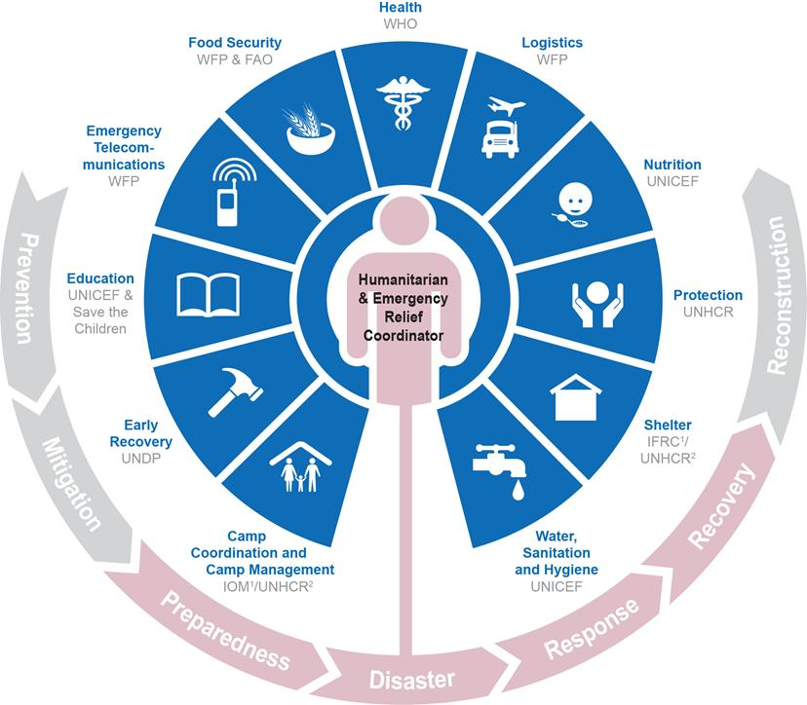
Diagram 1

The Nutrition Cluster is led by UNICEF at the global level. A strategic advisory group, including local and national organizations, provides input on priority issues. At the country level, nutrition clusters are led by UNICEF and often co-led by national authorities. NGOs support Nutrition Cluster leadership through a deputy or sub-national coordinator positions.

Why should my organization join the cluster system?

While there are some practical limitations, the cluster system can better enable your organization to serve affected people through:

- Increased influence, visibility, and understanding of procedures;
- Funding opportunities;
- Access to technical guidance and support;
- Access to information about what others are doing, and;
- Partnership opportunities with other organizations.

Can my organization have a bigger influence by joining a cluster?

Yes. One organization alone can struggle to influence the policies of the United Nations, donors and national authorities. For example, you might feel that United Nations partnership arrangements are not clear, that donor requirements for funding proposals are too restrictive, or that national authorities are unnecessarily blocking humanitarian access. By working in a cluster with other organizations, together you may have more persuasion that can lead to greater influence. You can also increase the visibility and impact of your organization by contributing to a cluster’s joint work, joining the technical working groups or strategic advisory group, or co-leading the cluster.

Can my organization get funding through a cluster?
Clusters do not provide funds directly, however cluster members have access to funding mechanisms that non-

members cannot access. For example, you can generally only apply for a country-based pooled fund grant if you are a cluster member. Donors also often expect organizations they fund to show that their projects are aligned with cluster strategies. Therefore, communicating program needs to the relevant cluster can flag key funding gaps for donors.

Clusters also help to decide how to allocate country-based pooled funds, which combine the financial contributions of several donors. The United Nations humanitarian aid coordination body, OCHA, allocates these funds to multiple projects at country level. Clusters also develop objectives, activities and accompanying budgets for their priority sectors as part of Humanitarian Response Plans. Donors refer to these to develop their key funding focus areas.

Can my organization access technical support by joining a cluster?

Yes. Cluster coordinators and cluster members may be able to provide advice on technical issues that are new to you and you may be able to do the same for other members. Several clusters have remote help desks to answer members’ questions and some may send in-country technical support specialist where a national cluster identifies a need.

The Global Nutrition Cluster Helpdesks can answer questions and provide technical support, including requests about coordination and information management. This includes sharing appropriate resources, tools, and guidance, or redirecting the request to an expert for further assistance. The GNC Helpdesks support requests in Arabic, English, French and Spanish.

Sector-specific technical guidance is also available online and you do not need to be a cluster member to download it. For

example, the Sphere Handbook includes the minimum humanitarian standards for water, sanitation and hygiene, food security and nutrition, shelter and settlement, and health, and is available in over 35 languages. The handbook provides the basis for an effective nutrition response.

Further recommended technical guidance for organizations implementing nutrition-related programs can be found on the GNC Technical Alliance website and on the Global Nutrition Cluster website.

What information can I get from a cluster?

Clusters produce information management tools like the “4Ws” – Who does What, When and Where. These can help your organization make informed decisions about what programs to undertake and where. Clusters also prepare needs assessments and gap analyses, which provide a foundation for funding priorities and response strategies. When organizational insights and expertise is shared, solutions to wider issues can be discovered and improve the overall quality and accountability of the response.

Can I expand my partnerships by joining a cluster?

Yes. By joining a cluster, you can build relationships with the cluster lead agencies and other cluster members, as well as national authorities. This allows you to exchange information with organizations that have complementary expertise to your own. Strong relationships can also lead to joint funding and advocacy partnerships, with both international and national
organizations. The widely accepted Principles of Partnership highlight the importance of equality and transparency in these relationships.

What is involved in being a cluster member?

There are no fixed membership criteria or application processes to join a cluster, but there are factors to consider:

- Time investment for sustained engagement - ability to attend regular meetings; input to strategy development; share relevant and timely information during meetings and in tools like the 4Ws; offer technical expertise when needed; take on co-leadership where appropriate; and raise attention to advocacy priorities.
- Relevance of your work- program implementation is relevant to one or more sectors.
- Minimum commitments - Your organization should:
    - Uphold the humanitarian principles of humanity, neutrality, impartiality and independence.
    - Commit to cluster-specific guidance and mainstream protection in all programs, including respect for principles of non-discrimination and “do no harm.”
    - Be ready to participate in actions that specifically improve accountability to affected people, in line with the Commitments to Accountability to Affected Populations and the Six Core Principles Relating to Sexual Exploitation and Abuse.

Cluster meetings and documents are usually in the main official language of a country or in international languages like English and French. The minimum commitments for cluster coordination states that clusters should provide interpretation in an appropriate language (including sign language), so all cluster partners can participate, including local organizations. This is, unfortunately, not standard practice yet, but some clusters in different contexts are making efforts.

How can my organization join the cluster system?

- Find out which cluster or clusters are most relevant to your work. Check humanitarianresponse.info or reliefweb.int for a list of active clusters and their areas of focus.
- Contact the Cluster Coordinator or IMO listed on the humanitarian response as the cluster contact.
- Find out the strategic priorities for the clusters in your country and see which ones are the best fit for your program activities – this will help you prioritize the discussions you participate in. The strategy document should be available on the websites above. The main points of the strategy will also be published as part of the Humanitarian Response Plan for your country and available on those websites.
- Identify one or more of your senior staff members with relevant technical knowledge to work consistently with those clusters.
- Identify the relevant cluster coordinators in your country from the websites above. They work on behalf of the cluster, not just for their agency, so they should be able to give impartial advice about how things work. OCHA staff can also explain more about the cluster system in your country.

What structures make up the cluster system?

In each humanitarian response, clusters work together in an inter-cluster coordination group chaired by OCHA. The heads of OCHA and other operational United Nations agencies, representatives of local, national and international NGOs, and the Red Cross/Red Crescent Movement also meet within the Humanitarian Country Team to discuss humanitarian response

strategy – a Humanitarian Coordinator chairs the Humanitarian Country Team. Cluster lead agencies are responsible for raising cluster- specific concerns and challenges with the Humanitarian Country Team. National government representatives and donors also sit on some Humanitarian Country Teams.

Humanitarian Country Teams and their members can take issues raised by national clusters to the global level for discussion at the Inter-Agency Standing Committee. This committee is chaired by the Emergency Relief Coordinator and brings together heads of operational United Nations agencies, IFRC, ICRC and global NGO consortium representatives.

In addition to the clusters, there are also initiatives to coordinate cross- sector humanitarian interventions and services. For example, members of a Communication and Community Engagement Working Group might collaborate on increasing accountability to and participation of affected people.

Outside the cluster system, NGOs often coordinate, exchange information and advocate within national or sub-national NGO forums. These forums are member-driven and collectively agree their terms of reference and membership criteria. They can be a useful support network if NGOs feel the cluster system is not addressing their concerns. A number of global NGO consortiums support NGOs to engage with the international humanitarian system. These include ICVA, InterAction, the Steering Committee for Humanitarian Response and the NEAR Network.

Diagram 2, next page, shows the main coordination structures NGOs can engage with at the different levels.

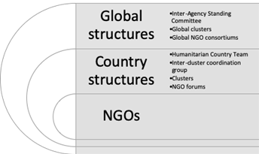
Diagram 2

Does the cluster system apply to all humanitarian crises?

Humanitarian crises vary in scale and complexity; therefore, coordination must adapt to the situation and may change as a response evolves. The cluster system applies when a national government has limited capacity to coordinate a humanitarian response and invites the United Nations to lead on coordination. In other contexts, national and local government authorities lead, while United Nations agencies co-lead; in these cases, the coordination groups are usually referred to as “sectors,” not clusters.

In refugee contexts, the United Nations refugee agency, UNHCR, coordinates humanitarian action, and establishes sectoral groups that may be led or co-led by host government bodies, NGOs and other humanitarian organizations. In mixed-migration contexts, IOM, the United Nations migration agency, can take a

coordination role. In mixed settings, where affected people include refugees, migrants, IDPs and other groups, clusters can co-exist with refugee or migration coordination. While these coordination mechanisms differ in their implementation, many of the principles highlighted in this guide apply to all.

What else do I need to know?
- Inter-Agency Standing Committee, Reference Module for Cluster Coordination at Country Level (2015). This document provides an in-depth explanation of the cluster system as a reference for humanitarian practitioners.
- UNHCR, Refugee Coordination Model. This webpage explains UNHCR’s refugee response coordination model and how it links to the broader humanitarian coordination structures and the cluster system.
- UNHCR-OCHA, Joint Note on Mixed Situations: coordination in practice (2014). This document describes in detail the division of responsibilities between the UNHCR Representative and the HC when a complex emergency occurs that has a refugee dimension.
- Global Protection Cluster, Protection Mainstreaming. This webpage explains how to implement protection principles and links to various protection-related resources.
- ICVA, Principles of Partnership: A Statement of Commitment. This webpage hosts various resources, including translations of the Principles of Partnership main document.
Other informative sites:

- Agora, e-learning modules on Nutrition Cluster Coordination
- Agora, e-learning modules on Information Management
- ICVA, Online learning stream on humanitarian coordination
- ICVA, Online learning stream on humanitarian financing
- Humanitarian Leadership Academy, online courses on the foundations of humanitarian response
- All In Diary (AID), series of one-page briefings on different aspects of the humanitarian sector
- Building Back Better, online course based on interactive scenarios and including an introduction to Sphere principles and standards
- DisasterReady.org, more than 600 training resources covering core topics for the humanitarian sector

Key coordination acronyms
- 3W / 4W - Database of who does what where and when
- AAP - Accountability to Affected Populations
- AoR - Area of Responsibility
- CAP - Consolidated Appeals Process
- CBPF - Country Based Pooled Fund
- CCRM - Cluster Coordination Reference Module
- CERF - Central Emergency Response Fund
- CLA - Cluster Lead Agency
- ERC - Emergency Relief Coordinator
- ERP - Emergency Response Preparedness
- GCCU - Global Cluster Coordination Unit
- GCLA - Global Cluster Lead Agency
- GHP - Global Humanitarian Platform
- GPC - Global Protection Cluster
- GNC – Global Nutrition Cluster
- HC - Humanitarian Coordinator
- HCT - Humanitarian Country Team
- HNO - Humanitarian Needs Overview
- HPC - Humanitarian Programme Cycle
- HRP - Humanitarian Response Plan
- IASC - Inter-Agency Standing Committee
- ICVA - International Council of Voluntary Agencies
- ICCG / ISCG - Inter-Cluster or Inter-Sector Coordination Group
- IM - Information Management
- IMO - Information Management Officer
- INGO - International NGO
- MIRA - Multi-sector Initial Rapid Assessment
- MSNA - Multi-Sector Needs Assessment
- NDMA - National Disaster Management Agency
- NGO - Non-governmental organization
- OCHA - Office for the Coordination of Humanitarian Affairs
- POLR - Provider of Last Resort
- SAG - Strategic Advisory Group
For more information related to coordination of the Nutrition Cluster, you are welcome to contact the Global Nutrition Cluster: https://ta.nutritioncluster.net/request-support
- Sitrep - Situation Report
- SOP - Standard Operating Procedure
- TEG - Thematic Expert Group
- ToR - Terms of Reference
- TWG / TWiG - Technical Working Group
- UNHCR - United Nations High Commissioner for Refugees
- UNICEF - United Nations Children’s Fund

