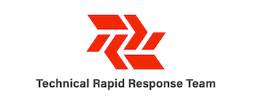

Maternal, Infant and Young Child Feeding in Emergencies (MIYCF-E) Capacity Report

Capacity Building Recommendations for IYCF-E sub Technical Working Group

May 2020

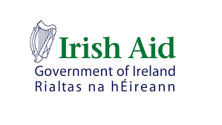

Author:
Brooke Bauer, IYCFE Advisor
Technical Rapid Response Team
Funded by Irish Aid

Acknowledgment

This Capacity Assessment Review was carried out as preparatory work to inform the development of an Operational Guideline on Infant and Young Child Feeding in Emergencies (IYCFE) with consideration to maternal health and gender for the Infant and Young Child Feeding in Emergencies sub-Technical Working group in Ethiopia. The Capacity Assessment was adapted from the Save the Children

The development of this document was led by the Technical Rapid Response Team (Tech RRT) funded by the Irish Aid with support of the FMOH, Maternal and Child Health Directorate Nutrition Case Team and Emergency Nutrition Coordination Unit (ENCU) and their partners. Special thanks to the World Food Programme for supporting the development and deployment of the Tech RRT adviser in Ethiopia and for highlighting the need to build capacity in MIYCF-E.

Note: These recommendations have been produced as preliminary work for the development of the national IYCFE guideline and subsequent action plans. They are limited in their scope and are have not been widely reviewed and validated.

Purpose of Document

The purpose of this Capacity Assessment Report is to review, assess and determine the level of knowledge that MIYCF staff have or have been exposed to for MIYCF-E. The purpose is also to highlight gaps between current training modules and global guidance on MIYCF-E capacity requirements, and to provide recommendations for the IYCF-E TWG as they develop the National Operational Guidance for IYCF-E in Ethiopia.

Background

Breastfeeding is one of the foundations of child health, development and survival. For these reasons WHO, UNICEF, and WFP recommend that breastfeeding should be initiated within the first hour after birth, that infants should exclusively breastfeed for the first 6 months and that timely, safe and appropriate complementary foods should then be introduced, with continued breastfeeding until 24 months of age or older.

Undernutrition due to suboptimal breastfeeding, inappropriate complementary feeding- including a lack of diet diversity- is estimated to be associated globally with 2.7 million child deaths annually or 45% of all child deaths each year.
A non-breastfed child is 14 times more likely to die than an exclusively breastfed child, yet, traditionally multi-sectoral nutrition interventions have focused on the treatment of acute malnutrition in emergencies rather than the protection, promotion, and support of breastfeeding.
The 2019 Ethiopia Mini Demographic and Health Survey (EMDHS) shows that 37% of children under 5 are stunted and 12% are severely stunted. Additionally, there is a high percentage of wasted children with as much as 32% in some regions. With regards to IYCF, 59% of infants under six months are exclusively breastfed and 6% of infants under 6 months are not breastfed at all, a dangerous and life-threatening practice. The danger at which infants are placed in an emergency is impacted by whether the child is breastfed or non-breastfed and dependent on infant formula. Infants who are dependent on infant formula are extremely vulnerable especially in an emergency setting.

Ensuring optimal nutrition for vulnerable groups, such as pregnant-lactating mothers, adolescent girls, infants and young children, is one of the strategies to break the cycle of chronic undernutrition within emphasis to the first 1000 days of life. The Ethiopian government’s commitment to address malnutrition incorporates the Lifecycle Approach where emphasis is put on the crucial development period from pregnancy through the first two years of life, the first 1,000 days.

Maternal nutrition is a key component to the Lifecycle Approach. It is not only crucial for women’s own ability to live a healthy life but the nutritional status of women at the time of conception, during pregnancy and through lactation as a crucial factor in the survival, healthy growth and development of her children.

It is also important to highlight that the multiple roles women play—producing food, generating income, giving birth, and providing care— place them at a critical nexus in food security and nutrition globally. In Ethiopia, poor dietary habits, including existing food taboos, of the women during pregnancy as well as socioeconomic and demographic factors, such as empowerment imbalance, control of farm produce, physiological density, household size and dietary habits during pregnancy are linked.

There is a need to support optimal Maternal, Infant, and Young Child Feeding (MIYCF) practices in all settings. However, during emergencies increased risks such as poor sanitation, disease outbreaks, infant formula donations, stress and trauma mean that support for appropriate, timely and safe Maternal, Infant, and Young Child Feeding practices in Emergencies (MIYCFE) is crucial. Therefore, staff working in emergencies, need skill sets and tools appropriate for emergency settings where they understand the urgency of MIYCFE response and are able to take appropriate action. Most specifically, MIYCF requires strong regulation prior to an emergency for capacity development of staff and specific consideration for non-breastfed children and the adherence to the International Code of Marketing for Breast Milk Substitutes (BMS) and subsequent related WHA resolutions, including the donation and distribution of BMS and commercial complementary feeding, bottles, and teats in emergencies.

Disregard of the WHO International Code of Marketing of Breastmilk Substitute (BMS) and subsequent World Health Assembly (WHA) resolutions, also known as ‘The Code’, in addition to misbeliefs about breast feeding during emergency and other suboptimal feeding practices are documented across Ethiopia. To significantly reverse poor MIYCFE indicators will require a strategic and highly coordinated effort by all. Hence, the IYCFE Technical Working Group (TWG), established as a sub-TWG of the AMIYCN TWG, has been initiated to standardize and strengthen the IYCF work during emergency situations in Ethiopia including the creation of a National IYCFE Operational Guideline and subsequent capacity building measures as objective number within the TWG ToR stating: “Ensure adequate awareness and technical capacity on IYCF-E among relevant sectors, experts and service providers for delivery of quality IYCF-E service at all levels.”

For the National IYCFE Operational Guideline to be implemented successfully MIYCFE has to be mainstreamed and integrated with all other sectors responding in the context. For successful integration, all stakeholders will be required to have a basic understanding of MIYCFE, even if they are not focused on nutrition specific interventions. There is a continued need in Ethiopia for a cadre of trained health and nutrition professionals to protect pregnant and lactating women and girls (PLW\G), infants and young children. By having sensitized staff across all sectors and with health and nutrition workers having been trained in MIYCF including in emergencies a strong MICYFE response can be realized.

Objectives

The objective of this MIYCFE Capacity Report was to:
- Identify contextualised MIYCF and MIYCFE training resources and to highlight gaps between current training modules and global guidance on MIYCF-E capacity requirements.
- Provide recommendations for the IYCF-E TWG as they develop the National Operational Guidance for IYCF-E in Ethiopia

Methodology

The methods for this review were:

- The assessment was designed as an online self-assessment tool and sent through a link emailed via the ENCU to health and nutrition partners. The assessment was in English, completed online, and contained questions on background previous trainings, as well as a rapid knowledge assessment.
- A desk review of national training documents was conducted from April to May 2020 through online searches and with support from the ENCU, IYCF-TWG and its partners. A total of ten documents related to MIYCF and nutrition training were reviewed (see Annex A for a full list). There were limitations with regards to language as only English language documents were reviewed.

Rapid Capacity Assessment Analysis

Introduction
The Rapid Capacity Assessment was a confidential and anonymous form sent through a Google Forms link. The purpose of this tool was to help the IYCFE TWG to understand what capacity currently exists to provide high quality Infant and Young Child Feeding services during a humanitarian emergency. The aim was to help the IYCFE TWG identify a tailored plan to address any identified Learning and Development gaps.

The assessment was adapted from the Infant and Young Child Feeding in Emergencies (IYCF-E) East and Southern Africa Capacity Mapping and Assessment Tool.

Target respondents for the assessment were health and nutrition staff across the country who were working in the humanitarian response. Due to movement restrictions as a result of COVID it was limited to those readily had access to internet. The goal of the assessment was to be as wide reaching as possible to get a broad understanding of knowledge and exposure to MIYCF and MIYCFE programmes. A total of twenty-one responses were received out of what was expected to be around 50 respondents.

Limitations
The assessment was sent during a time when programmatic adaptations for COVID-19 were taking place and most staff were switching to remote working. This could have had an impact on the lower than expected number of responses, receiving less than half of our target. That said, this exercise will allow for a brief snapshot that can help to inform future capacity building initiatives.

Section 1: Background of Respondents

Of the twenty on responses, four were female and seventeen were male. They worked at various international NGOs and in the Cluster Coordination: AAH, Care Ethiopia, Concern Worldwide, Emergency Nutrition Coordianation Unit (Nutrition Cluster), GOAL, IMC, Nutrition International, Plan International, World Vision, Save the Children and two from the Nutrition Cluster team were represented.

The respondents worked in the regions Amhara, Benishangul Gumus, Addis Ababa, Oromia, Afar, Somoli Region with the most reporting to be from Addis Ababa.

The majority, eleven, worked in a country office while the remaining worked in a mixture of sub offices, Health posts, nutrition centers, or coordination units.

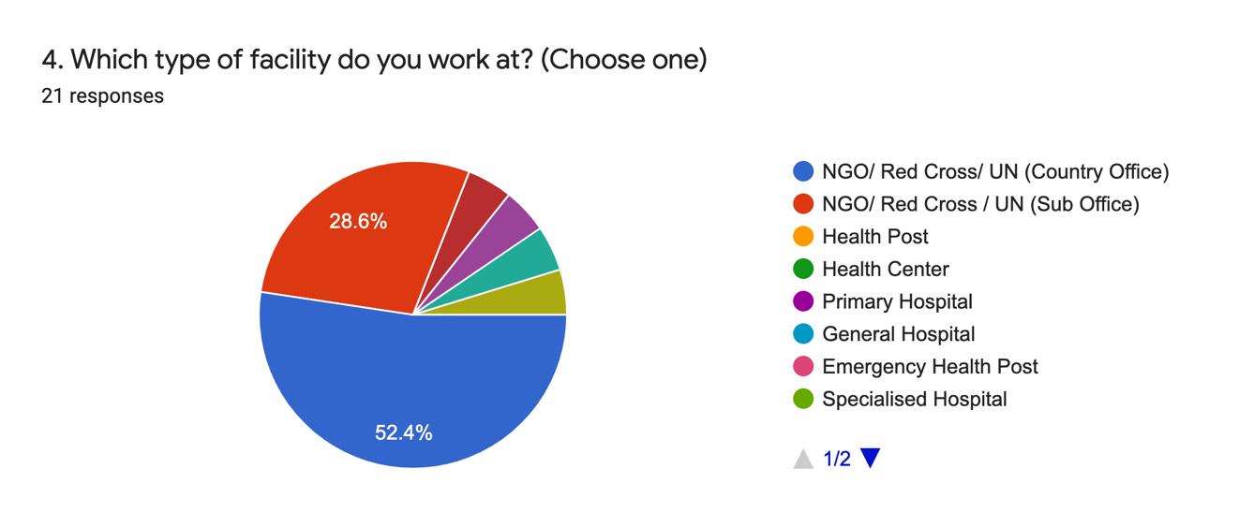

Job Roles
The majority of participants were project managers. The rest were CMAM staff, marketing specialist, health and nutrition advisors or team leads, and cluster coordinators.

Language
Amharic was the mother tongue for fourteen respondents. All twenty-one respondents stated that their comprehension for reading English was “very good” where most stated they were able to write (19), speak (18), and comprehend (17) English and the rest of participants respondents replying their writing, speaking, and comprehension was “good”.

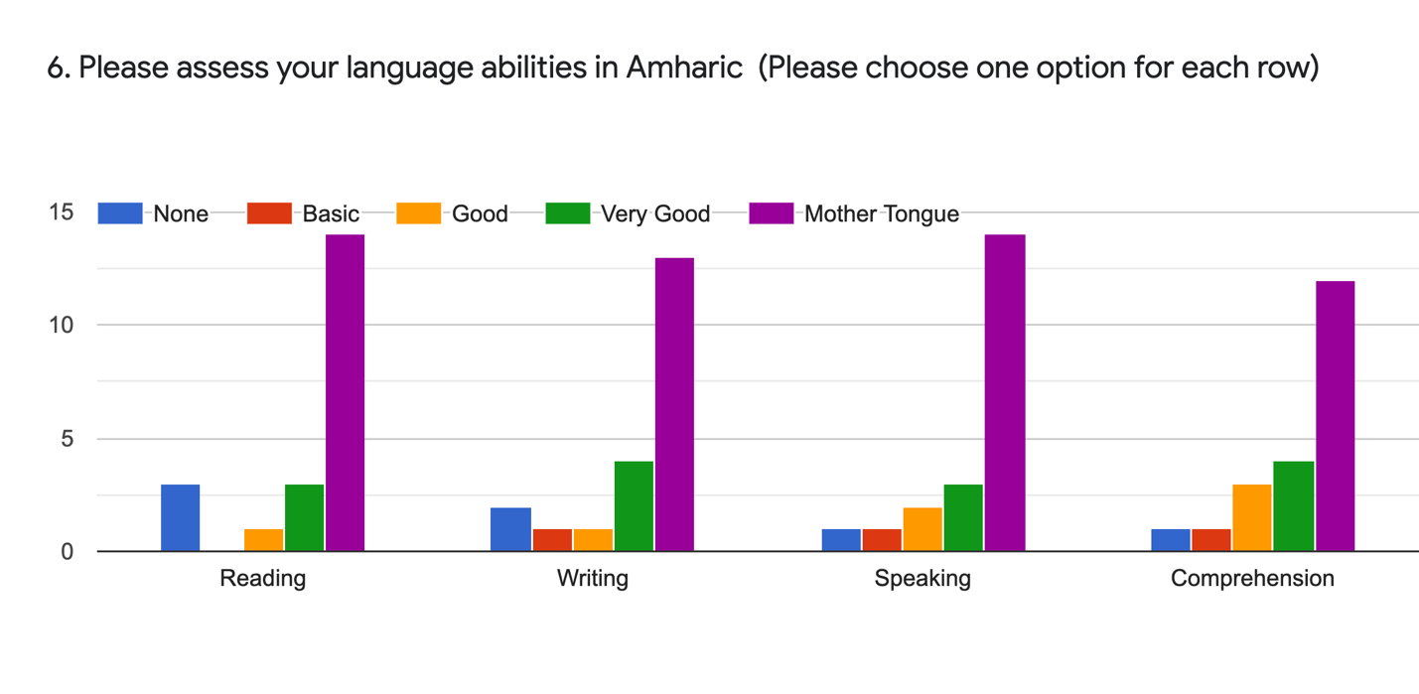
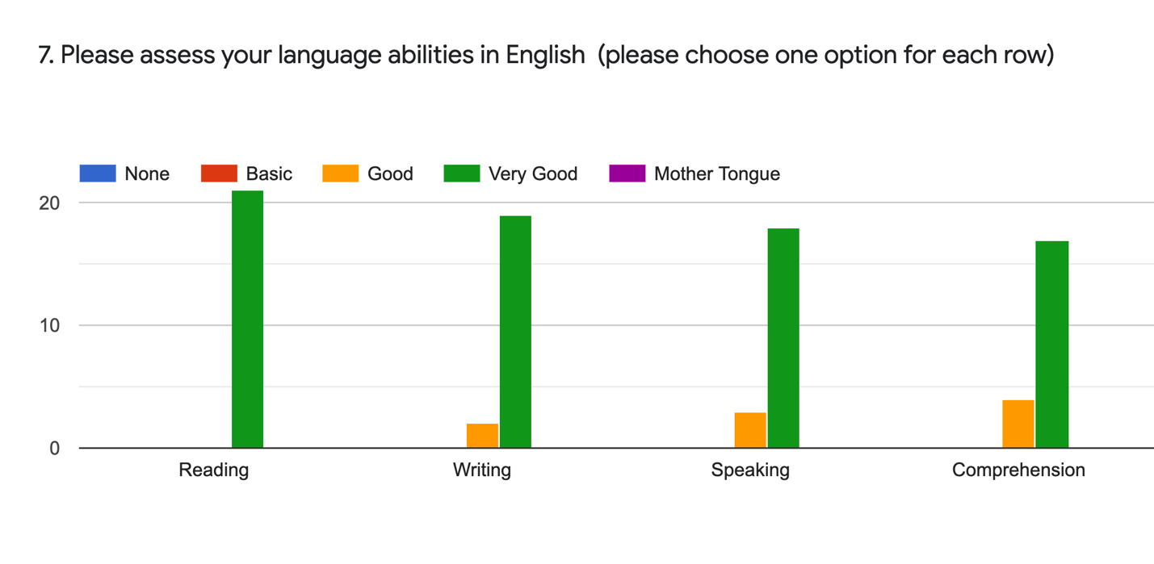

Training and Education
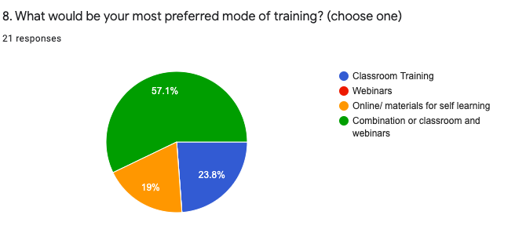
The preferred mode of training for twelve of the respondents preferred a combination of classroom and webinar trainings while the rest preferred only classroom (5) and only online for self-learning (4).

All of the respondents had completed a tertiary level educational degree with sixteen having completed postgraduate university, four completing undergraduate university, and one respondent having completed a PhD.
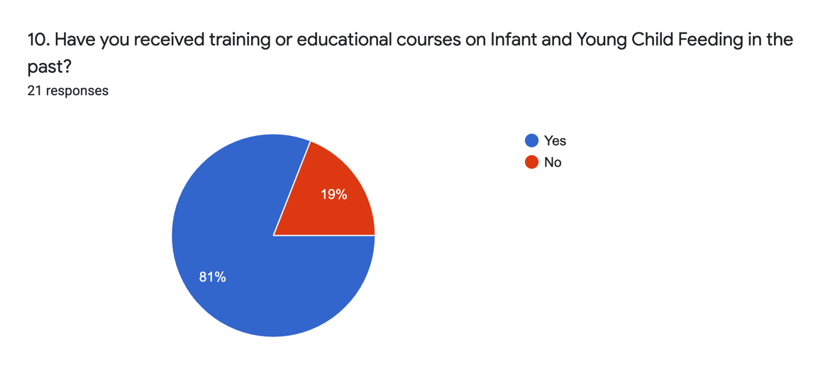

Participants had the opportunity to list up to four IYCF trainings that they have taken in the past 4 years (see Annex B). All but four had received at least one IYCF trainings in the past 4 years.

Of the seventeen participants who had received training six had received only one training and seven had received four or more trainings. Most trainings were one to three days long and were received one to three years ago.
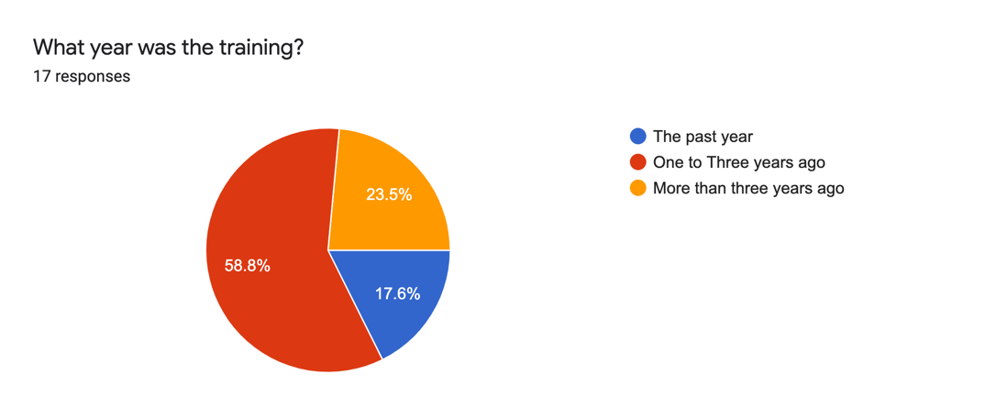

Practical demonstrations in the trainings included cascading breastfeeding basics to community members, IYCF counselling practice, cooking demonstrations for both the child and mother, delivering key messages, and positioning and attachment.

Out of the 21 participants, 17 had ever received at least one IYCF training. Some received up four trainings. Out of all the trainings reported, which was 44, 26 of those trainings did not provide on-the-job supervision (59%).

IYCF vs. Job Tasks
All respondents had worked in IYCF as part of their job with thirteen having done that in a humanitarian setting and eight in a development setting. The top responses were Community sensitization and education, monitoring and evaluation, nutrition sensitive programming, support groups and counselling.

Table 1. Types of IYCF programming participants have been involved in (multiple choices)
Programme type | Number of responses
Community Sensitization and Education | 17
IYCF monitoring and evaluation | 15
IYCF support groups | 12
Nutrition sensitive programming | 11
IYCF one to one counselling | 11
IYCF peer support | 8
IYCF Home visits | 8
Mother and Baby area programmes | 7
Communication and media | 6
Policies, plans and strategic development | 5
Management of non-breastfed infants | 3
Monitoring of BMS | 2
Training development/delivery | 1

All participants had personally implemented MIYCF programmes or activities. Most were involved in community sensitization, IYCF groups and counselling.
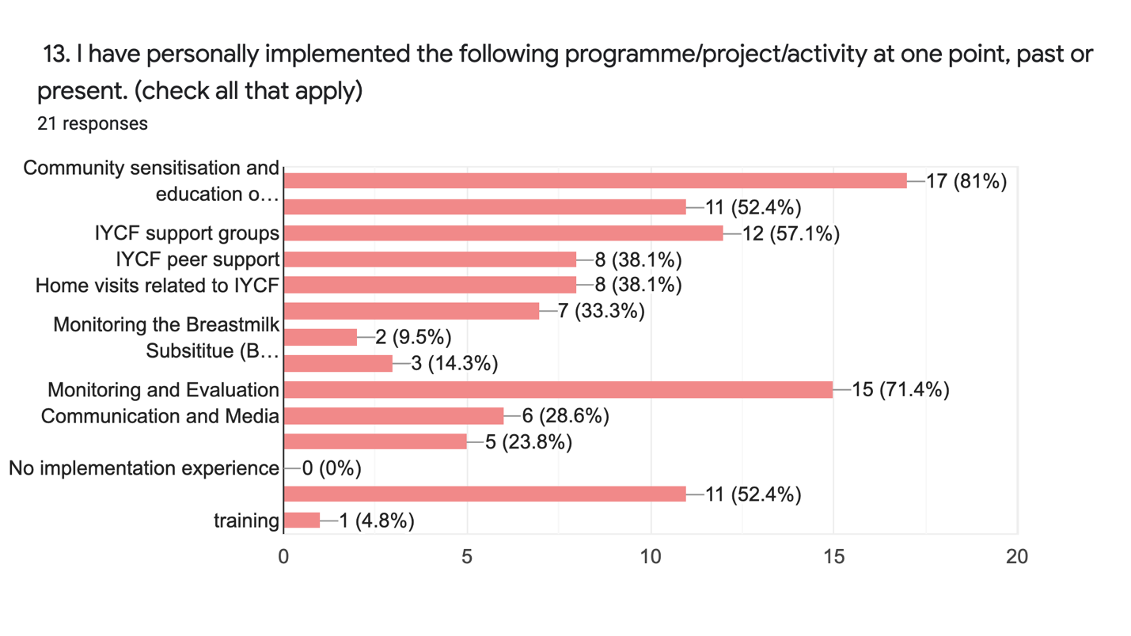

Respondents did not feel confident in their work with regards to counselling a pregnant woman living with HIV, relactation, managing the non-breastfed child, helping a mother with flat or inverted nipples, helping a mother with engorged breasts, hand expression, and feeding assessments.

Most respondents had provided support to non-breastfed children but few had experience with BMS provision, relactation, and wet-nursing support.

Materials and Equipment

The number of respondents who felt that they had the adequate access to equipment and materials related to their job role such as IEC materials, counselling cards, job aids was more than those who felt that they were trained to use that equipment..

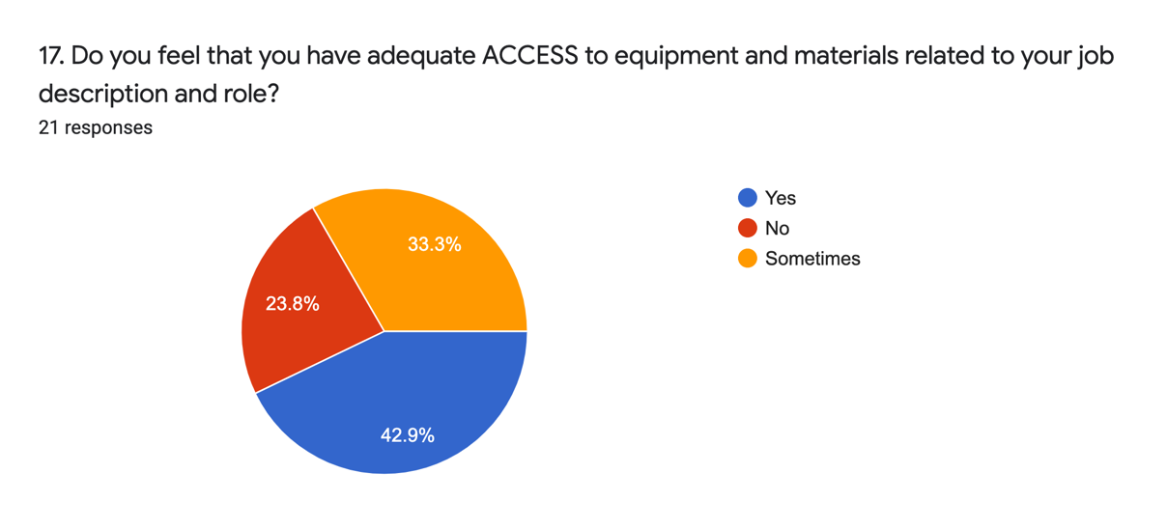

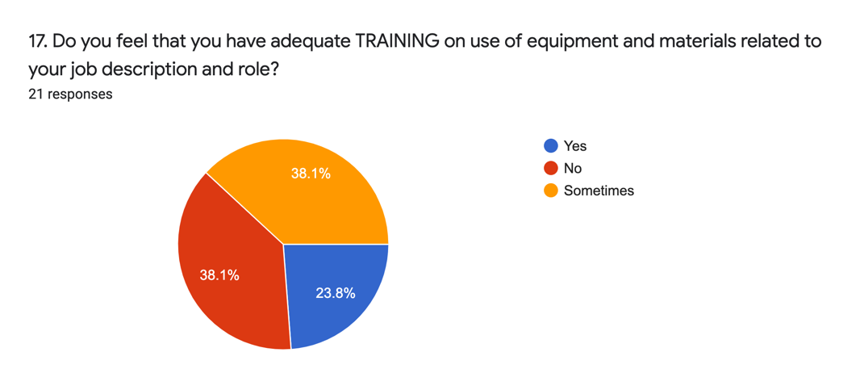

Section 2: Knowledge Assessment

Most respondents could identify appropriate skills to build a mothers confidence such as recognise and praise what a mother is doing well and give practical help.

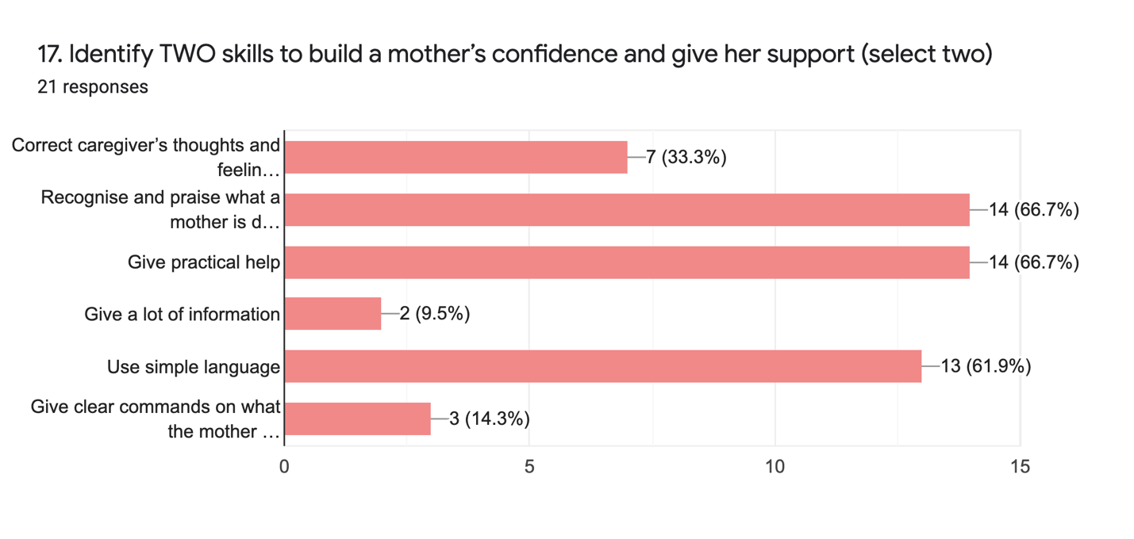

Most respondents knew that a mother should be counselled to feed her infant on demand.
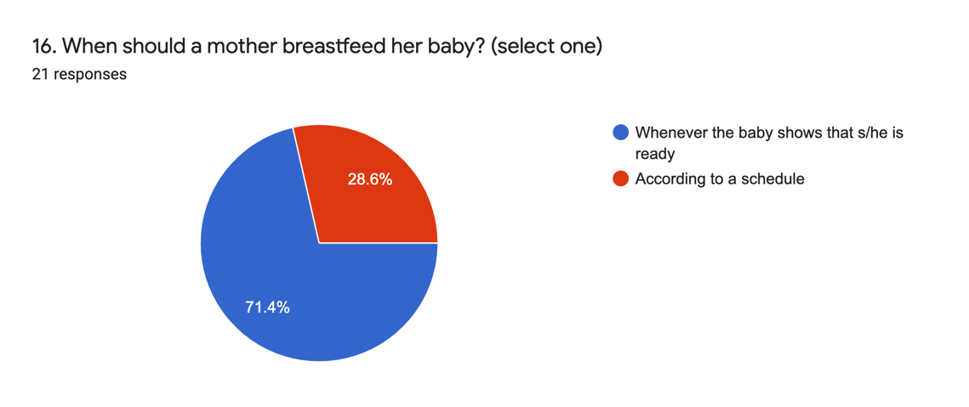

Many respondents identified poor weight gain as a reliable sign that the baby is not getting enough milk but fewer chose small amounts of concentrated urine, two of the reliable signs.

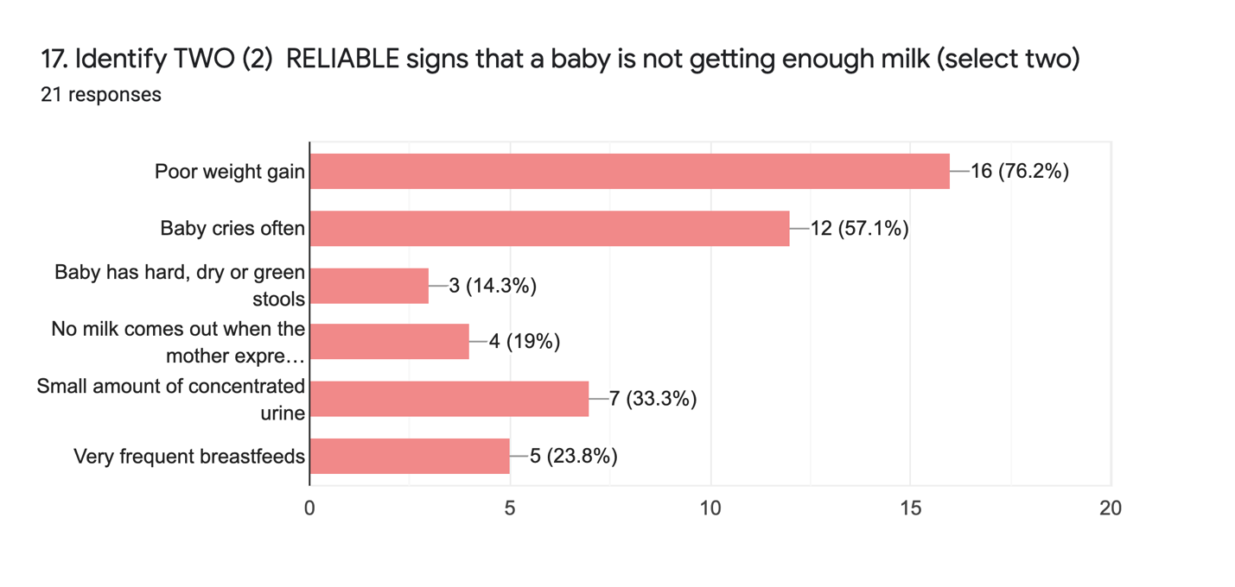

Most respondents answered correctly when they said that they would counsel a caregiver on assisting and encouraging a child to eat but not forcing and that the caregiver should know when and how much their child should eat.
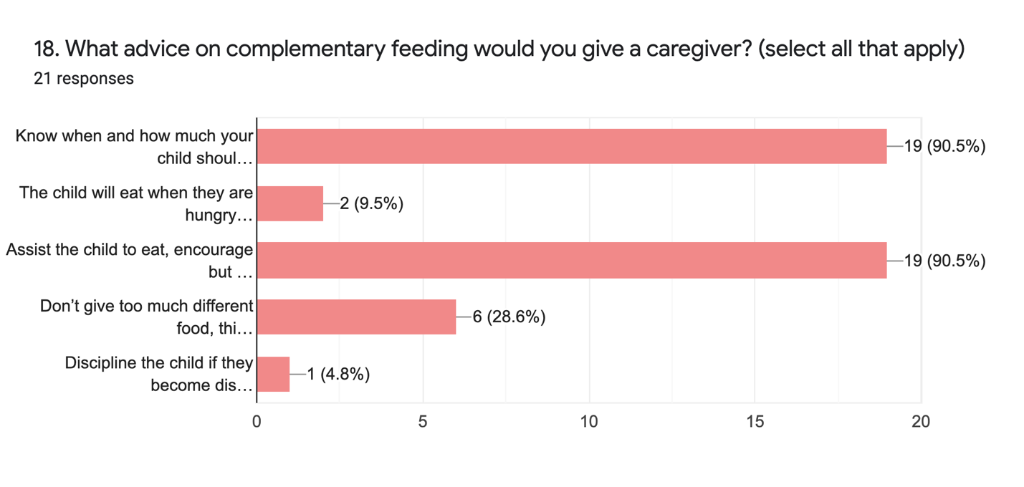

For acceptable reasons for a mother to not breastfeed her infant many responded with answers of actions that could be supported with counselling such as the mother working, worry, stress, and a painful experience.

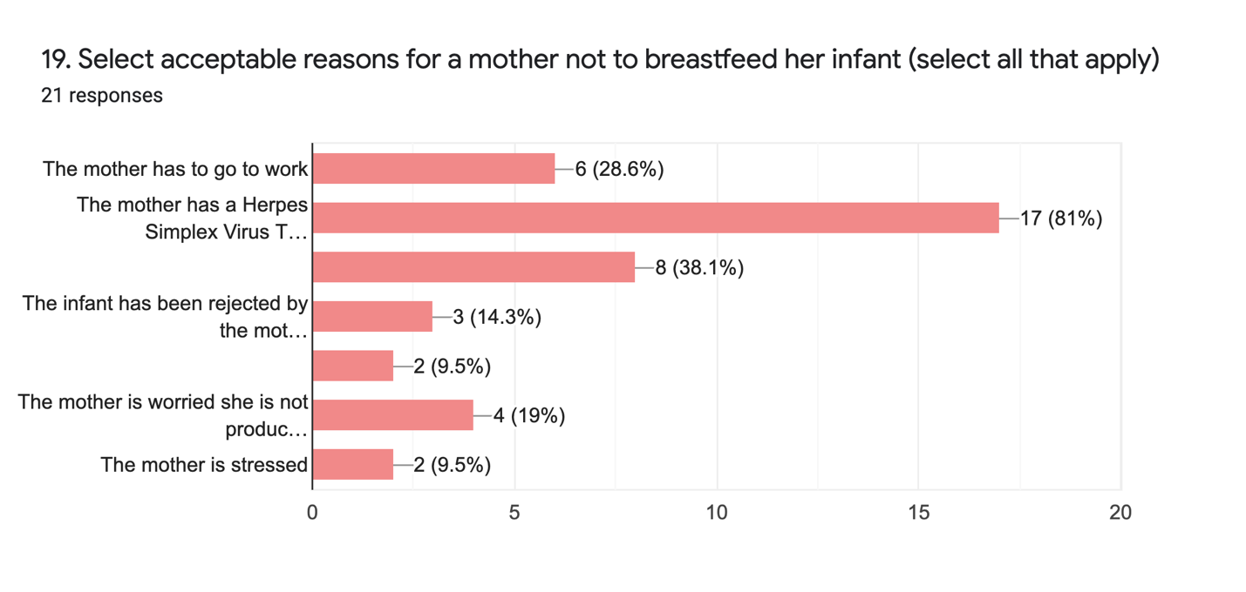

Most respondents stated correctly that the statement “Once a mother stopped breastfeeding that she cannot restart” is false.

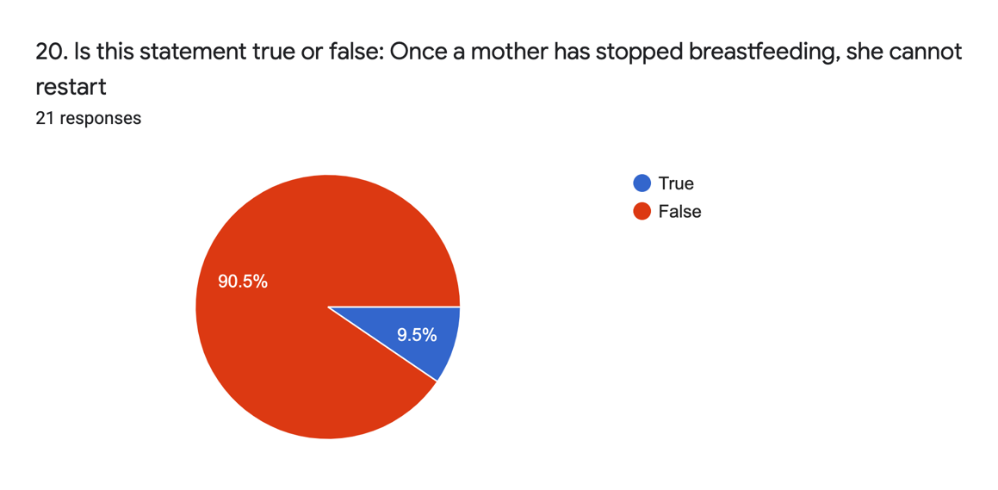

Most respondents understood the dangers of feeding bottles. But had less knowledge about the dangers or powder milk and formula donations.

Table 2. Myths and Misconceptions
Question |  |  | True |  | False
Feeding bottles are very difficult to clean, can make the child very sick and should not be recommended |  |  | 18 (86%) |  | 3 (14%)
Powder milk can be dangerous to give to children under two years as it can’t always be prepared properly and can make children sick. |  |  | 13 (62%) |  | 8 (38%)
Formula donations should never be requested or accepted in an emergency as they are dangerous |  |  | 9 (43%) |  | 12 (57%)
A mother who is stressed or malnourished is not able to produce the right kind of milk for her infant. |  |  | 8 (38%) |  | 13 (62%)
Children should eat less when they are sick |  |  | 2 (10%) |  | 19 (90%)
Colostrum is not healthy for the child and has to be thrown away |  |  | 3 (14%) |  | 18 (86%)
Note: | Correct Answer | Incorrect Answer

When asked what advice is best to give to the mother of a one year old child who is sick most answered correctly to continue to breastfeed and feed small amounts of food frequently.

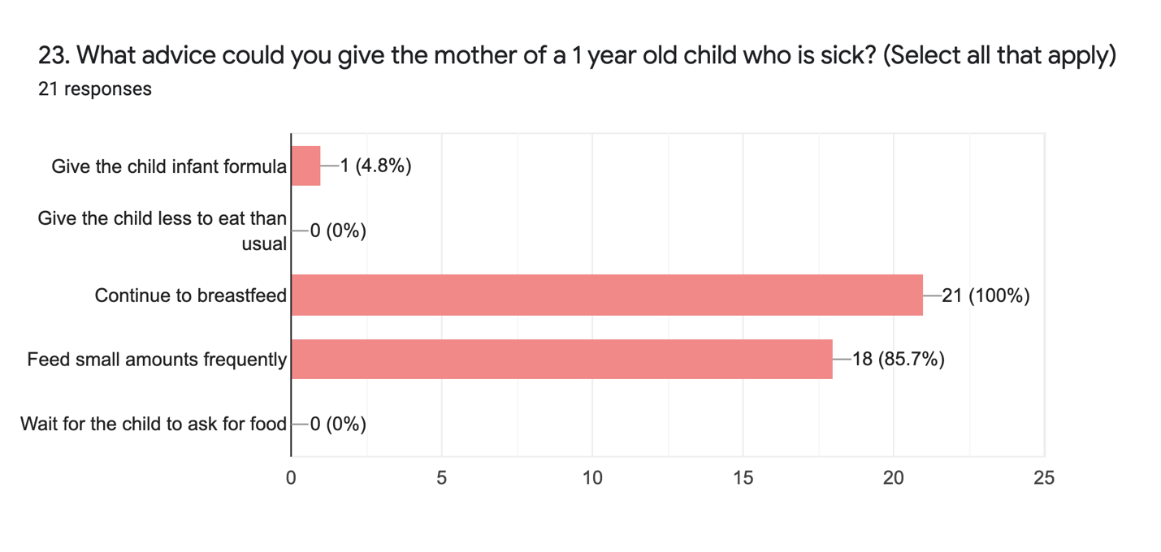

To provide safer support options to non-breastfed infants, the most common answers were to recommend relactation, wet-nursing/donor milk, and controlled BMS distribution.

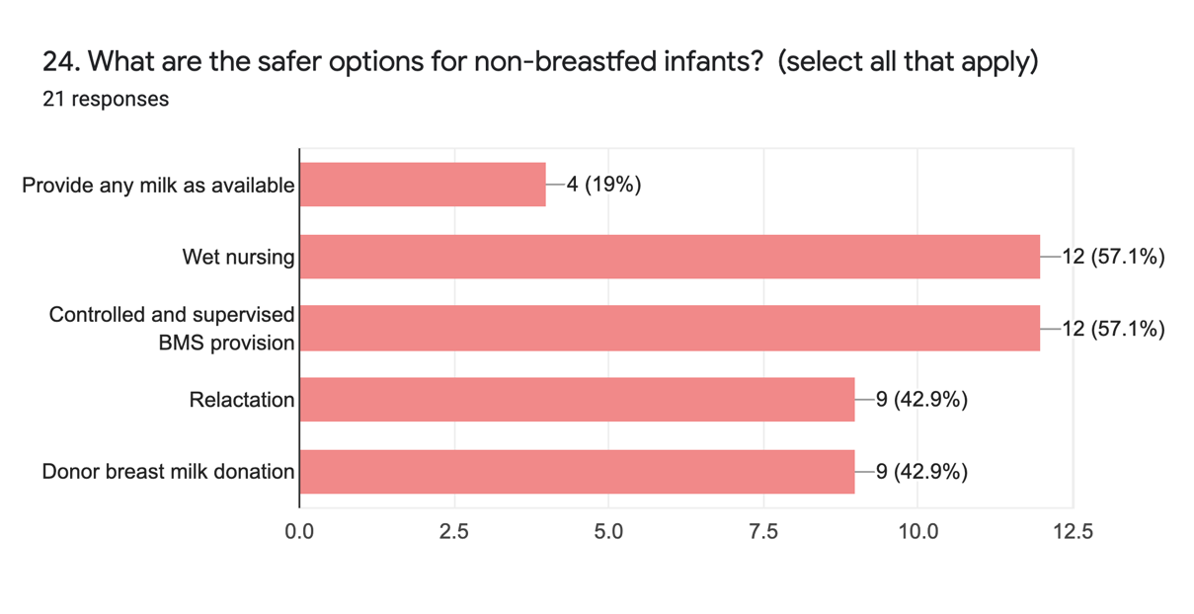

While most agreed correctly that formula donations should not be requested in emergencies 28% of respondents agreed that they should be requested.
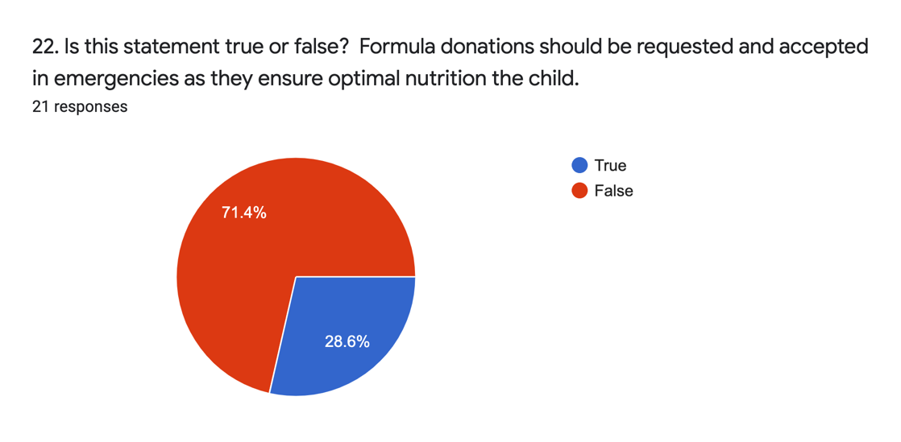

Participant Recommendations

When asked to provide any recommendations that are needed to improve MIYCF-E in the areas where they have worked the majority of respondents, eighteen, replied with training being the biggest need with specific focus on practical sessions and ToT so staff can train HEW and HWs. Other suggestions were integrations, evaluation, advocacy at national level, supportive supervision, on the job coaching, identification of IYCFE champions, and IYCFE mentorship programmes.

Additional feedback is that integration into health programmes and trainings of health workers is needed in all hospitals and health facilities. And that re-training or workshop sessions should be held regularly for all health and nutrition workers.

Analysis of Rapid Capacity Assessment

The results of the rapid capacity assessment shows that a relatively large portion of the respondents are aware of a number of key MIYCF messages and optimal practices. Most of the participants had previous training, and all participants worked within MICYF and/or IYCF programmes. However, there were still some knowledge gaps. Misunderstandings of myths and misconceptions were observed and misunderstanding of BMS, donations in emergencies, and bottles and teats were still common within the responses. Many respondents also cited having little confidence is supporting a woman to relactate and even less confidence for supporting a non-breastfed or artificially fed child.

Participants have a desire for more trainings and on-the-job supervision. Many stated that they felt that training health care staff will strengthen nutrition programmes in Ethiopia. It is important that training equipment and job aids be incorporated into the trainings and that this equipment and aids are made readily available to health and nutrition staff.

Recommended Capacity Building Initiatives

To strengthen the MIYCF-E response in Ethiopia several trainings should take place across both health and nutrition stakeholders including orientation and sensitization sessions across all sectors including national policy and decision makers.

There are resources that can be drawn upon when developing or updating MIYCF-E training materials in Ethiopia including the BFHI Hospital Initiative Training Materials, Nutrition in Emergencies Harmonized Training Package V.2, Infant and Young Child Feeding in Emergencies Module 2, The Introductory course on the International Code of Marketing of Breast-milk Substitutes and the WHO Infant and Young Child Feeding Counselling: An integrated course

Any training packages developed will have to be contextualized to the Ethiopian context and should be followed up with on-the-job coaching and supportive supervision. An overview study of the Kenyan Baby Friendly Community Initiative (BFCI) implementation may also be beneficial for providing insight into community level BFHI activies.

Please see Annex C for an overview of possible module topics, Annex D for available training materials including those previously used in Ethiopia. Annex D has a list of additional training resources. Annex F has examples of two case studies.

Strategic Objective
To improve awareness, knowledge and skills on MIYCF-E among stakeholders, program managers, and health care and nutrition programme providers

Recommendations
Sensitize key policy and decision makers and other important stakeholders at the National level. Sensitization meetings will also serve as an opportunity to highlight the issue of MIYCF-E and advocate for support to address gaps and needs. Using a cascade approach to the training roll-out, representatives from government, health and nutrition implementing partners, civil society organizations, and various healthcare workers will be trained on MIYCF-E. MIYCF Champions could be trained throughout all levels of programming to ensure coordination, advocacy, quality, and accountability. Support groups, comprising of care givers within communities will be the ultimate recipients of the messages and counseling around MIYCF-E learned through these trainings.

To compliment the MIYCF-E package at the community level, health and nutrition personnel in primary, secondary, and tertiary health facilities to ensure consistency of messaging and counseling at the referral facility level.

Joint supervision and mentoring visits to be conducted in tandem with IYCF-E TWG partners and government partners wherever the IYCF counseling package has been rolled out.

Incorporating a multi-tiered approach with a strong referral pathway will help to ensure that those who need support will receive it.

MIYCF Champions
An MIYCF champion is an individual who is willing to strongly support and advocate for MICYF and IYCF, especially during an emergency. The MIYCF champion ensures that MIYCF is included and advocated for in multi-sectoral coordination mechanisms and thus MIYCF services form a part of the integrated services for mothers and children. The MIYCF Champion shall helps to ensure that critical MIYCF action points and indicators are not overlooked.

MICYF champions can be from any sector, provided they have the desire and willingness to advocate for and promote MICYF. All sectors working with PLW, infants and young children coould eventually have one or more MICYN champions to ensure the protection of MICYF. These champions should be trained on the fundamentals of MIYCF including gender and nutrition, should have a comprehensive understanding of BMS monitoring and reporting, and have a good awareness of the risks identified for PLW, infants and young children. The MIYCF Champions could be anyone working in humanitarian response who is interested and committed to MIYCF, is engaged with IYCF-E TWG partners, and can be coordinated through the IYCF-E sub TWG relevant partners.

Sensitization sessions
National policy and decision makers, ministry officials, humanitarian cluster coordinators and key stakeholders should be sensitized to MIYCF-E and an overview of the action plan of the IYCF-E subTWG and the positive impact on maternal infant and young child nutrition and health a multi-sectoral approach could have. Their support is vital to promote and sustain the actions designed through the IYCF-E subTWG. Key decision makers could include directors, key administrators, representatives from other line ministries and key stakeholders. Decision-makers play a vital role in enabling the transformation needed at the community level.

Across all tiers, staff who have contact with PLW/G and caregivers of infants 0-23 months (including registration staff, cleaning staff, support staff) should all be given a sensitization session on MIYCF-E including the dangers of BMS and should be oriented to facility MICYF or breastfeeding policies.

These can be 15 to 30 minute presentations in cluster coordination meetings and/or one day sensitization sessions for stakeholders. The aim of sensitization sessions is to highlight the importance of MIYCF-E programming, the basics of MIYCF-E and how MICYFE fits within national guidance.

The sessions could include:
- State of MICYF in Ethiopia
- Overview of the importance of MIYCF-E programming
- Gender and Nutrition
- Basics of IYCF including myths and misconceptions and dangers of BMS and artificial teas
- The Code and BMS reporting and monitoring systems
- Coordination of MIYCF-E interventions
- Referral pathways

MIYCF-E Specific Trainings

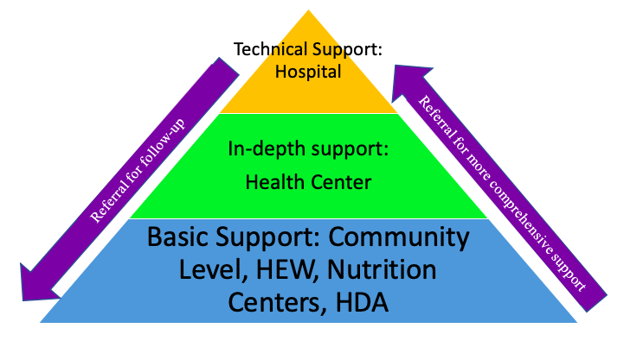
A three-tiered, integrated system could be put into place with strong referral pathways linking the tiers. These would link tertiary level health providers, Health post/center level staff, and community-based health and nutrition staff.

For staff providing direct support to PLW/G and caregivers of 0-23 months the MIYCF-E trainings for health and nutrition staff should be three to five days long depending on the level of technical support the staff member provides.
Figure 1. MIYCF Support Pathways

Recommendation for the IYCF-E TWG:

- Identify cadre to be trained ensuring a mixture of tertiary level to community level health and nutrition staff
- Participants have a desire and willingness to learn about and commit to MIYCF-E, should have a basic understanding of IYCF or MICYF, has direct contact with Pregnant and Lactating Women and Girls and/or caregivers of children aged 0-23 months.

In hospitals and health posts it is possible to have at least one more provider trained on technical MIYCF-E support who could also act as an MIYCF champion in their facilities. In all community level facilities there could be at least one MIYCF champion who is also familiar with up-to-date referral mechanisms.

- In hospitals all medical staff, especially those supporting pregnant and lactating women and girls (PLW/G) are trained in MIYCF-E with at least one medical provider trained in technical support for infant feeding challenges, especially LBW infant feeding, non-breastfed child, clinical management of MAM for infants, Malnutrition of PLW/G PMCT, BFHI, relactation, and supplemental suckling techniques.
- Health center and Health Post staff should be able to provide in-depth support to mothers and infants. They should receive the same MIYCF-E training and there should be at least one medical provider who is trained in more technical areas of breastfeeding counselling, breastfeeding challenges, supplemental suckling techniques, relactation.
- In the community level a broad, basic understanding of MIYCF-E, IFE, artificial feeding support, multi-sectoral interventions and the code.

Other relevant trainings could focus on gender and nutrition. As the training has an emergency focus, a session on Psychological First Aid would also be relevant.

Supportive Supervision, On the Job Coaching, and Mentoring

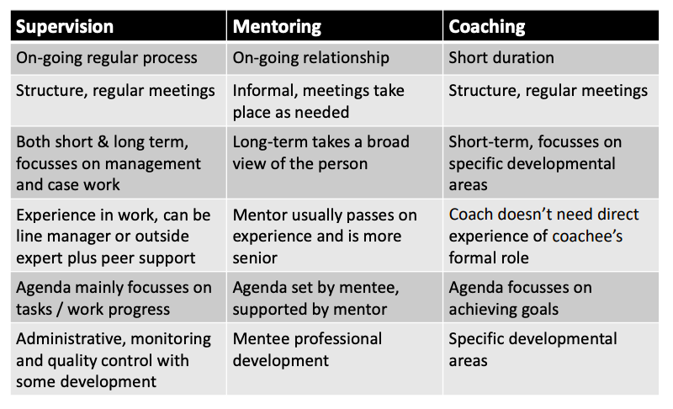
Supportive Supervision, on-the-job coaching and mentoring are important in helping health and nutrition workers to develop the skills they need to meet the challenges they meet in humanitarian settings, especially in emergencies. Staff working in the health and nutrition sectors in Ethiopia require a combination of the ability to act rapidly in extremely stressful situations, whilst making decisions that will have an impact on people’s lives and livelihoods for years to come. Regular coaching and mentoring sessions can increase staff skills and confidence, facilitate reflection, support learning and improve organizational productivity.
Table 3: Summary coaching, mentoring and supervision

By training MICYF programme manager staff on on-the-job coaching and supportive supervision it is ensuring the skills gained in trainings are able to be used appropriately once on-the-job and ongoing learning can take place.

Recommendations:
- Invest in and allocate resources including staff and tools for supportive supervision/on-the-job-coaching/mentoring for all participants after MIYCF specific training
- The type of supervision will depend on the level of support the mentee is providing but the goal is to ensure that skills learned in the trainings are transferrable at a facility level.
- The IYCF-E TWG to adapt tools for supportive supervision/on-the-job coaching/mentoring and to ensure that partners have access to and understand how to use these tools.

Supportive Supervision, mentoring, and coaching Training
There are two specific training modules for mentoring, coaching and supportive supervision (also outlined in Annex 2). They are:
- UNICEF Community Infant and Young Child Feeding (IYCF) Counselling Package: Module on Supportive Supervision/Mentoring and Monitoring
- Food Security and Nutrition Network Social and Behavioral Change Task Force: Care Groups: A Training Manual for Program Design and Implementation.

A overview of this type of training held in Kyrgyzstan, Training Supervisors to Mentor Health Workers Who Provide Counselling on Infant and Young Child Feeding: A Three-Day Course for Kyrgyz Mentor-Supervisors, in 2017 might be useful for reference.

Conclusion

Providing comprehensive training to health and nutrition staff will improve health and nutrition programmes in Ethiopa and will, in turn, improve the health and nutritional status of women and children. A multi sector, three tiered approach using MIYCF-E champions will allow for a broader understanding of MIYCF-E across all sectors while providing strong referral pathways from community to hospital level for technical support when needed.

In Ethiopia many national policies highlight the need for capacity building amongst health and nutrition workers within the areas of MICYF, IYCF, and IYCFE, but the National Guideline on Adolescent, Maternal, Infant and Young Child Nutrition (2016) is the most comprehensive policy document that details the need for training on IYCFE stating that it is important to ensure that health workers have accurate and up-to-date information about infant feeding policies, guidelines and practices, and that they have the specific knowledge and skills required to support children and their caregivers in all aspects of IYCF in emergency situations. It also states that there should be increased awareness and knowledge about the benefits of maternal nutrition and infant feeding among all stakeholders in emergency situations, expanding the capacity building beyond frontline workers to all stakeholders. The guideline also states that national expertise should be available as a resource for all emergency agency staff to gain a better understanding of the good practices of maternal nutrition and IYCF and to assist agencies in developing strategies to develop good practices. And that this expertise is available at both national and district levels to train health workers and community-based staff in AMIYCN issues so as order to ensure that consistent and well-informed advice is given.

The training course, Using the Essential Nutrition Actions to Improve the Nutrition of Women and Children in Ethiopia, including under Situations of Emergencies and HIV and AIDS (2004), is a four-day course that specifically includes IYCF in emergencies as well as the BMS code and alternative and replacement feeding. Unfortunately, it does not cover relactation, a missed opportunity when discussing IYCF and alternative feeding methods in emergencies. In general, a lack of mainstreaming IYCFE within training documents is a missed opportunity to build resilience and therefore should be included in the training guidance within the IYCFE Guidelines developed by the IYCFE subTWG.

By building upon currently used MICYF and IYCF modules the IYCF-E subTWG and health and nutrition partners will be able to implement strong MIYCF-E programmes at all levels of health and nutrition programmes as well as through the integration of MICYF sensitization across all sectors.

Annex A: Documents Reviewed
(Hyperlinked)

Training Documents Reviewed
Essential Care for Every Baby Training - Participants' Manual
Ethiopia Training of Trainiers Manual in Infant and Young Child Feeding (2011)
Basic Emergency, Obstetric, and Newborn Care (BEmONC) Training Manual 2013
Using the essential Nutrition Actions to Improve the Nutrition of Women and Children in Ethiopia, including under situations of Emergencies and HIV and AIDS (EPHI) 2004
Integrated Management of Newborn and Child Illness, Part 1 (FMOH) 2011
Integrated Management of Newborn and Child Illness, Part 2 (FMOH) 2011
Nutrition: Blended Learning Module for the Health Extension Programme (2011) FMOH
NUTRITION EDUCATION TRAINING FOR AGRICULTURE EXTENSION OFFICERS Training Sessions and Resources IYCN/USAID
Reproductive, Maternal, Neonatal and Child Health Program Overview and Pharmaceuticals Management Training for Pharmacy Professionals Participant Manual
Nutritional Core Competencies for Health Scientest Cadres and Nutritionists in Ethiopia (2012) USAID, Save

Annex B: Rapid Capacity Assessment: Previous Training Answers

Have you received training or education on IYCF in the past? | Yes | 17
 | No | 4
 |  | Training 1 | Training 2 | Training 3 | Training 4
What year was the training? | In the past year | 3 | 5 | 4 | 2
 | One to three years ago | 10 | 6 | 5 | 5
 | More than three years ago | 4 | 0 | 0 | 0
What was the title of the training? | IYCF | 2 |  | 2 | 1
 | IYCF-E | 9 | 5 | 3 | 3
 | IYCF and IYCFE | 1 | 0 | 0 | 0
 | Programming for infant and young child feeding | 1 | 0 | 0 | 0
 | AMIYCN | 1 | 1 | 0 | 1
 | CMAM and IYCF | 1 | 2 | 3 | 2
 | Nutrition in Emergency | 1 | 1 | 0 | 0
 | Nutrition through the life cycle | 1 | 1 | 1 | 0
What organisation or entity led the training? | IFHP | 1 | 0 | 0 | 0
 | Save the Children | 3 | 2 | 1 | 1
 | CARE | 1 | 1 | 0 | 0
 | UNICEF | 5 | 5 | 5 | 2
 | GOAL Ethiopia | 1 | 0 | 0 | 1
 | Unknown NGO | 1 | 0 | 0 | 0
 | Amhara Region Health Bureau | 1 | 0 | 0 | 0
 | Plan International | 1 | 0 | 0 | 0
 | Action against Hunger | 1 | 1 | 1 | 1
 | Concern Worldwide | 1 | 1 | 1 | 2
 | Wollo Univeristy | 1 | 1 | 1 | 0
Did the training follow a curriculum? | Yes | 11 | 6 | 6 | 4
 | No | 2 | 2 | 0 | 1
 | I do not know | 4 | 3 | 3 | 2
How many days was the training? | Partial day (less than one day) | 1 | 1 | 1 | 1
 | 1 to 3 days | 7 | 5 | 6 | 3
 | 3 to 5 days | 7 | 3 | 0 | 2
 | More than 5 days | 2 | 2 | 2 | 1
Did the training have a practical element? | Yes | 8 | 3 | 3 | 3
 | No | 9 | 8 | 5 | 4
Did you receive hands-on supervision or mentoring after the training was over? | Yes | 4 | 3 | 4 | 3
 | No | 12 | 7 | 4 | 3
 | I do not remember | 1 | 1 | 1 | 1

Annex C: Possible Training Topics

Tier 1. Hospitals
Hospital staff, especially medical staff directly supporting pregnant and lactating women and girls and caregivers of children 0-23 months.

Training Overview for all medical staff:
- Assessment of the mother/baby pair
- Trainings on Prevention of Mother to Child Transmission of HIV/AIDS
- Initiation of breastfeeding
- Positioning and latch
- IYCF including misconceptions, breastfeeding challenges
- MICYF counseling
- Maternal nutrition and recovery
- 1,000 days, lifecycle approach
- Medical reasons for BMS use including the 2016 Infant formula and Follow on Milk Directive and the code
- BMS monitoring and reporting
- BFHI hospital initiative
- Referral pathways
- Gender and nutrition
- PFA

Training overview health and nutrition staff
- Breastfeeding LBW infants
- Supplemental Suckling Techniques
- Metabolic conditions related to breastfeeding/breastmilk
- Jaundice and Breastfeeding
- Engorgement and Mastitis
- Breastfeeding Multiples
- Breastfeeding the Infant with Medical Challenges
- Breastfeeding in the NICU
- Medications and the Breastfeeding Mother
- Maternal Infectious Disease
- Breast Pumps and Hand Expression
- Non-breastfed and artificially fed infants

Tier 2. Health Centers/Health Posts
All Midwifes should be trained in the importance of breastfeeding initiation within one hour after delivery, IYCF including misconceptions and breastfeeding challenges.
Training Overview for all medical staff:
- Assessment of the mother/baby pair
- Trainings on Prevention of Mother to Child Transmission of HIV/AIDS
- Initiation of breastfeeding
- Positioning and attachement
- IYCF including misconceptions, breastfeeding challenges
- MICYF counseling
- Maternal nutrition and recovery
- 1,000 days, lifecycle approach
- Medical reasons for BMS use including the 2016 Infant formula and Follow on Milk Directive and the code
- BMS monitoring and reporting
- BFHI hospital initiative
- Referral pathways
- Gender and nutrition
- PFA

Training overview for health and nutrition support providers
- Breastfeeding LBW infants
- Supplemental Suckling Techniques
- Metabolic conditions related to breastfeeding/breastmilk
- Jaundice and Breastfeeding
- Engorgement and Mastitis
- Breastfeeding Multiples
- Breastfeeding the Infant with Medical Challenges
- Medications and the Breastfeeding Mother
- Maternal Infectious Disease
- Breast Pumps and Hand Expression
- Non-breastfed and artificially fed infants

Tier 3: Community level Nutrition and Health programmes
Training Overview for all community level staff:
- Assessment of the mother/baby pair
- Trainings on Prevention of Mother to Child Transmission of HIV/AIDS
- Initiation of breastfeeding
- Positioning and latch
- IYCF including misconceptions, breastfeeding challenges
- MICYF counseling
- Maternal nutrition and recovery
- 1,000 days, lifecycle approach
- Medical reasons for BMS use including the 2016 Infant formula and Follow on Milk Directive and the code
- BMS monitoring and reporting
- Referral pathways
- Gender and nutrition
- Integration of IYCF into CMAM
- PFA
- Mother and baby support groups and peer support groups
- Home visits
- Personal safety and security
- Ethics and confidentiality

Annex D. Training Packages
Note: all package titles are hyperlinked to document unless otherwise noted

Ethiopia trainings

“Essential Care for Every Baby Training Participants’ Manual” (2016) FMoH
Overview: The Essential Care for Every Baby training facilitators’ manual contains five modules. The main goal of the Essential Care for Every Baby is to deliver basic knowledge and skills to provide essential care for all babies including life-saving interventions provided for babies with asphyxia, infection and prematurity.

“Training of Trainers Manual for Counselling on Maternal, Infant, and Young Child Nutrition” (Year unknown) USAID, IYCN
Overview: This manual is a resource designed to equip health workers to train others on how to counsel mothers, fathers, and other caregivers, using counselling cards to optimally feed their infants and young children and mothers. The counselling cards cover a range of topics including antenatal care, maternal health and nutrition, hygiene, immunizations, special health conditions, breastfeeding, and infant feeding up to two years of age.

“Basic Emergency, Obstetric, and Newborn Care (BEmONC) Training Manual” (2013) FMoH (Note: file can be found in the ENCU Google Drive, IYCFE TWG Policy Analysis Background documents)
Overview: There are five modules in the package and each module describes the learning objectives, learning outlines, learning materials and assessment tools. Module one is introduction to maternal and newborn health, module two on rapid initial assessment and emergency management; module three on care during pregnancy; module four on care during labour and child birth and module five on post partum maternal and newborn care. Modules 3-5 start with basic care and then cover care for life-threatening obstetric emergencies and newborn problems following a symptom-based approach.

“Using the essential Nutrition Actions to Improve the Nutrition of Women and Children in Ethiopia, including under situations of Emergencies and HIV and AIDS” (2004). EPHI
(Note: file can be found in the ENCU Google Drive, IYCFE TWG Policy Analysis Background documents)
Overview: This Trainer’s Guide is intended to equip senior health instructors and planners in Ethiopia with the basic theory and technical update to design and implement the Essential Nutrition Actions (ENA) approach, or to train others to do so. The course is organized around different technical themes, which include malnutrition concepts and consequences, introduction to the ENA approach, infant and young child feeding, micronutrients, women’s nutrition, contact points for ENA, behavior change communication, and monitoring and evaluation.

“Integrated Management of Newborn and Childhood Illness, Part 1 Blended Learning Module for the Health Extension Programme” (2011) FMoH, UNICEF, the Open University, AMREF, WHO
Overview: The IMNCI Module, together with Antenatal Care, Labour and Delivery Care and Postnatal Care, provides a knowledge-base for many of the critical health services that Health Extension Workers and Health Extension Practitioners deliver for infants and children and their families.

“Integrated Management of Newborn and Child Illness, Part 2” (2011) FMoH, UNICEF, the Open University, AMREF, WHO
Overview: The IMNCI Module, together with Antenatal Care, Labour and Delivery Care and Postnatal Care, provides a knowledge-base for many of the critical health services that Health Extension Workers and Health Extension Practitioners deliver for infants and children and their families.

“Nutrition: Blended Learning Module for the Health Extension Programme” (2011) FMoH, UNICEF, the Open University, AMREF
Overview: The Nutrition Module has 13 study sessions, starting with the basics of nutrition and finishing with a session on the Nutrition Information System in Ethiopia. The first three Study Sessions cover food, diet and nutrition; nutrients and their food sources (in Ethiopia); and nutritional requirements throughout the human lifecycle. Study Session 4 deals with infant and young child feeding in the context of our country. Following this, you will learn different methods of nutritional assessment (Study Session 5) both at individual and community level. In Study Sessions 6 and 7, the nutritional problems that are of public health importance in Ethiopia are elaborated; followed by household food security (Study Session 8). Study Sessions 9 and 10 cover the treatment and control of the main nutritional problems of Ethiopia, including severe micronutrient malnutrition. In Study Session 11 you will learn about education and how to counsel people in your community to prevent or address nutrition problems. Nutrition and HIV is considered in Study Session 12. Finally, in Study Session 13 you look at the Nutrition Information System in Ethiopia and your role in collecting data that helps to inform decisionmaking in relation to nutrition programmes and other interventions in Ethiopia.

“Nutrition Education Training for Agriculture Extension Officers: Training Sessions and Resources” (Year unknown) USAID, IYCN
Overview: Provides training on nutrition integration into Agricultural programmes.

“Reproductive, Maternal, Neonatal and Child Health Program Overview and Pharmaceuticals Management Training for Pharmacy Professionals” (2018) FMoH
Overview: This training material aims to capacitate pharmacy professionals on the programmatic and operational priorities to pharmacy professionals. Findings indicate that most pharmacy professionals lack understanding on programmatic priorities and targets related to RMNCH services. They often fail to establish the links between program priorities and RMNCH lifesaving pharmaceuticals. On top of that, the collaboration and coordination remain weak between pharmacy professionals and other health professionals.

Baby Friendly Hospital Initiative

BFHI: WHO, UNICEF

Nutrition in Emergencies

“Harmonised Training Package (HTP) v. 2 ” (2011) ENN
Overview: The Harmonised Training Package (HTP) is a training resource and technical reference document that comprehensively documents the latest information on Nutrition in Emergencies (NiE). The HTP is the main international NiE training resource developed under the Global Nutrition Cluster (GNC). It is recommended as a key resource for capacity development at country level.

IYCF and IYCFE

“Infant and Young Child Feeding in Emergencies, Module 2” (2007) ENN, IBFAN-GIFA, Fondation Terre des hommes, CARE USA, Action Contre la Faim, UNICEF, UNHCR, WHO, WFP, Linkages
Overview: Module 2 on IYCF-E was developed for health and nutrition workers working to support IYCF in emergency situations. It was developed to fill a gap in content that was accessible to this staff and particular to the challenges of emergency contexts. It is produced by the ENN and managed by the IFE Core Group.

“Infant and Young Child Feeding Orientation Package” (2001-2010) The ENN and the IFE Core Group
Overview: This is a package of resources to help in orientation on infant and young child feeding in emergencies (IFE). These resources are targeted at emergency relief staff, programme managers, and technical staff involved in planning and responding to emergencies, at national and international level.

“Infant Feeding in Emergencies IYCF-E e-Learning” (2008) IFE Core Group
Overview: The IYCF-E e-learning lessons were produced as part of a package of resources to help in orientation on infant and young child feeding in emergencies (IFE) developed by the ENN, IFE Core Group members and collaborators. These resources are targeted at emergency relief staff, program managers, and technical staff involved in planning and responding to emergencies, at national and international level. The e-learning lessons are designed to be part of the IYCF in emergencies orientation package and to support Module 17 of the Harmonised Training Package (HTP).

“Integration of IYCF into CMAM” (2009) ENN, IFE Core Group, and Collaborators
Overview: The resources comprise facilitator notes and handouts to support training on integration of IYCF in to key contact points in CMAM programming. The purpose of the course is to train health care personnel and community health workers in the integration of recommended infant and young child feeding (IYCF) practices within Community Based Management of Acute Malnutrition (CMAM) programmes. These health workers will support mothers/caregivers in prevention as well as rehabilitation.
“Community Based Infant and Young Child Feeding” (2010) UNICEF
Overview: UNICEF developed a new set of generic tools for programming and capacity development on community based IYCF counselling with high quality graphic illustrations for low-literacy contexts. Aimed for use in diverse country contexts, the package of tools guides local adaptation, design, planning and implementation of community based IYCF counselling and support services at scale. It also contains training tools to equip community workers (CWs), using an interactive and experiential adult learning approach, with relevant knowledge and skills on the recommended breastfeeding and complementary feeding practices for children from 0 up to 24 months, enhance their counselling, problem solving, negotiation and communication skills, and prepare them to effectively use the related counselling tools and job aids.

BMS and The Code

“The Introductory course on the International Code of Marketing of Breast-milk Substitutes: Online Learning” (Year Unknown) UNICEF and WHO
Overview: This comprehensive e-learning course and resource package has been prepared in order to reach as many people as possible in a cost-effective and sustained manner. It is intended to provide a comprehensive introduction to the Code, its contents, and ways in which it can be implemented and monitored. It does not, however, provide an in-depth training on development of national Code laws and regulations (e.g. legal drafting), or establishing ongoing monitoring and enforcement mechanisms and processes. For such in-depth training, WHO, UNICEF and other partners, including IBFAN (through the NetCode network), have developed tools and training.

Coaching and mentoring

“Training Supervisors to Mentor Health Workers Who Provide Counselling on Infant and Young Child Feeding A Three-Day Course for Kyrgyz Mentor-Supervisors Facilitator’s Guide” (2017) USAID and SPRING
Overview: The purpose of this facilitator’s guide is to prepare mentor-supervisors to help health workers improve their counselling performance through the provision of ongoing mentoring. Although the focus of this particular training is infant and young child feeding (ICYF), these mentoring skills can be applied to other content areas such as counselling on maternal and adolescent nutrition and anemia; and growth monitoring and promotion, where the mothers/caregivers receive counselling on the feeding and care of their children based in part on the results of their anthropometric and feeding assessments. Mentoring is intended to be used flexibly and as needed. As health workers become more proficient in one area (e.g., IYCF counselling), the mentoring process may be used to address another task (e.g., counselling on women’s nutrition), checking periodically to see that the worker continues to retain the skills developed in IYCF counselling.

Annex E. Other Training Resources

Counseling Cards
(hyperlinked unless otherwise noted)

Maternal, Infant and Young Child Nutrition: For Heathcare Workers

Infant and Young Child Feeding Recommendations When COVID-19 is Suspected or Confirmed

Infant and Young Child Feeding: For Community Workers

Training Aids

“The Community Infant and Young Child Feeding Counselling Package: Training Aids” (2012) UNICEF

Annex F. Case Studies

“Developing an Integrated MICYF/PMTCT Counseling Package in Rwanda: From Harmonization to Implementation” (Year unknown) The Elizabeth Glaser Pediatric AIDS Foundation
Overview: Rwanda’s integrated MICYF/PMTCT counseling package was developed to achieve four goals:
1. Promote social and behavior changes in the population related to MICYF, including the following:
    - Improved maternal diet during pregnancy and breastfeeding, early initiation of breastfeeding, exclusive breastfeeding during the first six months of life, timely introduction of complementary feeding, and feeding of the sick child
    - Kitchen gardens and small animal husbandry to promote dietary diversity
2. Promote social and behavior changes related to safe water and hygiene, PMTCT and IYCF in the context of HIV, family planning and healthy timing and spacing of children, kangaroo mother care, and other preventive health areas
3. Facilitate social and behavior changes in the population related to health-seeking behaviors, including immunization, growth monitoring and promotion, and recognition of danger signs
4. Improve the interpersonal communication and counselling skills of both community and facility health workers by providing specific interpersonal communication training and a comprehensive, integrated set of counseling tools

“Kenyan Baby Friendly Community Initiative (BFCI)” (2016) MoH
Overview: Baby Friendly Hospital Initiatives (BFHI) which has been in place has played a major role in improving maternity services, enabling mothers to breastfeed thus having the best start in life. The few gaps remaining can be achieved through extending the work to the community level through Baby Friendly Community Initiative (BFCI) which is a community-based initiative to protect, promote, and support breastfeeding, optimal complementary feeding and maternal nutrition. The BFCI implementation guidelines are designed to help the government and development partners to improve maternal infant
and young child nutrition (MICYF) practices through implementation of activities at community level. This include; promotion, protection and support of exclusive breastfeeding for the first six months of life, care, support and follow up for pregnant and lactating women, defining the roles and responsibilities of partners in promoting appropriate MICYF practices and providing guidance on how to sustain baby friendly supportive environment at community level.

ANNEX XXX

Remote Supportive Supervision Checklist during COVID

Note: This is a version 1.0, and in the next 3 months, we aim to collect experiences, feedback, inputs, so that we could improve and update the tools. For any comments and suggestions please contact: Alessandro Iellamo: a.iellamo@savethechildren.org.uk

Food and Nutrition Needs in Emergencies WHO, UNICEF, UNHCH, WFP https://www.unhcr.org/en-ie/45fa745b2.pdf (I would replace it with the WHO/UNICEF Global Strategy).consistency with font size and fonts
Infant and Young Child Feeding: Key Facts WHO https://www.who.int/news-room/fact-sheets/detail/infant-and-young-child-feeding
UNICEF Press Release https://www.unicef.org/media/media_92038.html
Ethiopia Mini Demographic and Health Survey (EMDHS) (2019) EPHI, FMoH
Bhuttaet al. (2013) Evidence-based interventions for improvement of maternal and child nutrition: what can be done and at what cost? Lancet https://pubmed.ncbi.nlm.nih.gov/23746776/
Khara, Tanya & Mates, Emily. (2014). MATERNAL NUTRITION IN EMERGENCIES Summary of the state of play and key gaps Background Technical Paper for the round table DG ECHO
IASC (2018) The Gender Handbook for Humanitarian Action https://interagencystandingcommittee.org/system/files/2018-iasc_gender_handbook_for_humanitarian_action_eng_0.pdf
PCI Media (2019) C4D/SBCC Framework for Improving Maternal, Infant and Young Child Feeding in Ethiopia
Ersino, Getahun et al. (2018) Gender and household structure factors associated with maternal and child undernutrition in rural communities in Ethiopia. https://www.ncbi.nlm.nih.gov/pmc/articles/PMC6171833/
WHO (1981) International Code of Marketing of Breast-milk Substitutes
The Code applies to the marketing and practices related thereto, of the following products: breast milk substitutes including infant formula; other milk products, foods, and beverages, including bottle‐fed complementary foods when marketed or otherwise represented to be suitable, with or without modification, for use as a partial or total replacement of breast‐milk, feeding bottles and teats. It also applies to their quality and availability and to information concerning their use (Article 2. Scope of the Code, WHO, 1981).
Tech RRT (2016) Ethiopia IYCFE Action Plan DRAFT
IYCFE subTWG ToR
Save the Children and UNICEF ESARO (2020) Infant and Young Child Feeding in Emergencies (IYCF-E) East and Southern Africa Capacity Mapping and Assessment Tool
Found here: https://www.unicef.org/nutrition/index_24850.html
Found here: https://www.ennonline.net/ourwork/capacitydevelopment/htpversion2
Found here: https://www.ennonline.net/ourwork/capacitydevelopment/iycfemodule2
Found here: https://agora.unicef.org/course/info.php?id=12360
Found here: https://www.who.int/nutrition/publications/infantfeeding/9789241594745/en/
Found here: https://www.mcsprogram.org/wp-content/uploads/2018/04/BFCI-Implementation-Guidelines.pdf
Webinar: The alliance for Child Protection Coaching, mentoring and supervision in the humanitarian sector found here: https://alliancecpha.org/sites/default/files/coaching_mentoring_and_supervision_webinar_1_global_alliance_for_child_protection_in_humanitarian_action.pdf
Found here: https://www.unicef.org/nutrition/files/Supervision_mentoring_monitoring_module_Oct_2013(1).pdf
Found here: https://coregroup.org/wp-content/uploads/media-backup/documents/Resources/Tools/tops_care_group_training_manual_2014.pdf
Found here: https://www.spring-nutrition.org/sites/default/files/publications/trainingmaterials/spring_eng_training_supervisors_mentoring.pdf

