2021 JIAF GUIDANCE

6 August 2020

The JIAF Guidance Document is made up of 4 sections:

Section 1 introduces the JIAF and provides background and rationale for its development.
Section 2 Provides an overview of the JIAF concepts and structure.
Section 3 goes into more detail on the JIAF components, and how they fit together.
Section 4 provides a step-by-step guide on implementing the JIAF.

ANNEXES provide additional resources and examples of application.

Table of Contents
1 INTRODUCTION 3
1.1 What is the Joint Intersectoral Analysis Framework (JIAF)? 3
1.2 Why is the JIAF important? 3
1.3 What are the limitations of the JIAF? 4
1.4 Origins 5
2 JIAF OVERVIEW 6
2.1 The JIAF conceptual Framework 7
3 JIAF APPROACH 11
3.1 Building technical consensus 12
3.2 Applying analytical standards 12
3.3 Joint intersectoral analysis 13
3.4 Severity of Humanitarian Conditions and contributing factors 13
4 JIAF STEP BY STEP 16
4.1 Plan & design a joint intersectoral analysis process 16
4.2 Collating and collecting data for JIAF 22
4.4 JIAF analysis 28
4.5 Validation of current and forecasted humanitarian needs. 38

1 INTRODUCTION

This guidance is presented to support the 2021 Humanitarian Programme Cycle (HPC) and to help build on the ‘Enhanced HPC Approach’ initiated in 2019. This document intends to inform, support and guide the work of experts, tasked by country teams (or a similarly empowered entity) to produce a joint intersectoral needs analysis in support of the HPC. It outlines an analytical framework for such an analysis – the Joint Intersectoral Analysis Framework (JIAF) – to assist country teams with the identification of inter-linkages between various drivers, underlying and contributing factors, sectors and humanitarian conditions for their consideration in preparing their Humanitarian Needs Overviews (HNOs) and subsequent Humanitarian Response Plans (HRPs).
This document is offered only as an additional resource for country teams and does not supersede or replace any current Agency, Organization or IASC guidance including, but not limited to the IASC Reference Module for the Humanitarian Programme Cycle.
Finally, in consideration of the circumstances field operations are experiencing this year due to the COVID-19 pandemic (i.e. significant challenges / limitation to primary data collection, multiplicity of planning process) country teams should utilize those elements that are technically feasible, and that can contribute to a simplified process for 2021.

1.1 What is the Joint Intersectoral Analysis Framework (JIAF)?
The main objective of the JIAF is to provide the country teams and humanitarian partners (International and national Non-Governmental Organizations, Government, Donors, UN agencies, experts, clusters/sectors, ICCG, etc.) with a common framework, tools and methods to conduct intersectoral analysis, and to lay a foundation for regular joint needs analysis, to inform strategic decisions, response analysis and subsequent strategic response planning and monitoring. The JIAF offers a methodological approach and a structured sense-making process to support regular joint needs analysis through:
- Supporting the collation, analysis and storage of data by identifying key analytical outputs and products step-by-step;
- Providing a way to organize what data to collect and how to analyse it;
- Guiding a joint analysis process involving multiple stakeholders;
- Serving as a driver for collaboration between humanitarian actors and a reference throughout the entire joint analysis process;
- Underpinning response analysis and strategic decision making through support of, but not exclusively, production of the Humanitarian Needs Overview (HNO) and the subsequent Humanitarian Response Plan (HRP).

1.2 Why is the JIAF important?
Under the Grand Bargain on Needs Assessment, the first commitment of the aid organisations and donor signatories is to: “Provide a single, comprehensive, cross-sectoral, methodologically sound and impartial overall assessment of needs for each crisis to inform strategic decisions on how to respond and fund ….” Donors, agencies and other humanitarian actors committed to improve performance through a coordinated approach on needs assessment. The Joint Intersectoral Analysis Group (JIAG) was established to pursue common agreement and tools to support a comprehensive needs analysis underpinning humanitarian response plans, improving strategic prioritization and response analysis. It is recognised that failing to communicate the coexistence, correlation, and causality of needs comprehensively in crises, risks the credibility of many consolidated appeals resulting in decreased funding and donor fatigue.

An intersectoral analysis approach is critical to ensure that the broader humanitarian system is able to respond effectively to affected communities and individuals with limited resources targeted for delivery with maximum impact. While an understanding of sectoral needs and severity is important, so too is recognizing the interlinkages and compounding effects across the sectors. This is particularly true when some needs will not be solved unless others are addressed in the best sequence (for example, food requires water, covering basic needs with a cash modality requires functioning markets, resumption of cultivation or attendance to schools requires security of access etc.).

An intersectoral approach should ensure the centrality of protection and integrate cross-cutting issues, e.g., gender, age and disability, and foster integrated response approaches across sectors. Concrete steps should be taken to ensure mainstreaming efforts are included, integrated or well aligned.
Three of the most immediate specific benefits stemming from this approach will be enhanced quality of Humanitarian Needs Overviews (HNOs), more informed, strategic, prioritized and better coordinated Humanitarian Response Plans (HRPs), and improved response monitoring and results frameworks.

1.3 What are the limitations of the JIAF?
It is acknowledged that the JIAF is still evolving, and this guidance represents an early attempt at formalization. Given the complexity of the framework and its innovative nature, it is essential to learn from its first implementation in 2020-2021 and make the necessary changes and adjustments for the next iteration.
A challenge also common to other analysis processes is that the JIAF relies on a combination of primary and secondary data which are often collected through various methodologies, all subject to limitations inherent to humanitarian contexts, e.g. access, safety considerations, etc. COVID-19 puts further limitations on how data can be collected.
To strengthen confidence in the available data and its findings, the JIAF proposes the use of standard indicators and aggregation methods and a clear documentation of information gaps. However, there are specific aspects of the JIAF requiring further development:
- The JIAF has not yet undergone formal testing and peer review but plans for this are underway. The structure and concepts will continue to evolve with learning.
- The framework currently does not apply weighting to indicators or sub-pillars, this needs to be explored further.
- Articulating needs that are covered by existing service provision are still a work in progress and will be incorporated in later stages of the JIAF development more concretely.
- Not all indicators and severity thresholds suggested in reference tables have been fully tested in the context of intersectoral aggregation. While many have been used in HNO severity analysis techniques in the past, it was typically done so without linking severity to people in need (PiN) calculations.
- Risk-based analysis (particularly relevant for COVID-19 situation and impacts) have only recently been integrated in the framework, particularly when it comes to its linkages to severity analysis and PiN calculations. Linkages with other risk analysis frameworks are not assured and will have to be established in future.
- The framework structure developed by the Global Information Management and Analysis Cell for COVID-19 (GIMAC) to guide joint analysis on the impact of the pandemic is expected to yield useful lessons learned for the JIAF over the coming months. These will have to be discussed and considered for the update of the guidance in 2021.
- Linkages between intersectoral vs. sectoral severity and PiN calculations requires a more thorough discussion and clarity.
In order to learn from the guidance’s implementation, an independent evaluation will be commissioned, and its findings will be presented during the second quarter of 2021 to inform the revision of the JIAF that will take place in 2021. The evaluation will be undertaken by independent consultants experienced in humanitarian action or qualitative and quantitative analysis methods who have not been involved in the development of the JIAF. It will draw on the feedback from cluster coordinators, humanitarian partners, including local actors, donors, OCHA, HCT members, HCs, beneficiaries of humanitarian programs and other relevant stakeholders both at country and global level. An initial outline of the methodology will be prepared and shared in mid-September (to be further discussed).

1.4 Origins
The JIAF was developed based on a meta review of analytical frameworks (2017) and several rounds of consultations/ workshops among JIAG members between 2017 and 2020. With an emphasis on humanitarian conditions and an understanding of their contributing factors (impact, shocks, context), the JIAF structure and sequential logic aligns with several commonly used frameworks in the humanitarian systems:
- Needs Analysis Framework, 2007
- Multidimensional Poverty Index, 2010
- IPC Analysis Framework, 2012
- MIRA Analysis Framework, 2015
- ICRC Economic Security Conceptual Framework, 2015
- Basic Needs Analysis and Response Toolkit, 2018
- Global Crisis Severity Index, INFORM, 2018
- Essential needs analysis, WFP, 2018
- IFRC Needs Analysis Framework, 2019
·
The new JIAF developments include:
- A process for intersectoral identification of affected geographical areas and population groups, based on joint analysis of context, shocks and impacts.
- Revised indicator reference table updated by global clusters and Areas of Responsibility (AoR).
- A pilot aggregation method for calculation of number of people in intersectoral severity class per affected area and/or population group as well as for estimating intersectoral people in need figures.
- A process to identify underlying factors and establish relationships with humanitarian conditions.
- Link to risk analysis and forecasted number of people in need by severity class.
- A set of structured analytical techniques that foster analytical rigor and confidence.
1.5 Acknowledgements
- to be completed

2 JIAF OVERVIEW
The Joint Intersectoral Analysis Framework is a set of protocols, methods and tools to classify the severity of humanitarian conditions (including humanitarian needs) resulting from a shock/event or ongoing conditions, identify their main drivers and underlying factors, and provide actionable insights for decision making. It entails a systematic set of procedures undertaken for the purposes of setting priorities and making decisions about strategy, programmes, system improvement and allocation of resources. Applying JIAF allows to answer the following key questions:
- Which geographical areas and population groups are most affected or at-risk by the crisis and shocks?
- Who and how many people will face severe, critical and catastrophic needs over the time period the HNO covers?
- Where are these people located?
- What are their survival and livelihood problems, and how are they coping?
- Why are these problems occurring (at immediate and underlying/structural levels)?
- How are the needs expected to evolve in the future, based on ongoing and planned responses and other potential events?
The JIAF’s overall narrative on humanitarian conditions also contributes to the comprehensive understanding of the coexistence of and interlinkages between unmet needs, and how they change over time, as well as how sectoral needs and factors correlate with and compound each other. Implementing JIAF can inform decisions such as:
- Which affected group, geographical area and issues should we prioritize for humanitarian intervention?
- Which sections of the population are most adversely affected by, or at risk from, the consequences of the crisis due to intersectional causes of vulnerability - including gender, age, disability etc. and what their specific needs are to be addressed?
- What adjustments to the collective international response should be considered to help meet these needs? What collective actions could help prevent occurrence of needs or mitigate risks?
- What are the causal factors responsible for generating needs and how can humanitarian interventions be better sequenced, layered or integrated to address these?
Key outputs of the JIAF include:
- Identification of affected geographical areas and population groups by gender and age;
- Detailed narrative of how context, shock, impact and unmet needs combine and contribute to humanitarian conditions;
- Identification of survival and maintenance needs and their inter-relationship;
- Identification of barriers that increase risk brought about or exacerbated by the humanitarian situation that lead to exclusion of diverse population groups from assistance;
- Understanding the coping capacities, enabling factors and mechanisms adopted by the population affected with consideration of gender and other factors that exacerbate vulnerability;
- Severity of humanitarian needs and its distribution;
- Number of people in need (PiN);
- Projection of number of people in need by severity class for the planning period.

2.1 The JIAF conceptual Framework
The JIAF is built around five main pillars, each of which contains different subpillars. The main purpose of pillars and subpillars is to help organise information, visualize relationships and bring a consistent structure to the analysis. Put simply, the JIAF should help tell the story about how a population has been affected by a shock or stress in a consistent and comprehensive manner. A visual representation of the JIAF is seen below:
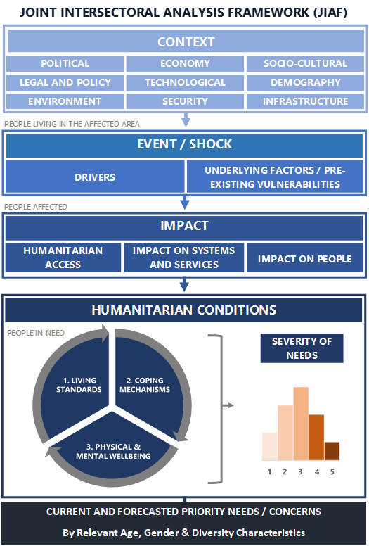

The JIAF Pillars are described and illustrated below:
2.1.1 Context
Context refers to the relevant characteristics of the environment in which affected populations live. It includes, however is not limited to, general characteristics of the political, socio-cultural, attitudinal, economic, legal and policy, technological, demographic, security, public infrastructure (i.e. schools, hospitals, water treatment facilities, etc), service delivery and environmental profile. The context pillar should clearly indicate the total number of people in the considered geographical areas, as well as key demographic characteristics, e.g. gender and age distribution, average family size, etc. as defined in the 2016 IASC Humanitarian Profile Support Guidance.
2.1.2 Shock/Event
Shock/event refers to a sudden or on-going event that seriously disrupts the functioning of a community or society. JIAF seeks to identify characteristics and the immediate causes of the shock, including type, location, intensity, etc. The shock/event (drought, cyclone, floods, conflict, disease outbreaks etc.) and areas of exposure should be localized geographically.
2.1.3 Impact
The primary effects (positive and/or negative) of the event/shock on the population, systems/services and humanitarian access in the affected area.
- Impact on people includes issues related to displacement, gender concerns, losses and damages to private property/non-food items, tensions within the community, etc. Positive examples could include favourable agricultural conditions, easing of community tensions, etc.
- Impact on systems and services may encompass damages to critical public infrastructures (healthcare facilities, schools, communication towers, water systems, etc.), disruption of social cohesion, support networks, markets, prices, attacks on critical infrastructures, etc. All issues related to the availability, functionality, performance or coverage of basic services should be reported under this sub pillar. Positive examples might include resuming markets, increased service coverage, etc.
- Impact on humanitarian access refers to the ability to deliver effective humanitarian assistance without restrictions or limitations. It entails an understanding of the following obstacles or challenges:
  - Obstacles impeding people affected to access services: attitudinal or institutional barriers that lead to exclusion; impediments to entry into country (bureaucratic and administrative); restriction of movement (impediments to freedom of movement and/or administrative restrictions); interference into implementation of humanitarian activities; violence against personnel, facilities and assets;
  - Obstacles/barriers impeding relief actors to access people affected: denial of existence of humanitarian needs or entitlements to assistance; restriction and obstruction of access to services and assistance; restrictions due to explosive ordnance contamination;
  - Other physical and security constraints: ongoing insecurity/hostilities affecting humanitarian assistance; presence of explosive ordnance; physical constraints in the environment (obstacles related to terrain, climate, lack of infrastructure, etc.)
A joint analysis and understanding of the context, shocks and impacts allows to identify affected areas and estimate the number of people affected by the humanitarian crisis, as defined in the 2016 IASC Humanitarian profile Support Guidance. It also enables to account for the total number of people affected by humanitarian access restrictions. Such analysis provides the baseline for more geographically and population targeted analysis of the severity of humanitarian consequences and PiN calculations, linking the different pillars of the framework.

2.1.4 Humanitarian conditions
The Humanitarian Conditions Pillar is where the consequences of the shock/event’s impact on people are identified in terms of magnitude and analyzed in terms of severity. The severity of Humanitarian Conditions is estimated by taking into account three humanitarian consequences:
- Living Standards: This sub pillar refers to the ability of the affected population to meet their basic needs. This is generally measured using indicators of population’s access to essential goods and services, e.g. healthcare, food, education, rule of law, shelter, water and sanitation facilities, livelihoods and productive assets, etc. The exact list of basic needs may vary from one context to the other and should be contextually defined.
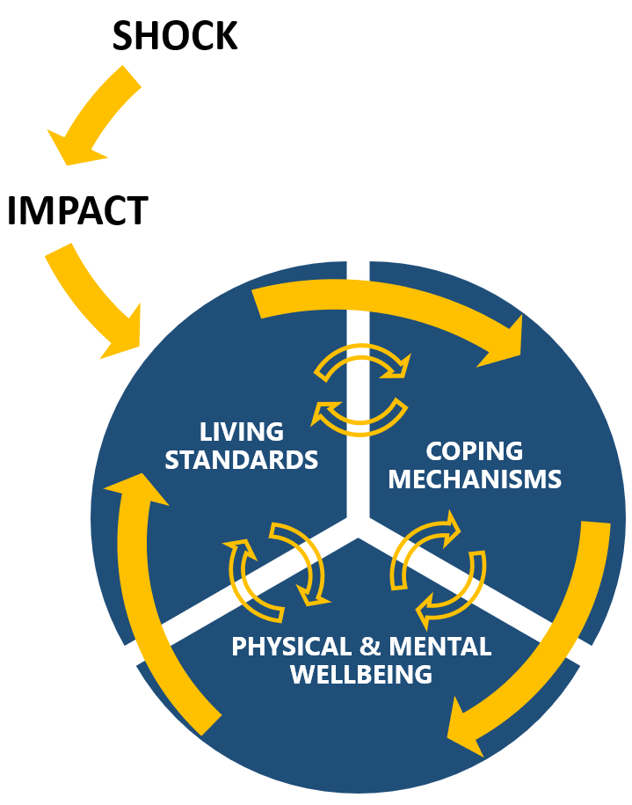
- Coping mechanisms: This sub pillar is used to understand and assess the degree to which individuals, households, communities and systems are coping or facing challenges with impact recovery, and understand the severity of the coping strategies they are relying on to cope with Living Standards or Physical and mental Well Being issues. Coping mechanisms can be positive or negative (e.g. borrowing money to purchase food items), sustainable or unsustainable (e.g. reliance on humanitarian aid).
- Physical and Mental Wellbeing: This sub pillar refers exclusively to information and indicators about the physical and mental health of the affected population. Measures and observations include morbidity and mortality data, malnutrition outcomes, psychosocial or physical impairment, injuries and trauma, fear, etc. In addition, and when data is available, grave human rights violations such as killing, maiming, rape, arbitrary detention and disappearances can also be considered under this category.
Note that the Humanitarian Conditions subpillars are all interrelated, and the progression of humanitarian consequences does not always follow a linear sequence from the inability to access basic goods or services to the adoption of negative coping mechanisms and finally the impact of the previous on Physical and Mental Wellbeing.
Feedback loops exist between the three sub pillars and each can contribute to negative outcomes in the other, e.g. disabilities or malnutrition can in turn lead to challenges in accessing basic goods and services, etc. Since it is difficult to understand what exactly precedes and contributes to what, attempts to understand causality effects between the humanitarian conditions sub pillars are not recommended.
The severity in one subpillar taken individually or in isolation of other sub pillars is also not recommended for use, as it provides only a partial picture of people’s humanitarian conditions. For instance, a population group can present a good level of access to basic goods or services (living standards subpillar), but only because they started to engage in negative and irreversible coping strategies (coping mechanisms subpillar). Taken individually, the living standards severity score can also be easily misinterpreted. Only the three sub pillars taken together and aggregated into a final Humanitarian Condition narrative and score can reflect on the overall humanitarian conditions and their severity.
2.1.5 Current and Forecasted needs
This is the main analytical output of the JIAF, an agreed list of key needs and factors associated, established for each geographical area, affected group and issues to address, broken down by severity class, sex, age, disability and diversity characteristics. That includes also needs that are currently being met through humanitarian assistance, if that assistance is required. For example, households that will not have food without direct food assistance may not be severely food insecure with the food assistance but will be without it and thus are in need of that assistance.
The JIAF will also have to apply a forward-looking lens identifying the needs from the most likely evolution of the situation during the planning period it is meant to help inform (for more detail see section 4.5.4).

3 JIAF APPROACH

JIAF analysis is based on the core principles to guide the process:
- Collaborate and bring together all relevant stakeholders who contribute data and insights regarding the interpretation of results to achieve technical consensus on the nature and severity of humanitarian needs;
- Follow sequential analytical steps (descriptive, explicative, interpretive, anticipative). Each step requires the use of specific tools and generate different outputs;
- Be driven by data, but allowing adjusting / contextualising of findings and supplemental information based on joint analysis;
- Ensure analytical rigor and standards are respected during the process.
- Ensure the most robust evidence base possible to inform response planning.
A set of procedures and tools are proposed in support of JIAF analysis to mitigate the impact of selection, processing and group biases on the quality of conclusions. The analysis is:
- Facilitated by an appointed (by HCT/ICCG), neutral individual (or organization) equipped with analytical experience, skills and the backing to facilitate consensus effectively;
- Transparent with the entire process being documented, including dissent, participants, changes, key assumptions, etc. allowing for reproducibility and auditing of conclusions if necessary;
- Iterative to draw and update conclusions based on newly available information ;
- Scalable as it allows to conduct analysis at any geographical and group level, depending on time and resources available
- Forward-looking with anticipation for the next 6-12 months taking into account risks and alternative scenarios.
- Reproducible and verifiable as the methodology and data are documented

3.1 Building technical consensus
While the JIAF does involve transforming data from diverse sources into actionable information for humanitarian decision-makers, it is at its core a collaborative process, and is as much about bringing together thematic experts to reach consensus opinions as it is about the data that is used in the process. Technical consensus is the desired endpoint of the JIAF process, where the results are jointly ‘owned’ by the participants. This joint ownership should then contribute to a better coordinated and relevant humanitarian response.
Steps to build technical consensus are outlined in section 4 and begin with building an analysis team that includes all relevant stakeholders, providing a neutral and consensual environment for analysis, and allowing for technical debate and presentation of alternate viewpoints throughout the process.
Agencies, NGOs, representatives from government where appropriate, thematic and contextual experts for example should all have equal place in the Analysis Team and the process must strive to be free of bias.
Technical consensus does not mean that each decision, interpretation and conclusion made in executing the JIAF needs to be unanimous. Challenges in achieving positive consensus may include dominant voices driving conclusions, partners not being heard or disengaging, competing interests and mandates stifling compromises. Dissenting views should in every case be handled transparently and be recorded in the results. The limitations of a weak consensus should be communicated clearly. This requires effective, strong and neutral facilitation.

3.2 Applying analytical standards
The development of the JIAF can be seen as an attempt to bring greater consistency in methods, measures, terminology and results to intersectoral needs analysis where it has been lacking in the past. In this sense, applying the analytical standards of the JIAF first refers to using the methods and tools of the JIAF in the way that they were intended, to ensure the desired results. Adaptation of the JIAF will often be required from context to context, for example based on the available information for use as indicators and their thresholds. Nevertheless, the overall logic and structure must be maintained.
More generally, the following standards apply to conducting needs analysis:
- Objectivity and independence from political considerations.
- Systematic review of ALL relevant available information.
- Clear identification and assessment of the quality and credibility of underlying sources, data and methodologies.
- Transparency regarding limitations, uncertainties (including missing data) and confidence in main analytic judgments.
- Clearly distinguishing facts, assumptions and judgments.
- Incorporating alternative hypotheses when and where appropriate.
- Ensuring the analysis provides relevant and timely decision-support.
- Clear and logical argumentation tied to evidence, reasoning and claims.
- Structured techniques to mitigate the influence of cognitive biases on conclusions.

3.3 Joint intersectoral analysis
A joint intersectoral analysis of the context, shocks and main impacts of the humanitarian crisis on the population, systems and services is a key process that can be facilitated by the JIAF, allowing a common understanding of the underlying factors and drivers of humanitarian conditions and jointly agreeing on the scope and focus of the humanitarian needs analysis, in particular:
- Identify affected geographical areas.
- Identify and profile affected population groups, including specific vulnerable groups, and establish common baseline figures.
This analysis should be linked as well as contribute to the in-depth and integrated analysis of protection risks, violations and harms that should inform humanitarian action and response as set-out in IASC Policy on Protection in Humanitarian Action, as well as ensuring proper analysis and integration of risks and vulnerabilities affecting specific groups (at minimum including factors related to age, gender, disability and other diversity considerations).
This analysis will also contribute to foster linkages with the triple humanitarian-development-peace nexus, allowing to develop area-based approaches as per the Nexus IASC Guidance and providing the baseline for a joint analysis of context, risks and vulnerabilities as recommended in the recent IASC Guidance on Humanitarian-Development Collective Outcomes.

3.4 Severity of Humanitarian Conditions and contributing factors
Measuring intersectoral severity (the degree of harm brought by all combined humanitarian consequences) is a central function of the JIAF and is achieved by applying the JIAF severity model, supported by the set JIAF Severity Scale (illustrated on the following page). For each level in the scale, information from the three Humanitarian Conditions subpillars is combined to identify a degree of severity, aligned to specific response objectives.
JIAF SEVERITY SCALE REFERENCE TABLE
Severity Class | Name | Key reference outcome | Potential Response objectives
1 | None / Minimal | - Living Standards are acceptable (taking into account the context): possibility of having some signs of deterioration and/or inadequate social basic services, possible needs for strengthening the Legal framework.  - Ability to afford/meet all essential basic needs without adopting unsustainable Coping Mechanisms (such as erosion/depletion of assets).  - No or minimal/low risk of impact on Physical and Mental Wellbeing. | Building  Resilience  &  Supporting  Disaster Risk Reduction
2 | Stress | - Living Standards under stress, leading to adoption of coping strategies (that reduce ability to protect or invest in livelihoods).  - Inability to afford/meet some basic needs without adopting stressed, unsustainable and/or short-term reversible Coping Mechanisms.  - Minimal impact on Physical and Mental Wellbeing (stressed Physical and Mental Wellbeing) overall.  - Possibility of having some localized/targeted incidents of violence (including human rights violations). | Supporting  Disaster Risk Reduction  &  Protecting  Livelihoods
3 | Severe | - Degrading Living Standards (from usual/typical), leading to adoption of negative Coping Mechanisms with threat of irreversible harm (such as accelerated erosion/depletion of assets). Reduced access/availability of social/basic goods and services  - Inability to meet some basic needs without adopting crisis/emergency - short/medium term irreversible - Coping Mechanisms.  - Degrading Physical and Mental Wellbeing. Physical and mental harm resulting in a loss of dignity. | Protecting  Livelihoods  &  Preventing & Mitigating  Risk of extreme deterioration  of Humanitarian conditions
4 | Extreme | - Collapse of Living Standards, with survival based on humanitarian assistance and/or long term irreversible extreme coping strategies.  - Extreme loss/liquidation of livelihood assets that will lead to large gaps/needs in the short term.  - Widespread grave violations of human rights. Presence of irreversible harm and heightened mortality | Saving  Lives & Livelihoods
5 | Catastrophic | - Total collapse of Living Standards  - Near/Full exhaustion of coping options.  - Last resort Coping Mechanisms/exhausted.  - Widespread mortality (CDR, U5DR) and/or irreversible harm. Widespread physical and mental irreversible harm leading to excess mortality.  - Widespread grave violations of human rights. | Reverting/Preventing  Widespread death and/or  Total collapse of livelihoods

Evidence of humanitarian conditions, in the form of indicators, is entered into the JIAF severity model (See Annex 1 and 2 detailing the aggregation methods) and classified using the JIAF Severity Scale. Typically, these indicators are derived from needs assessments, surveys, monitoring systems, studies etc. In the absence of data, they can in some cases be derived from expert judgment elicitation (a methodology involving a number of experts coming to a consensus.
The JIAF methodology derives a Humanitarian Condition score/phase for different units of analysis (households and/or geographical/affected group level). When executed to its fullest potential, the methodology enables distribution of the total number of people in an area or affected group across the five severity classes. The JIAF Severity model represents a standardization of previous severity estimation methods applied in HNOs since 2013 using the Needs Comparison Tool (NCT) and aims to offer a more robust and logical link between severity estimates and the calculation of the number of people in need.
When analysing the severity of humanitarian outcomes and determining an effective response, one has to go further than identifying the main issues and their severity and must consider contributing factors. These factors can relate to availability, access, quality, usage and/or awareness. For instance, access to a basic service can be due to an economic problem (unaffordable fees) or safety issues (insecurity on travel routes). The identification of contributing factors will be used later on for response analysis and allow response objectives to focus on addressing the causes of the problem as well as the problem themselves. A typology of factors commonly influencing humanitarian outcomes is featured in section 4.5.3.

4 JIAF STEP BY STEP
JIAF is primarily a data driven process including technical consensus derived from evidence and joint analysis. This section gives a general overview of the main steps required to conduct a joint intersectoral needs analysis. Greater detail on individual steps can be found in the annexes that follow it.
The JIAF is organized around the following process steps:
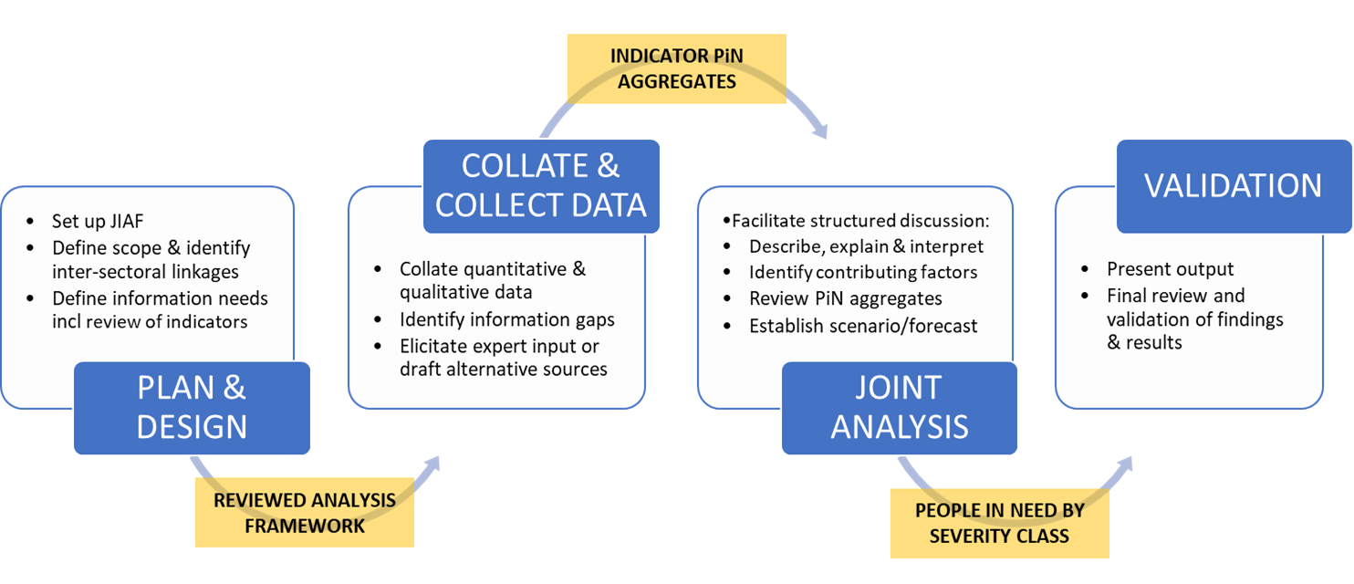

4.1 Plan & design a joint intersectoral analysis process
JIAF is a participatory and inclusive process. To generate buy-in, the collaboration and effective participation of all relevant stakeholders should be sought, documented and facilitated. The first step is to create a JIAF team that will conduct and coordinate the analysis on behalf of the humanitarian stakeholders, under the strategic leadership of the HCT. The team will have to review existing guidance and templates, agree on and align the scope of the analysis and production timelines with the overall planning process (such as the HPC) discussed at HCT/ICCG levels, and review which of JIAF indicators are applicable in the given context.
4.1.1 Form the Analysis Team
Intersectoral analysis is better conducted in group settings, and JIAF should ideally be planned for and carried out through partnerships with governments (where feasible), humanitarian actors, national civil society organisations, and with participation of diverse representatives of the affected population (e.g. ethnicity, religion, socio economic diversity, gender, etc.). A practical approach is to appoint through existing coordination structures (for HNOs the joint analysis is an HCT/ICCG led process) a multi-sectoral and gender-balanced team and lead analyst that will conduct the intersectoral analysis on behalf of the humanitarian coordination structure, submit results to the HCT/ICCG and where relevant discuss with a wider audience (government, representatives of the affected communities, clusters, etc.) and liaise with subject matter and contextual/cultural experts as required. A country-level JIAF team can be formed from an existing Assessment & Analysis Working Group, or formalised as a "workstream" or "task team" of a standard A&AWG, reporting to the ICCG.
The JIAF team should be coordinated by a lead analyst with a demonstrated analytical and facilitation/coordination skill set. The lead analyst should be specifically tasked with leading the intersectoral analysis on behalf of the humanitarian stakeholders and is accountable for the quality of the results while the overall responsibility for the quality of the HNO continues to rest with the HCT/ICCG. The ideal lead analyst skill set should include all of the following. However, when such a profile is not available, a combination of colleagues with parts of this skillset could play the lead role:
- An understanding of the different analysis steps (descriptive, explicative, interpretive, anticipative) and the possible analytical techniques applicable to each.
- Expertise in developing and using frameworks to guide data collection and analysis.
- Knowledge of main data collection techniques, limitations and strengths.
- Knowledge of criteria to assess reliability of sources and credibility of information.
- An ability to work with both quantitative and qualitative data, both primary or secondary, to produce JIAF analytical results.
- An understanding of main analytical standards used to assess the quality and credibility of analysis (e.g. Grand Bargain methodology to assess the quality of coordinated needs assessments, HNOs and HRPs, etc.).
- The ability to understand and recognise cognitive biases and their impact on conclusions (i.e. process, selection and group biases) and to make use of recommended structured techniques and strategies to mitigate against judgment errors.
- Excellent facilitation/coordination skills to achieve strong consensus between stakeholders.
- Excellent critical thinking skills, including challenging assumptions, considering alternative hypotheses and looking for inconsistent data or negative cases.
- Excellent analytical writing skills.
The JIAF lead analyst will first ensure all JIAF team members are familiar with the JIAF objectives, approach, framework and expected outputs. He/she should make sure the required range of technical knowledge and expertise is available in the team to conduct quality analysis, including:
- Technical skills (quantitative and qualitative analysis, Excel, GIS, graphic design, etc.).
- Sectoral expertise (team members should be drawn from clusters and AoR and act as a liaison to their members to gather additional data and expertise if required).
- Cross-sectoral expertise (cash and voucher, AAP, disability, gender, etc.)
- Contextual and cultural expertise (at the very least one member of the team should know the context and situation on the ground well)
4.1.2 Set and agree on timeframe, roles and responsibilities
To successfully deliver results, a well communicated work plan should be developed and agencies/clusters/sectors’ roles and responsibilities defined. The workplan should contain clear milestones including timing, tasks, responsibilities and participation, e.g., timeframe to collect/collate data, preliminary results, validation workshop, final results, etc. and for each milestone, clearly identify who will facilitate the process and consolidate the data, who will participate in the joint analysis, including, where feasible, the affected population itself. The JIAF team should plan in advance for external consultations and results validation workshops. Clear instructions and timeline regarding the process, the different steps and methods to be used should be disseminated early in the process to avoid bottlenecks and delays. It is recommended to keep track and record the stakeholders’ participation and contributions at different stages of the process, using for instance a list of participants as evidence, as well as a record of decisions made.

To increase the understanding and appropriate use of the JIAF as well as buy-in to the results, participants should be trained prior to the joint analysis on the main JIAF concepts, terminology, definitions and overall approach. In preparation of the joint analysis, main stakeholders should be clearly communicated the objectives, tools, analytical standards and procedures that will be applied throughout the process.

4.1.3 Review guidance and templates
The JIAF team should visit the HPC resource repository at www.humanitarianresponse.info to check if any substantive changes were made that would influence the type of information/indicators that needs to be collected and analysed. Requirements from the HNO template and outputs from the JIAF should be matched to ensure no critical information is forgotten and that a clear relationship exists between the JIAF outputs (intersector PiN, contributing factors, etc.) and the HNO template sections.

4.1.4 Set the scope of JIAF analysis
Setting the scope of the analysis involves using the JIAF Pillars of Context, Shock and Impact to begin developing the ‘Humanitarian Profile’ of the crisis. In this step, consensus is reached on the overarching characteristics and key measures of the crisis, and how the population is affected, where and why. Conclusions are also reached on the most effective means of organising the analysis of intersectoral needs to follow (units of analysis, key themes to focus on, etc.),
Based on an in-depth review of available secondary data, the scope and parameters for the JIAF are set based on identified and agreed geographical areas, population groups (including groups with specific needs), and cross-sector thematic issues to ensure an intersectoral approach. The analysis of the crisis context, key shocks/events and impacts is based on available knowledge of the humanitarian situation and builds upon previous analyses. It aims at describing:
- The context or environment in which humanitarian actors operate (policies and legal framework, security profile, socio-cultural and demographics characteristics, infrastructure, etc).
- The exposure of the population to different shocks and risks which define the humanitarian crisis in the given country (including conflict/violence, human rights violations, natural hazards, disease outbreaks, etc.)
- Impact of the crisis on affected population (including displacement / mobility), systems and services and humanitarian access.
- Key vulnerability characteristics (including based on age, gender and disability and other contextually relevant characteristics)
- The linkages and causal factors between all of above elements

The following steps should be considered:

Step 1. Identify and consolidate available information (qualitative and quantitative) on context, shocks, impact and vulnerabilities including available indicators that can be aggregated or disaggregated to the selected geographical unit of analysis ensuring they are comparable between each other. A suggested set of indicators has been compiled based on a review of commonly available data and consultation with sectoral experts (see here reference table).

Step 2. Review and analysis of indicators. Clusters and AoR will guide the analysis of quantitative context-shock-impact indicators based on their sectoral expertise. This can be done in a simple manner by ranking / classifying indicators values most appropriate for each context. See Annex 3 for further guidance on options for indicators analysis.

Step 3. Joint interpretation. Consensus on the geographical areas affected by the crisis should be facilitated by the JIAF Team bringing together sector coordinators and experts. Analysis and interpretation of the consolidated information should be done one by one for each of the geographical units of analysis. Once agreement is reached, the discussion can move to the next area. In case of difficulties for reaching such consensus, it is preferable to include the specific area in an effort to capture all needs and determine through the JIAF exercise the level of severity.

Step 4. Identify and profile affected population groups. Identification of affected groups in affected areas and establishing figures of the number of people affected using as reference the 2016 IASC Humanitarian profile Support Guidance. The figures should be disaggregated by key demographic and vulnerability characteristics related to the context, as a minimum by: gender, age groups (children, youth, adult, older persons) and disability. Where possible, further break down children into the age groups used by the different sectors (0-6 months, 6 months-2 years, 3-5 years, 6-11 years, 12-17 years), as well as groups that require particular attention in each context (e.g. widows, children-at risk, minorities, pastoralists, among others).

Step 5: The common understanding and agreements reached during this process should be formalized in a narrative format that describes how context, shocks and impact results are linked focusing on the most vulnerable groups and locations. The narrative should explain the causal factors and linkages between these JIAF pillars and group them by vulnerable groups and affected areas.

Step 6. Present for endorsement to the HCT/ICCG as the premise for setting the scope of the HNO

The main analytical outputs are agreed-upon affected geographic areas, population groups (both affected groups and groups with specific needs), and levels of disaggregation. This should be accompanied by:
- Brief rationale for focusing on these geographical locations and specific groups, e.g. based on changes that have occurred, achievements and gaps in response. This can be complemented with a ranking of affected geographic areas;
- Clarification that the analysis may or may not cover the whole country and every population groups, depending on what the priorities are for programming decisions, and what changes have occurred in the context compared to previous analyses;
- Acknowledgement where barriers to humanitarian access will limit the depth of the analysis and recommended strategies to overcome information gaps;
- Agreement on units of analysis and disaggregation
Data collection and protocols:
It is important that clusters and other stakeholders/partners align their data collection, organization and analysis efforts with the agreed-upon units and disaggregation levels, and that divergences are explained and documented. Main units of analysis generally include:
- Affected Geographical area: Provinces, districts, sub-districts, municipalities, villages, settlements, etc.
- Affected groups: IDPs, host communities, refugees, non-displaced affected populations, the country humanitarian profile will help determine which affected groups should be considered.
- Time: Pre-crisis, in-crisis, in the future;
- Demographic groups: Sex, age (disaggregated by relevant year intervals),
- Groups with specific needs, e.g. female headed households, chronically ill, disability status, pregnant and lactating women etc.
- Specific contextual or vulnerability categories: Rural vs urban, coastal vs inland, specific ethnic/minority groups;
Disaggregation certainly offers greater analytical opportunities; however the number of aggregations has an impact on the number of analyses that need to be conducted and the amount of data required to populate the JIAF. The JIAF team, the main information providers and coordination bodies need to agree on practical disaggregation levels, balancing the imperative to distinguish the severity of humanitarian conditions by affected groups, geographical areas and other important units, the level at which data is the most commonly available and the pragmatics of quality, speed and cost.
4.1.5 Review indicators and define sources
Once the exact units of analysis and disaggregation levels have been identified and agreed upon, the JIAF team can start consulting with the relevant cluster/AoR and main data providers to review and identify which indicators will be used to populate the JIAF.

JIAF provides a working list of core indicators for the Humanitarian Conditions pillar, each accompanied by thresholds recommended by global clusters/AoR and categorized by pillar and subpillar. Not all indicators and thresholds presented in the current list have been tested and context adaptation is possible, through discussions with corresponding Cluster/AoR lead prior to their application to this JIAF analysis.

The review process should entail a facilitated discussion with cluster leads and main humanitarian stakeholders to review and select relevant and appropriate indicators for the context. The contextualization of JIAF indicators follows two steps, described below:

- The JIAF lead analyst should facilitate a discussion with cluster leads and main humanitarian stakeholders to establish a list of basic goods/commodities and services adapted to the context. This will allow to clearly identify indicators eligible under the Humanitarian Conditions pillar compared to the Impact pillar. For instance, if the list of basic needs includes ‘Information’, then indicators about access to information or risk education could be included under the living standard subpillar dedicated to measuring the ability to meet basic needs. If the list does not include ‘Complaints and Feedback Mechanisms’, then CFM indicators will be placed under the Impact on services subpillar.
- Once the list of basic needs is established, the JIAF team will request Cluster/AoR to identify their candidate indicators for JIAF. The following core principles should be respected when submitting Humanitarian Conditions indicators:
- Validity: A clear relationship between the indicator and what is being measured exists.
- Unit of analysis: JIAF indicators can be either at household or geographical level.
- Transparency: Each indicator has a robust and accepted methodology/instrument attached.
- Severity thresholds: each indicator has severity thresholds organized along a 5-point scale and at a minimum a 3-point scale, aligned with JIAF severity scale definitions and humanitarian population figures, e.g. severity class 2 means being affected, severity class 3-5 means being in need. Binary indicators (yes/no) are not recommended for the Humanitarian Conditions pillar as they cannot be used for severity calculation as defined at this time.
- Simplicity: Indicator is easy to understand and self-explanatory.
- Uniqueness: Indicators should be used only once in estimating severity of Humanitarian Conditions. This is to avoid redundancy and over weighting a particular indicator.
- Disaggregation: data by sex, age categories, disability status as much as feasible

Based on a review of the use of indicators in the HNO 2020, the following is not recommended:
- A sector PiN should not be used as a measure of severity in the Humanitarian Conditions pillar. Sector PiN, when already calculated, will be used at a later stage as part of the review and finalisation of JIAF and sector findings.
- Response indicators, e.g. % of the population who have received (or not received) XX, should not be included in the JIAF as they are not needs-related indicators. They can be used separately to calculate gaps in response and inform the projection of needs.
- Risk indicators, e.g. number of people living in flood prone areas should be used only to support JIAF risk analysis (see section 4.5.4).

Once the submitted indicators have been reviewed, contextualized and established for all pillars, the JIAF team should ensure that each indicator has an owner and a source (government or local authorities, agencies, clusters/sectors, research institute, etc.). The JIAF team should liaise with the respective clusters/AoR or with the main data providers to see how data can be obtained. In some cases of information gaps that cannot be filled otherwise, expert judgement elicitation sessions can be organized to obtain the best estimates (see 4.2.2), based on available secondary data.
Although severity scales are not always available for indicators under the impact pillar in the JIAF spreadsheet, JIAF teams, in consultation with relevant Cluster/AoR representatives, are free to develop and use their own, contextually adapted when necessary.
4.1.6 Identify 'critical' indicators and define sources
Identifying critical indicators will be important when it comes to aggregation and overall severity classification. Critical indicators are those that correspond most directly to time-critical life-threatening consequences as seen in the JIAF Severity Scale. These critical indicators should be used when aggregation results are scrutinized by subject matter experts, to ensure that these indicators are compared against aggregated results and if appropriate, lead to an override by the critical indicator(s)the final severity score.
Identifying critical indicators represents one of the most important roles for the Analysis Team. To do this, the Analysis Team must ensure that these indicators at the highest levels (e.g. severity 5) equate to ‘imminent death’. The severity level of these indicators can then override the severity of others. Using an individual level example, consider a person with severe malnutrition. If they are in such a severe state that death is imminent, it does not matter if all other indicators are positive, they still should be categorised at that severity level, regardless of what the insersectoral severity level was determined to be
Additional examples could include: Number of cases or incidence rates for Ebola, severe food insecurity, civilian population killed or injured by violence, conflict, explosive ordonnance or natural hazards depending on the context. Ultimately, these indicators need to be decided at country-level, in consultation with the GCCG if support in the selection is needed.
Indicators from well-established assessment methodologies whose severity indices relate to ‘imminent death’ in the highest categories should be given precedence in the selection of critical indicators. The chief example of this is the Integrated Phase Classification (IPC) and Cadre Harmonise (CH) whose severity classifications should always be treated as critical indicators.

4.2 Collating and collecting data for JIAF
At a minimum, JIAF should be based on a thorough secondary data review. It is however unlikely that secondary data alone will be sufficient to execute the JIAF to its fullest potential. Coordinated approaches (joint or harmonized) to data collection will be required to ensure sufficient and timely data is available to conduct JIAF analysis, e.g. Cluster/AoR assessments include JIAF indicators, leveraging the use of Multi Sector Needs Assessments (e.g. MSNAs), harmonizing data collection forms or sampling from different stakeholders, etc. In the partial or total absence of data, expert judgment elicitation sessions i.e. key informant interviews with subject experts at local level can be organized to populate the JIAF (see 4.2.2).
Most of the data in the Context and Shock pillars of the JIAF can be collated using secondary data review. Gathering data for the impact and humanitarian conditions pillar generally require more careful field assessment planning and coordination.
Before to start gathering data, the JIAF team should circulate a JIAF dataset template to all JIAF main data contributors to clearly communicate how data will be organized and structured.

4.2.1 Secondary Data Review
The Secondary Data Review process entails collating data or information relevant to JIAF pillars and sub-pillars in a systematic and structured manner. It generally comprises findings and information from sectoral statistics and reports, nationwide economic or demographic surveys, published research, web content, videos, humanitarian products, recordings or media reports. It can be either qualitative (videos, news report) or quantitative information (SMART, MICS or DHS datasets, IOM DTM dataset, ACLED data, etc.). Collecting secondary data generally involves:
- Planning: Setting up a team or identifying focal points in each Cluster/AoR in charge of the secondary data review, developing a tagging guidance (analysis framework, definitions, examples, assessment registry, etc.), developing information sharing and confidentiality protocols (MoUs, storage, archiving, etc.), defining outputs requirements (report template, dataset, sourcing, etc.).
- Collating secondary data: locating, screening for relevance and gathering data.
- Structuring data: Coding/tagging and storing secondary data into a common structured repository (spreadsheet or DEEP). All information should be coded and tagged based on relevant units of analysis agreed upon. In addition, all assessment reports should be entered in the assessment registry.
Ideally, secondary data review should be conducted on a regular basis. In the contrary case, at least 9-12 months of data will be required to conduct JIAF appropriately, capture seasonal variations and trends, e.g. if JIAF is conducted in September for the HNO, secondary data from January to September will have to be collated at a minimum.
A team of several people (e.g. one person per cluster/AoR) is usually required to process a significant amount of secondary data. Capacity building and training is required on how to appropriately tag information using the JIAF framework; quality control is required to ensure inter-tagger consistency and accuracy. In the case information is sensitive, information sharing and confidentiality protocols) should be developed to facilitate information exchange and restrict access to the information.

4.2.2 Telling the intersectoral story
Building upon all previous steps, the preliminary narrative developed during the analysis of the context, shocks and impact, should be expanded to unpack how context, shocks and impact result in humanitarian conditions, maintaining the focus on the most vulnerable groups and locations. The narrative should explain the causal factors and linkages between the JIAF pillars and identify which groups and sub-groups present different types of humanitarian conditions and why.
It should start identifying what the most critical problems are related to Physical and Mental Wellbeing and livelihoods and how people are coping with these. The narrative should highlight both commonalities and factors that explain differences in the humanitarian conditions the analysed groups and areas are presenting. These factors may include vulnerability characteristics (e.g. age, gender, disability), exposure to contextual factors and capacities of local and national institutions to respond.
An example of where causal factors and linkages between pillars have been described well can be found in the HNO 2020 (published Oct 2019) of the Central African Republic (see sections 1.2, 1.3, 1.5). In this example an effort was made to systematically link context and impact of the crisis and explain how and why humanitarian conditions manifested themselves among specific groups.

4.2.3 Identifying the” data scenario” for the humanitarian conditions pillar aggregation
Two scenarios (A & B) have been identified, for aggregation of indicators in the humanitarian conditions pillar, to obtain the initial, estimated JIAF PIN calculations. The scenarios are determined based on the availability of JIAF indicator data, in particular whether data is available at household and/or area level. It is important to note that the aggregation methods outlined in the annexes of this guidance are still in piloting stage and have only been tested with simulated data.
It is recommended that IF Data Scenario A is applicable in a given crisis (see definitions below), then the Data Scenario A aggregation methodology should be used. This is because Data Scenario A is easier to implement, more precise and allows for a full breakdown of population by severity class, which is not possible for Data Scenario B. However, given the current COVID context, Data scenario A may often not be possible, where household level data has not been possible to collect at all. A decision-tree is outlined below, summarising how to identify the data scenario in a given crisis. A more detailed description of the scenario definitions follows further below.
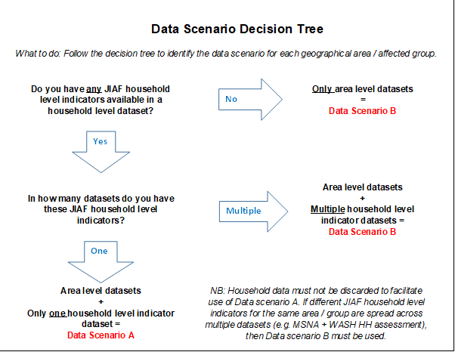
Data Scenario A
Definition: Any JIAF household level indicators collected at household level for the humanitarian condition pillar for an area & population group, is contained in one household level dataset.

For Data scenario A to be possible in a given crisis, the available JIAF household indicators must be contained in one dataset. If different household level indicators have been collected and are available for the same area and population group in multiple datasets - or if household level indicators are not available at all - then Data scenario B should be used. Household data should not be discarded to facilitate use of Data scenario A.
The household indicator data that is available, may have been collected using a single household level assessment covering all geographical areas (e.g. multi sector coordinated assessments, such as an household level MSNA) - or multiple household level assessments covering different geographical areas but using the same questions (i.e. harmonized household level assessments). It may be the case that no household level multi-sector assessments have been done at all but some JIAF household indicators are available from one other household level assessment (e.g. WASH household survey).
Any number of JIAF area level indicators that are available in a given crisis, can then be added to this household level indicator data, as long as the geographical location of the households are known (i.e. which area they are in).
Since all indicators then refer to the same unit of analysis, i.e. the household level indicators are “linked”, the co-occurrence/cumulation/interlinkages of needs can be easily derived, e.g. households that face deprivations in sanitation AND access to an improved water source AND have school aged children not attending school regularly. This linkage is a crucial advantage of scenario A, since the co-occurrence of needs can be determined within or between pillars and sub-pillars.
The household level indicators can and should be complemented by all area level indicators originating from other surveys or needs assessments. This is possible as long as geographical location of households and area indicator can be matched. The full aggregation method for scenario A is outlined in Annex 1, including how to build the aggregation dataset using multiple datasets and how to produce the aggregation and obtain the outputs.
An example of the final output table obtained through the scenario A aggregation is shown below. The interpretation of the aggregated results is outlined in the joint analysis section XXX below, including how to develop the overall HNO PIN estimates, building on the aggregated results in the table below.
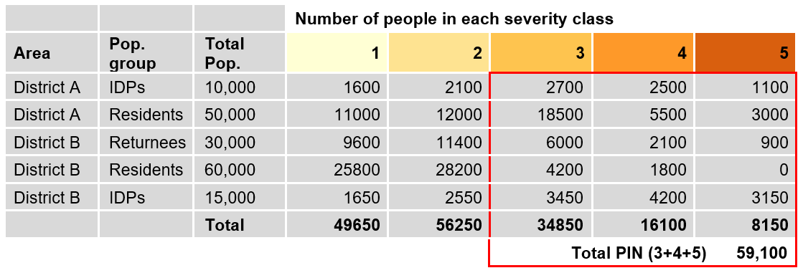
Under the current conditions associated to COVID-19, primary data collection through household surveys will, in several crises, not be appropriate, meaning no household level data set containing JIAF indicators may be available at all. Hence data scenario A described above (which requires one household level data source) would not be possible. Data scenario B (below) would in this case need to be followed instead.

Please note that if Data scenario A is followed --> only refer to Data scenario A instructions throughout the rest of this document (so ignore any instructions relating to Data scenario B). Detailed instructions on how to produce the Data scenario A aggregation are outlined in Annex 1.

Data Scenario B
Definition: There are either no JIAF household level indicators collected at household level for a given geographical area / group, or the available household indicators are spread across multiple household level datasets.
All situations other than that outlined under Data scenario A above, are classified as Data scenario B. This means the values of all household level indicators cannot be known for all households in all the datasets. This might be the case when data contributed to JIAF originate from different assessments and were not collected for the same units of analysis, e.g. food security indicators are provided by Emergency Food Security Assessment data, shelter indicators by the shelter cluster assessment and education indicators by an education survey. Since not the same people were assessed for shelter, food and education, it is challenging to distinguish if the same people are facing issues in the three sectors or if they are simply different people with different issues. In this scenario, the household level indicators are thus “unlinked” and the percentage of the population in the data that have co-occurring needs is unknown.
Nevertheless, an aggregation approach has been identified for Data scenario B, which (to some extent) can estimate the co-occurrence of indicators. The full aggregation method for scenario B is outlined in Annex 2, including how to build the aggregation set using multiple datasets and how to produce the aggregation and obtain the outputs.
An example of the final output table obtained through the scenario B aggregation is shown below. The interpretation of the aggregated results is outlined in the joint analysis section 4.4 below, including how to develop the overall HNO PIN estimates building on the JIAF PIN estimates shown in the final column on the right in the table below.
 |  |  |  | Population by severity class on critical indicators
Area | Pop. Group | Population size | Overall area severity class | Household Hunger Scale - class 3 | Household Hunger Scale - class 4 | Household Hunger Scale - class 5 | etc | etc | Min. # of pop. in this severity class (or higher) | JIAF PIN estimate is:
District A | IDPs | 10,000 | 4 | 24% | 21% | 0% |  |  | 2,500 | >2,500
District A | Residents | 50,000 | 3 | 12% | 0% | 0% |  |  | 12,500 | >=12,500
District B | Returnees | 30,000 | 1 | 0% | 0% | 0% |  |  | 30,000 | <7,500
District B | Residents | 60,000 | 2 | 0% | 0% | 0% |  |  | 15,000 | <15,000
Etc | ... | …. | ... |  | ... | ... | ... |  | ... | ...

It is recommended that beyond the 2021 HNO, further development and testing is conducted to identify a robust methodology that allows a breakdown of population by severity class 1-5 for scenario B, i.e. a methodology to enable production of the same output table as seen for scenario A above.
Please note that if Data scenario B is followed → only refer to Data scenario B instructions throughout the rest of this document (so ignore any instructions relating to Data scenario A). Detailed instructions on how to produce Data scenario B aggregation are outlined in Annex 2.
Regardless of which data scenario is being considered, it is important to note that whenever IPC/CH analysis is available, the results should be used as input into the JIAF analysis.

4.3.1 Consolidating JIAF data
All JIAF data should be consolidated into one spreadsheet, organized based on the JIAF framework.
UNOCHA should provide the JIAF team with the Common Operational Dataset (CODs) considered by the JIAF, as well as the population figures and demographics in each of those areas. Displaced population data will originate from the CCCM cluster for IDPs in camp/sites and from UNHCR for refugees, both in regards to the overall population figure and the PIN.
The JIAF team should check for completeness of the final dataset and redirect data collation/collection efforts in case of information gaps. Depending on its format and source, some values in the spreadsheet will have to be transformed to fit JIAF data format requirements. However the original data should always be available for further checks or control.
Each row represents one single unit of analysis, generally a combination of geographical area and affected group. If there are 3 affected groups in one geographical area, e.g. residents, IDPs and returnees, then 3 rows should be made available for this geographical area.
- Main units of analysis should be displayed on the left columns, e.g. geographical areas, groups, etc.
- Each column represents one indicator for the given unit of analysis. Indicators should be grouped by pillars and sub-pillars of the framework. Context indicators should start on the left (population data, demographics, etc.), followed by shock/events indicators (e.g. conflict intensity, precipitation levels, etc.), impact indicators (e.g. number of schools partially or totally destroyed, number of functioning markets, etc.) and humanitarian conditions indicators (Living Standards, Coping Mechanisms, Physical and Mental Wellbeing).
- No cell should be left blank. Therefore, analysts should check blank cells to determine if data may be missing or the data value may be zero (and filled accordingly). Expert judgement elicitation/key informant interviews may be used where appropriate to fill information gaps.
- Each indicator should be clearly labelled. One tab of the master spreadsheet should indicate source, date and the methodology used to generate the value (e.g. expert judgment/key informant interviews, HH survey, etc.) and any calculation performed on the original data, e.g. percentage, severity classification, etc.

4.3.2 Initial estimates of the total number of people falling under each severity class
Once all the data is consolidated into one single spreadsheet and in a tidy format, the JIAF team should produce initial calculations of the number of people falling under each severity class for each unit of analysis, based on the data available under the humanitarian conditions pillar and sub-pillars.
Depending on the selected data scenario (A or B), a specific set of aggregation methods are recommended to produce initial estimations of the total number of people in need by severity class and the severity phase classification for each geographical area and group. Annex 1and 2 provide detailed step-by-step instructions for how to implement the aggregation methods for data scenario A and B respectively. Section 4.2.3 outlines how to identify the data scenario in a given crisis.

4.4 JIAF analysis
Analysis is the process of transforming data and information into actionable insight. Needs analysis is the process designed to provide estimates or informed opinions about humanitarian conditions and their contributing factors. It entails a systematic set of procedures and the use of specific lines of inquiry to identify current and forecasted humanitarian needs, and inform decisions about programme design, system improvements and allocation of resources. The process of bringing several subject matter and contextual/cultural experts (usually in the form of one or several workshops) from different humanitarian organisations to conduct analysis is known as Joint Needs Analysis.

Joint analysis is one of the most important steps of the process. JIAF analysis is conducted by the Analysis Team who are tasked with bringing all the various data points together and interpreting them. This pre-identified panel of ‘experts’ will come together to interpret the available data and come to a final judgement on PiN and Severity for each administrative area taking into consideration all information available. Defining ‘experts’ can be problematic in humanitarian settings. It is recommended that the following profiles be included in the panel that will provide the analysis:
- Knowledge of analysis and a firm understanding of the aggregation methods agreed
- Local knowledge on the areas being evaluated – this can be individuals who have spent significant amounts of time working on the ground, conducting research, or who are from that area
- Sector specific technical knowledge
- Intersectoral technical knowledge (e.g. emergency program management)
- Knowledge of the datasets being used to inform the analysis, particularly anyone who worked on the assessments in question
Joint analysis sessions should be carried out in plenary and all clusters and AoR should participate in them as well as field staff who are well informed about the various areas, M&E or assessment staff, IMOs and/or analysts. In some cases, there may be staff who are known to be knowledgeable that should be sought out – regardless of their current title. It is important to ensure there are representatives from each sector present on the Analysis Team. It is also recommended that Cluster /AoR coordinators keep their constituencies updated of the process. The objective is to find a panel of individuals who are knowledgeable on the subject matter.
The JIAF team is in charge of ensuring all JIAF principles are respected and abided by during the analysis process. It is recommended that a workshop be arranged to discuss and review the various indicators in the master table and any other contextual information available for each unit of analysis. Subject matter, context and cultural experts should be included in the workshop. The JIAF team in collaboration with UNOCHA and under the strategic leadership of the HCT, will provide a facilitation role for these discussions with the group needing to have a majority agreement on any decisions taken. Where agreement is required on topics that are specific to one or two sectors, it is important to ensure the relevant sectors agree and, if not, that their concerns are documented to their satisfaction.
The Analysis Team will need to review all the available data, covering all pillars, to determine how many people are in need, what characteristics are shared by those people in need, how severe the need is and what underlying factors may be contributing to those needs along with making predictions for how needs may change (or not) in the coming months. It is during this step that the PIN and severity figures will be finalized through an interpretive analysis process that will look at all available information, consider if any adjustment is required, and finalize the figures for each administrative area. Refining the findings requires consideration of a number of factors:
1) Is there any conflicting data?
If so, the Analysis Team should review the different datasets and determine what is the most accurate depiction of needs on the ground. It will be extremely important to ensure this process is well documented.
2) Is the data reliable?
Data reliability is always a concern. With rapidly evolving situations, it is important to ensure data is as up to date as possible, sufficiently representative, and collected using a transparent and well-defined methodology. However, in humanitarian situations, it is often necessary to rely on data that are not considered highly reliable. If the reliability of data sources is considered questionable, the Analysis Team should consider if any results using those data sources should be adjusted in light of reliability concerns.
As data collection is likely to be more difficult this year, it is quite likely that some of the data sources being incorporated into the JIAF analysis may be less than ideal. One of the most anticipated problems is incorporation of data that is out-of-date. If circumstances on the ground have altered significantly since the data was collected, it is recommended that the Analysis Team factor this into their analysis process and flag any potential concerns they may have. For example; if data were collected early in the year for a given area and it is known that assistance that populations had relied on had since been blocked by movement restrictions, while situation reports had qualitatively identified a worsening situation in the area, the Analysis Team may decide to increase the severity level in the area. They should document the rationale for this increase, including the supporting evidence in terms of the time-lag in the available quantitative data; the assistance that ceased; and the (qualitative) situation reports indicating a worsening situation.
3) Is the intersectoral PIN in-line with the sectoral PIN?
As different methodologies are used to calculate sectoral PIN and the intersectoral PIN produced through the JIAF analysis, it is quite likely that circumstances will arise where sectoral PIN differs unexpectedly compared to intersectoral figures. Specifically, as intersectoral PIN covers all sectors, it could be expected that the figures may be higher than the individual sector level PIN figures. However, there are multiple reasons for why this may not be the case. One of the most important tasks of the Analysis Team is to review the sectoral and intersectoral PIN figures, documenting the explanations for discrepancies and identifying the most accurate possible HNO PIN. This process is outlined in detail in the sections below.
The joint analysis process overall must be well documented with all concerns recorded along with any dissenting opinions. JIAF analysis always follow the same steps:
- Review the description of people’s humanitarian conditions and factors associated, and the estimated, initial calculations of people in need by severity class and severity phase
- Describe main issues and the characteristics of the estimated people in need by severity class
- Establish underlying factors
- Anticipate future conditions
- Agree on current and forecasted humanitarian needs
4.4.1 Review the narrative developed exploring the linkages between the pillars, the description of people’s humanitarian conditions and factors associated and estimated, initial calculations of people in need and severity phase estimation.
The departure point is the understanding of what the humanitarian conditions of people consist of and why, in addition to the estimated, initially calculated number of people in need falling into each severity class and the resulting severity phase obtained through the aggregation. In practice, the description of people’s humanitarian conditions and factors associated (step 4.4.2 below) is done iteratively with the severity analysis and PiN calculation. An understanding of people’s humanitarian conditions and causes is essential to ensure the relevance and validity of the severity analysis and PiN estimation. Conversely, the severity analysis and PiN contribute to finalise the description of people’s humanitarian needs and causes of these needs.

The estimates should be reviewed and agreed upon by subject matter and cultural/context experts to check for plausibility.

For the review of estimated, initial calculations of PiN, the specific process and types of decision that need to be made will differ depending on the data scenario and thus, aggregation methods that were used in the previous steps. Analysis and interpretation should be done for each geographical area and group, one by one. Once there is consensus in one of them, the discussion can move to the next.

4.4.2 Data Scenario A
See Annex 1 for details on how to produce the initial estimated PIN results that are reviewed in the steps below. Please refer to Data Scenario B section below instead if estimated PiN results were produced using the Data scenario B aggregation methods.
- Review the humanitarian conditions and combination of humanitarian consequences that they represent, and why they are occurring, including differences amongst various population groups/sub-groups according to vulnerability and diversity characteristics, impact of the shock, and context (see 4.5.2 below for more details).
- Scrutinize the summary finding percentages and numbers estimated in the various severity classes, comparing against individual indicators, qualitative data, contextual information, common sense.
- Cross-check JIAF PIN estimates against any individual sector PIN estimates available for each area / group. Since the JIAF aggregation aims to produce an intersectoral finding, i.e. to capture needs across sectors, any given individual sector PIN could conceptually be expected to be equal or lower than the estimate obtained here. If a sector PIN is higher than your estimate, explore the methodology and type of data behind the sector PIN and double-check the data and aggregation behind your estimate, to identify the reason for the sector PIN being higher. Ensure there are sector representatives on the Analysis Team who have a firm understanding of their own PiN methodologies and can agree on any conclusions reached that relate to sector specific PiN.
  - Sector PINs may be higher in cases where the sector PIN includes people that are not in need but that are currently receiving assistance, who would be in need if this assistance was not provided. This could explain why a sector PIN could be higher, since the JIAF PIN includes only people that are currently in need.
  - Sector PINs may be higher because they were calculated covering a different geographic area despite the agreed scope of the needs analysis (e.g. the sector may have looked at a larger area)
  - The rule followed at sector level to input missing data for the PiN, for example for inaccessible areas, may have been different than the one followed in the intersectoral approach.
  - Sector data used for the PiN may have included some data that are of a different nature than those used in the intersectoral analysis (e.g. not covering the same time period, or not coming from the same sources of information for a given population group or geographic area) etc.
- Cross-check the areas PiN estimate and severity score against known presence of concentrated pockets of potential high needs in an area with otherwise low severity need. An example of this can be the presence of one or more camps in an area with otherwise lower needs severity. The presence of these concentrated pockets can inform an adjustment of the estimates and severity scale of the area.
- Adjust the JIAF estimate if appropriate based on the considerations outlined above, to obtain the most accurate possible estimate for the HNO PiN and ensure to carefully document the rationale and supporting evidence behind each adjustment. For extreme cases (severity phase 5), evidence should be very clearly documented, dissent reviewed, and additional subject matter experts consulted if necessary.
The final output of this step is thus an updated (if any updates are made) table outlining the breakdown of households by severity class - along with an updated table (if any updates are made) where the percentage findings have been multiplied by the total population size, to obtain the PIN estimates.
It is recommended that the final output table also flags any areas and groups that are currently receiving assistance, to ensure that the current severity phase is understood as dependent on current levels of assistance. The implication being that IF current assistance would decrease, the severity phase would increase.

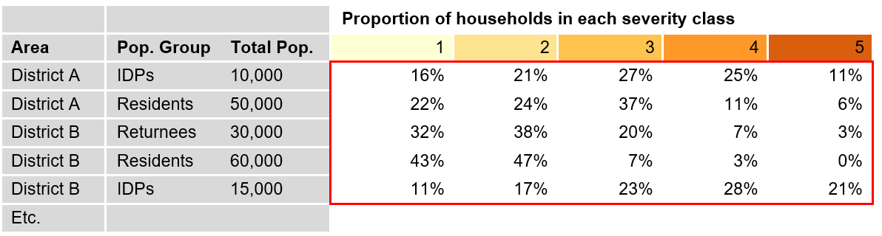
4.4.3 Data scenario B
See Annex 2 for details on how to produce the results that are reviewed in the steps below. Please refer to Data scenario A section above instead if estimated PiN results were produced using the Data scenario A aggregation methods.

In scenario B, the values on all household level indicators cannot be known for all households in all the datasets as the indicators are unlinked and therefore, a disaggregation of population by individual severity class is not possible. However, it is possible to estimate the overall area/group severity phase, along with an estimate of the percentage of the population falling in that phase or a higher phase. This area/group severity phase should be contextualised by a breakdown of any percentage of the population found in high severity phases on “critical” indicators, revealing pockets of severe needs. See Annex 2 for details on how to produce these results that are reviewed in the steps below.
- Review the humanitarian conditions and combination of humanitarian consequences that they represent, and why they are occurring, including differences amongst various population groups/sub-groups according to vulnerability and diversity characteristics, impact of the shock, and context (see 4.5.2 below for more details).
- Scrutinize the summary finding percentages and numbers, comparing against individual indicators, qualitative data, contextual information, common sense.
- Interpret the JIAF estimates. Where the JIAF estimate is preceded by a “>” (see table below), the “true” PIN is likely higher than the JIAF PIN estimate. Where the JIAF estimate is preceded by a “<”, the PIN could likely be lower than the JIAF PIN estimate. Using the table below as an example, they can be interpreted as follows:
- Where the overall class was “4”, we know that the 25% does not include people in class 3 (threshold for inclusion in PIN), so the “true” PIN is likely higher than 2,500.
- Where the overall class was “3”, we know that the 25% could represent the “true” PIN, if exactly 25% were found in classes 3,4 and 5 overall. However, it is more likely that more than 25% were found in classes 3,4 & 5, hence the true PIN could also be higher than 12,500.
- Where the overall class was “1”, we know that less than 25% were found in classes 2,3,4 & 5. Hence the “true” PIN is likely less than 7,500.
- Where the overall class was “2”, we know that less than 25% were found in classes 3,4 & 5. Hence the “true” PIN is likely less than 15,000.
- Compare the JIAF estimates against the “critical indicator” breakdown of population by severity class (see table below).
  - Where the % of population found in classes 3-5 of critical indicators is higher than the JIAF estimate, this supports the notion that the true PIN is higher than the JIAF estimate.
  - Conversely, where the % of population found in classes 3-5 of critical indicators is lower than the JIAF estimate, this could indicate that the true PIN is lower than the JIAF estimate.
- Compare JIAF estimates with individual sector PIN estimates available for each individual area / group, to estimate the HNO PIN. Since the initial calculations reviewed here aimed to produce an intersectoral finding, i.e. to capture needs across all sectors, any given individual sector PIN could be expected to be equal or lower than the JIAF estimate, where the JIAF estimate is preceded by “<” (since here the JIAF may be overestimating the PIN). It could likely be higher where the JIAF estimate is preceded by “>” (since JIAF here is underestimating the PIN). If a sector PIN is higher than your estimate, explore the methodology and type of data behind the sector PIN and double-check the data and aggregation behind your estimate, to identify the reason for the sector PIN being higher. Ensure there are sector representatives on the Analysis Team who have a firm understanding of their own PiN methodologies and can agree on any conclusions reached that relate to sector specific PiN.
  - Sector PINs may be higher in cases where the sector PIN includes people that are not in need but that are currently receiving assistance, who would be in need if this assistance was not provided. This could explain why a sector PIN could be higher, since the JIAF PIN includes only people that are currently in need
  - Sector PINs may be higher because they were calculated covering a different geographic area despite the agreed scope of the needs analysis (e.g. the sector may have looked at a larger area)
  - The rule followed at sector level to input missing data for the PiN, for example for inaccessible areas, may have been different than the one followed in the intersectoral approach.
  - Sector data used for the PiN may have included some data that are of a different nature than those used in the intersectoral analysis (e.g. not covering the same time period, or not coming from the same sources of information for a given population group or geographic area) etc.
- Cross-check the areas PiN estimate and severity score against known presence of concentrated pockets of potential high needs in an area with otherwise low severity need. An example of this can be the presence of one or more camps in an area with otherwise lower needs severity. The presence of these concentrated pockets can inform an adjustment of the estimates and severity scale of the area.
- Estimate the overall HNO PIN based on the considerations outlined above and ensure to carefully document the rationale and supporting evidence behind each estimation. For extreme cases (severity phase 5), evidence should be very clearly documented, dissent reviewed and additional subject matter experts consulted if necessary.
It is recommended that the final output table also flags any areas and groups that are currently receiving assistance, to ensure that the current severity phase is understood as dependent on current levels of assistance. The implication being that IF current assistance would decrease, the severity phase would increase.

 |  |  |  | Population by severity class on critical indicators
Area | Pop. Group | Population size | Overall area severity class | Household Hunger Scale - class 3 | Household Hunger Scale - class 4 | Household Hunger Scale - class 5 | etc | Min. # of pop. in this severity class (or higher) | JIAF PIN estimate is: | HNO PIN estimate is:
District A | IDPs | 10,000 | 4 | 24% | 21% | 0% |  | 2,500 | >2,500 | 8,000
District A | Residents | 50,000 | 3 | 12% | 0% | 0% |  | 12,500 | >=12,500 | 12,500
District B | Returnees | 30,000 | 1 | 0% | 0% | 0% |  | 30,000 | <7,500 | 3,500
District B | Residents | 60,000 | 2 | 0% | 0% | 0% |  | 15,000 | <15,000 | 5,000
Etc | ... | …. | ... | ... | ... | ... | ... | ... | ... | ...

4.4.4 Describe main issues and the characteristics of people in need by severity class including associated and contributing factors

As mentioned, this step should be iterative with the severity analysis and estimation of the PiN above. An understanding of people’s humanitarian conditions and factors associated is essential to ensure the relevance and validity of the severity analysis and PiN estimation. Conversely, the severity analysis and PiN contribute to finalise the description of people’s humanitarian needs and the factors contributing the most to unmet needs.

For each unit of analysis and severity classes, the JIAF team should describe the type of issues in Living Standards, Coping Mechanisms and Physical and Mental Wellbeing. Small summary findings describing main issues and characteristics of the population falling in each severity class should be provided, using the individual indicators mostly driving the results.

Once done, the JIAF team should identify underlying factors. Two levels of underlying factors are to be established:
- Immediate factors directly contributing to humanitarian conditions. A typology of immediate factors and subfactors commonly influencing humanitarian conditions is proposed in Annex 5 and can be adapted at country level. For instance, access constraints can be due to a physical problem (distance to the school, roads are in poor state, etc.), a financial problem (loss of income or increased fees cause difficulties for children to access education services regularly), security issues (e.g. checkpoints or attacks on the way in or out of school) or social discrimination (e.g. of people with disabilities). For all problems listed under Living Standards, Coping Mechanisms and Physical and Mental Wellbeing, the main contributing factors should be clearly identified and ranked. This will produce a ranked list of contributing factors generally comprising three to five items. More can be added if it is possible to appropriately disentangle or order their contribution to Humanitarian Conditions. This list of ordered factors will later be aggregated and further used during the response analysis stage to identify main response objectives (e.g. increase access to…, etc.) and select the most appropriate response options.
- Other more distant factors, linked to context, shocks or impact. Main characteristics of the context, the shock and its impact should be described.

The results for each unit of analysis can be summarized in a table. A fictitious example is presented below for District A - Affected Group IDPs, from which a descriptive narrative can be produced.

District A |  | Group IDPs |  | Date XX/XX/XXXX
Total people in the area: |  | 100,000 |  | Team B
Severity class | 1.None/minimal | 2.Stress | 3. Severe | 4. Critical | 5. Catastrophic
PIN # & % | 15,000 (15%) | 25,000 (25%) | 30,000 (30%) | 20,000 (20%) | 10,000 (10%)
Physical and Mental Wellbeing | - >2% HHs have been identified with disabilities | - >4% HHs have been identified with disabilities | - >15% HHs have been identified with disabilities  - 10% GAM for children U5 based on their weight for height | - >25% HHs have been identified with disabilities  - 15% GAM for children U5 based on their weight for height | - >35% HHs have been identified with disabilities  - 30% GAM for children U5 based on their weight for height
Coping mechanisms | No stress, crisis or emergency coping observed | 35% using stress strategies | - >40% engaged into crisis livelihood Coping Mechanisms  - Etc. | - >55% engaged into emergency livelihood Coping Mechanisms  - >30% are using irreversible Coping Mechanisms to access basic needs, including XX and XX  - Etc. | - >65% have totally exhausted their essential needs coping strategies  - >60% are using irreversible Coping Mechanisms to access basic needs, including XX and XX  - Etc.
Living Standards | - >85% living within a 30min walking distance from basic services | - >30% are living within a 1H00 walking distance from basic services | - >60% are living within a 1H00 walking distance from basic services  - 35% have lost their documentation  - 45% have lost their productive assets and property title  - Etc. | - >50% are living within a 2H00 walking distance from basic services  - 55% have lost their documentation  - 85% have lost their productive assets and property title  - Etc. | - >70% are living within a 2H00 walking distance from basic services  - 85% have lost their documentation  - All have lost their productive assets and property title  - Etc.
Immediate underlying factors | None | - Quality/Diversity | - Access/Financial  - Availability/Transfer  - Quality/Diversity  - Access/Physical  - Etc. | - Availability/production  - Access/Financial  - Access/Physical  - Etc. | - Availability/production  - Access/Physical  - Access/Financial  - Etc.
Associated impact on people | - No or minimal impact reported  - All have kept their sources of income or have grown businesses  - No tensions between IDPS and Host communities | - < 15% of HH working members have lost their source of income | - 35% are displaced in rented accommodation and 15% live in IDP camps, 50% are in hosted families  - > 70% experience a reduced income level of 20-40%  - No tensions between IDPs and host communities  - Etc. | - 5% are displaced in rented accommodation and 35% live in IDP camps, 30% are in public building and 30% in self settled camps  - > 70% experience a reduced income level of 40-70%  - High discrimination against IDPs  - Frequent tensions between IDPs and communities  - Etc. | - 15% live in IDP camps, 50% are in public building and 35% in self settled camps  - >70% experience a reduced income level of 70-100%  - High discrimination against IDPs  - Etc.
Associated impact on services | - All basic services are functional in the area | - Limited damage to critical infrastructure  - < 10% of markets are not functional | - Serious damage to critical infrastructure  - 70% live in areas where basic services (school, healthcare) are disrupted  - Intermittent electricity and water system  - < 30% of markets are not functional | - Extensive damage to critical infrastructure  - 45% live in areas where basic services (school, healthcare) are non-functional  - Irregular electricity and water system  - < 50% of markets are not functional | - 75% live in areas where basic services (school, healthcare) are non-functional  - Electric grid and communication systems are non-functional  - Water system and service have broken down/collapsed  - < 70% of markets are not functional
Associated impact on Humanitarian access | No humanitarian access constraints | No humanitarian access constraints | 25% of the population live in areas with regular access interruptions | - 55% of the population live in areas with severe access issues  - EO contamination | - 65% of the population live in areas with severe access interruptions and 30% in areas with no humanitarian access  - EO contamination
Nature of the shocks | All are in areas with no conflict | <10% are in areas of low conflict intensity | >70% are in areas of low conflict intensity | >60% are in areas of medium conflict intensity | >75% are in areas of high conflict intensity
Associated context | Functional rule of law, upgraded infrastructure | Functional rule of law, upgraded infrastructure | Dysfunctional rule of law, poor infrastructure, high number of female headed households, etc.

Based on the summary findings table, the JIAF team can summarize visually the chain of cause and consequence by using a problem tree for each severity class, showing causal mechanisms between types of issues and final outcomes.

4.4.5 Anticipate future conditions
The next step is to anticipate future conditions. As a first step, existing risk analyses should be consulted (previous HNOs, Emergency Response Plans (ERP), preparedness and contingency plans of humanitarian organisations). In case such risk analyses are absent or outdated it is recommended to look at the main shocks and stresses identified so far in the analysis process and develop a ‘most likely scenario’ that spans across the period of the planning decisions the JIAF outputs intends to inform (e.g. 12 months period of an HRP). Based on the most likely scenario, a percentage increase reflecting the expected evolution in the impact and humanitarian conditions should be offered to support the projections in need, disaggregated by severity class and unit of analysis. Details on how to determine the most likely scenario and thus the corresponding percentage increase is provided in the forthcoming Risk Analysis Guidance,.

4.5 Validation of current and forecasted humanitarian needs.
The final step is for the JIAF team to aggregate all the previous analysis results and derive current and forecasted most severe needs, including:
- Most severely affected geographical areas can be derived from the geographical area severity phase classification
- Most severely affected groups can be derived from the group severity phase classification
- Most essential issues to address this can be derived from the projected list of main issues and immediate underlying factors. This will directly support response analysis for the HRP.
Priority needs can be further disaggregated by sex, age and disability, as well as other diversity characteristics. Experts inputs and data can be used to derive time-critical and relevant severity of needs for other important units of analysis, e.g. male/female, groups with specific needs, vulnerable groups, etc.
Once geographic, population groups and issues most essential to address (due to their severity, time-criticality etc.) have been derived from the JIAF results, a final validation workshop should take place to validate the main conclusions. Depending on the context it might help increase the understanding and buy-in if members of the ICC/ HCT be invited before final outputs are submitted to the ICCG for final validation and endorsements.
4.5 Present for endorsement to the HCT/ICCG the joint intersectoral analysis results.

END

LIST OF ANNEXES

Annex 1. Data Scenario A: Aggregation method for the humanitarian conditions pillar
Annex 2. Data Scenario B: Aggregation method for the humanitarian conditions pillar
Annex 3: Additional guidance for the analysis of context-shocks-impact indicators for
identification of affected geographical areas and population groups

Annex 5: List and definitions of underlying factors
Annex 6: Glossary of Terms (under production)

Annex 1. Data Scenario A: Aggregation method for the humanitarian conditions pillar
***Please only refer to this Annex if working with Data Scenario A; If Data scenario B is identified, please ignore this Annex 1 and refer instead to Annex 2 where the aggregation method for Data scenario B is outlined. To identify which data scenario is applicable in a given crisis, please see section XXX above.***
This annex outlines the appropriate aggregation method for Data scenario A, where all household level indicators available for the humanitarian conditions pillar in a given crisis, exist in one single household dataset, to which any number of area level indicators can be added. Step-by-step guidance is provided on how to construct the dataset for analysis and how to implement the aggregation using the dataset. All steps can be completed using Excel.
Step 1. Prepare the household and the area level datasets. Each indicator value should be re-coded to only represent the severity score (from 1 to 5) in both datasets. A common geographical field (Admin 0, 1, 2, 3 etc. and P CODES) should be available for each household and area level indicator to facilitate merging.
Step 2. Reconcile household and area level indicators. Add all area level indicators to the household level dataset. This results in one household level aggregation dataset, including all data with both household and area level indicators “linked” for each household. Since several households might have been interviewed within a single geographical area, the same area level indicator value will be repeated for all the interviewed households in the area, as shown in the example below.
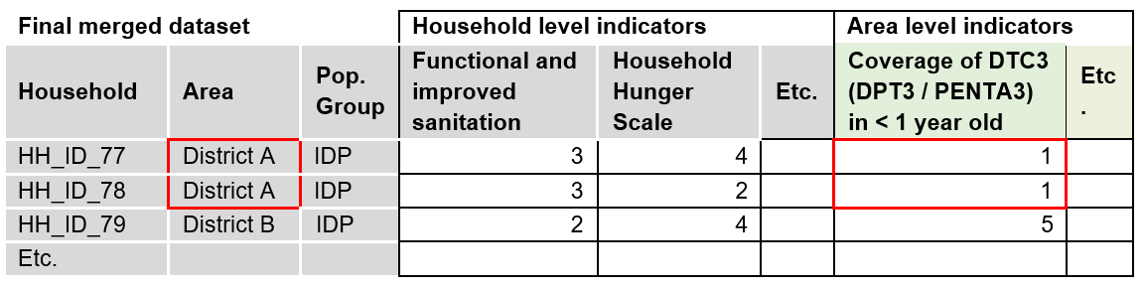
Step 3. Aggregate all indicators within the humanitarian condition pillar. The recommended aggregation method is the “Mean of Max 50% of indicators” if there are more than 4 indicators, and simply the mean if there are less than 4 indicators. For each household, the “Mean of max 50%” returns the mean of the area and household indicators that have the highest scores, focusing only on the 50% of indicators that have the highest scores.
NB: the original aggregation testing, that identified the “Mean of Max 4” as a preferred option, was based on the aim to aggregate scores by sub-pillar. However, given ongoing discussions about allocation of indicators by sub-pillar it is recommended that the aggregation is conducted on the humanitarian conditions pillar overall. This means the number of indicators aggregated in one step increases significantly, hence it is recommended that the “Mean of Max 4” is replaced by “Mean of Max 50%” of indicators, since the likelihood of at least 4 indicators having very high severity scores increases significantly when all indicators in the humanitarian conditions pillar are aggregated at once.
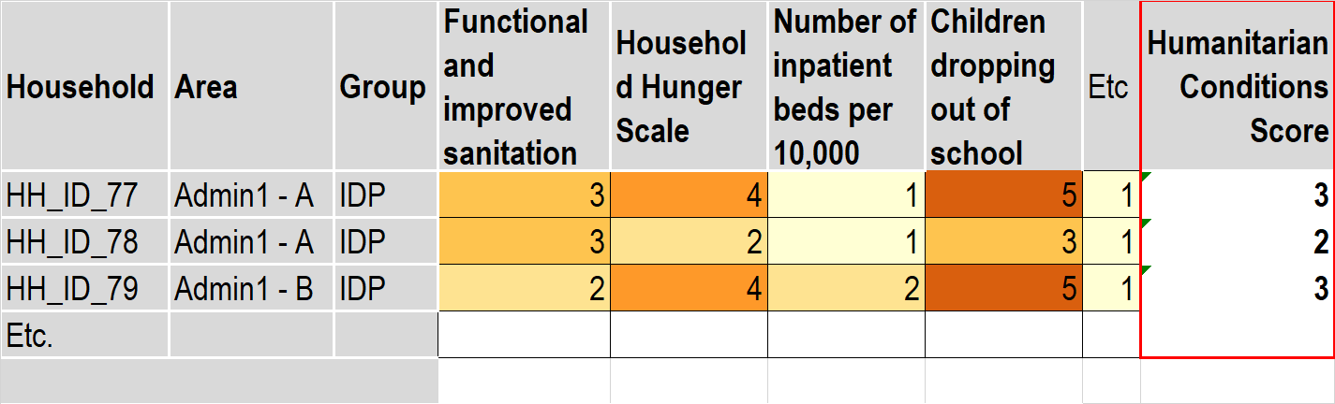
Step 4. Check if any “Critical” indicator (see section 4.1.4) severity score is higher than the final Humanitarian Condition score. If so, replace the Humanitarian Conditions Score with the “Critical” indicator score.
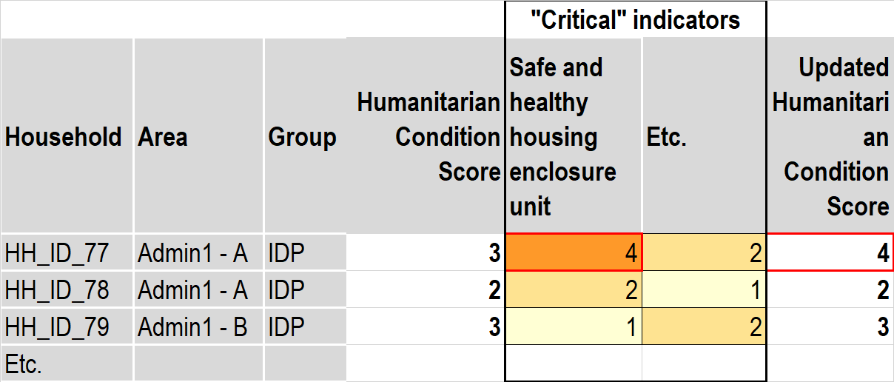

Step 5. Estimate the percentage of households falling under each severity class. Simply calculate, out of the total number of households in the dataset, the proportion of households per Humanitarian Condition Score (identified in the previous step).
Step 7. Estimate the number of households/people falling under each severity class. Multiply the percentages obtained in the previous step by total population figures to obtain the corresponding number of people falling under each severity class. For District A / IDPs: multiply 27% that are under class 3 by the total number of IDPs in District A (10,000) = 2,700 IDPs in severity class 3, 2,500 in class 4, etc. To obtain the total PIN, sum up the number of people falling under severity class 3 to 5.
If probability sampled data has been used for the aggregation, the summary findings should be presented in conjunction with the estimated level of precision with which the findings can be generalized to the population overall (e.g. the confidence level / error margin).
It is recommended that the final output table also flags any areas and groups that are currently receiving assistance, to ensure that the current severity phase is understood to be as dependent on current levels of assistance. The implication being that IF current assistance would decrease, the severity phase would likely increase.
This marks the end of the “automated” aggregation to produce estimated, initial PIN calculations. The next step is to review, interpret and adjust these estimations as part of the joint analysis process. Please see section XXX in the main narrative for details on how to do this.

Annex 2. Data Scenario B: Aggregation method for the humanitarian conditions pillar
***Please only refer to this Annex if working with Data Scenario B; If Data scenario A is identified, please ignore this Annex 2 and refer instead to Annex 1 where the aggregation method for Data scenario A is outlined. To identify which data scenario is applicable in a given crisis, please see section XXX above.***
This annex outlines the appropriate aggregation method for Data scenario B, where we either have no household level indicators and data available for a given geographical area at all, or the available household indicators are spread across multiple household level datasets. This means the values on all household level indicators cannot be known for all households in all the datasets. Step-by-step guidance is provided on how to construct the dataset for analysis and how to implement the aggregation using the dataset. All steps can be completed using Excel.
Step 1. Prepare the area level dataset. To build the JIAF dataset, all data should be summarised at area level and added into one dataset. Each indicator value should be re-coded to only represent the severity score (from 1 to 5). A common geographical field (Admin 0, 1, 2, 3 etc. and P CODES) should be available for each area level indicator to facilitate merging.
Step 2. For each indicator, geographical area/affected group, calculate the percentage of people per severity class. This results in one area level aggregation dataset including all household and area level data but with “unlinked” indicators. For area level indicators that by definition apply to the total population of an area, this means 100% of the population will fall in a given severity class depending on the result for a given indicator. E.g. the indicator “Percentage of population that can access primary healthcare within one hour’s walk from dwellings” has the following severity classes “1”: >= 80%, “2”: 75% < 80%, “3”: 70% < 75%, “4”: 65% < 70% and “5”: < 65%. That means, if more than 80% of the population can access health care within one hour’s walk, 100% of the population will be categorised as severity class “1”.
 |  |  |  | Severity classes
Area | Pop. Group | Living Standards Indicators | Indicator level | 1 | 2 | 3 | 4 | 5
District A | IDP | Water sources | HH | 14% | 27% | 14% | 24% | 21%
District A | IDP | Sanitation facilities | HH | 30% | 0% | 50% | 8% | 12%
District A | IDP | Food diversity | HH | 32% | 15% | 3% | 25% | 25%
District  A | IDP | Distance to health facilities | Area | 100% | 0% | 0% | 0% | 0%

Step 3. Estimate the severity phase for each indicator. For each geographical area/population group and each specific indicator in the dataset, apply a “25% rule” by adding up the cumulative sum from right to left, until reaching at least 25% of the population. This will return a severity phase for each indicator. E.g. following the example from the previous step, where 100% of the population were categorised as severity class “1”, we apply the 25% rule and the severity phase for the indicator will be “1”. In fact, for the area level indicators, the 25% rule will always return the same phase as that the population has been categorised as overall. We still need to go through this step to obtain an overall severity phase for BOTH area and household level indicators.

Area | Pop. Group | Indicator | 1 | 2 | 3 | 4 | 5 | Indicator Severity Phase
District A | IDP | Water sources | 14% | 27% | 14% | 24% | 21% | 4
District A | IDP | Sanitation facilities | 30% | 0% | 50% | 8% | 12% | 3
District A | IDP | Food diversity | 32% | 15% | 3% | 25% | 25% | 5
District A | IDP | Distance to health facilities | 100% | 0% | 0% | 0% | 0% | 1

Step 4. Aggregate all indicator severity phase scores within the humanitarian conditions pillar for each geographical area/affected group. The recommended aggregation method is the “Mean of Max 50% of indicators” if there are more than 4 indicators, and simply the mean if there are less than 4 indicators. For each area, the Mean of Max 50% returns the mean of the indicators that have the highest scores, focusing only on the 50% of indicators that have the highest scores.

NB: the original aggregation testing, that identified the “Mean of Max 4” as a preferred option, was based on the aim to aggregate scores by sub-pillar. However, given ongoing discussions about allocation of indicators by sub-pillar it is recommended that the aggregation is conducted on the humanitarian conditions pillar overall. This means the number of indicators aggregated in one step increases significantly, hence it is recommended that the “Mean of Max 4” is replaced by “Mean of Max 50%” of indicators, since the likelihood of at least 4 indicators having very high severity scores increases significantly when all indicators in the humanitarian conditions pillar are aggregated at once.

 |  |  | Living Standards indicators
Area | Pop. Group | Total pop. | Water sources | Sanitation facilities | Food diversity | School attendance | Etc | Humanitarian Conditions Score
District A | IDPs | 10,000 | 3 | 4 | 5 | 2 | 2 | 4
District A | Residents | 50,000 | 4 | 2 | 3 | 2 | 1 | 3
District B | Returnees | 30,000 | 1 | 1 | 1 | 2 | 1 | 1
District B | Residents | 60,000 | 1 | 2 | 2 | 2 | 1 | 2
Etc | ... | ... | ... | ... | ... | ... | ... | ...

Step 5. Estimate the “minimum number of people” falling under each severity phase. Since the “25%” rule was used to obtain the area/affected group severity phases, and the combination of 25% rule and the Mean of Max aggregation method was found to relatively accurately predict co-occurring indicators, 25% can be multiplied by the total population figures to estimate the minimum number of people that fall in the severity class (or higher). E.g. For IDPs in District A in the table below, where the total population is 10,000, the calculation would be 25% x 10,000 = 2,500, for Residents in District A it would be 50,000 x 25% = 12,500 etc.
Area | Pop. Group | Population size | Humanitarian Condition Score | Minimum number of people in this severity phase or higher (25% of population)
District A | IDPs | 10,000 | 4 | 2500
District A | Residents | 50,000 | 3 | 12500
District B | Returnees | 30,000 | 1 | 30000
District B | Residents | 60,000 | 2 | 15000
Etc | ... | ... | ... | ...

To provide more disaggregated findings on top of the severity class of the 25% most in need carefully identify pockets of severe needs within areas.
1. Review “critical” individual indicators where any percentage of the population is found in higher severity classes (e.g. classes 3, 4 or 5) and report this in the final output
2. Add any percentage of the population found in high severity classes to the final output table, to reveal pockets of severe needs within areas.

 |  |  |  | Population by severity class on critical indicators
Area | Pop. Group | Population size | Overall area severity class | Household Hunger Scale - class 3 | Household Hunger Scale - class 4 | Household Hunger Scale - class 5 | etc. | etc. | Min. # of pop. in this severity class (or higher) | JIAF PIN estimate is:
District A | IDPs | 10,000 | 4 | 24% | 21% | 0% |  |  | 2,500 | >2,500
District A | Residents | 50,000 | 3 | 12% | 0% | 0% |  |  | 12,500 | >=12,500
District B | Returnees | 30,000 | 1 | 0% | 0% | 0% |  |  | 30,000 | <7,500
District B | Residents | 60,000 | 2 | 0% | 0% | 0% |  |  | 15,000 | <15,000
Etc | ... | …. | ... |  | ... | ... | ... |  | ... | ...

It is recommended that the final output table also flags any areas and groups that are currently receiving assistance, to ensure that the current severity phase is understood to be as dependent on current levels of assistance. The implication being that IF current assistance would decrease, the severity phase would likely increase.

This marks the end of the “automated” aggregation to produce estimated, initial PIN calculations. The next step is to review, interpret and adjust these estimations as part of the joint analysis process. Please see section XXX in the main narrative for details on how to do this.

Annex 3: Additional guidance for the analysis of context-shocks-impact indicators for identification of affected geographical areas and population groups

To guide the analysis of context-shocks-impacts, a suggested set of indicators has been compiled based on a review of commonly available data, indicators used in HNOs 2020 and consultation with sectoral experts. The list and methodology should be considered as a baseline to build upon based on its use in 2021 HNOs analysis, as well as future developments of the framework.
The following sections provide further guidance for the consolidation and analysis of available information and indicators.
- Which geographical unit of analysis should be considered? The geographical unit of analysis to be considered for this process should be the same one as the one decided by the HCT as a unit for the HPC analysis. This unit is always part of the Common Operational Dataset (COD) - Admin levels 1 to 4.
Some sectors like Health or Education may find that their line national ministries follow a different geographical division from the COD’s administrative divisions (i.e. Health Administrative Provinces). In this case, the sector can aggregate the dataset to the COD unit of analysis.
In addition, the analysis should also consider sites or locations within larger geographical units where affected populations are concentrated (i.e. camps, camp-like settlements), to ensure they are not left behind or de-prioritized from needs analysis and response planning. CCCM clusters/sectors can provide the relevant information for this identification.
● Should the context-based indicators be either aggregated or disaggregated at the agreed geographical unit of analysis? Yes. Every indicator should be either aggregated or disaggregated at the agreed unit of analysis to ensure they are comparable between each other.

For example: If the indicator (i.e. # of people internally displaced in the last XX months) is only available at Admin 1 (National level) but the unit of analysis is Admin 3 (sub-district); it will not be possible to use the indicator in the geographical prioritization.

● How can context-shocks-impacts indicators be analysed to identify affected areas and groups? Clusters and AoR will decide how to analyze each of their indicators based on their sectoral expertise. Following considerations on how to tackle the range of different indicators are recommended ( noting the final decision is with country level clusters)
- Above/below average: Indicators that use average (i.e. average population per functioning health facility (HF), by type of HF and by administrative unit) can be aggregated as above/below the average.
- Humanitarian / sectoral standards: Indicators that are Humanitarian/sectoral standards (i.e. Prevalence of Global Acute Malnutrition (GAM)) can be systematically reflected in those geographical units of analysis where they have been identified below the sectoral minimum standard.
- Maximum/Minimum: Thresholds for indicators that they consider either ratio, functionality, percentage or number (of) can be contextualized at country level following a maximum/minimum rationale. For example: Indicator of Child Protection services functionality status. Thresholds: Fully operational/Partially operational/Not operational
- Prevalence: Some indicators will be available as prevalence at national level (i.e. Child Abuse, Dependency Ratio etc.) only. These prevalence indicators can be applied standardized across the geographical unit of analysis. They will complement the other context-based indicators and the joint interpretation/analysis will define if the specific geographical unit of analysis is affected by the humanitarian crisis or qualifies more as a development situation
- Presence of affected population groups: On every geographical unit of analysis with presence of affected groups (i.e. IDPs, refugees, returnees, host communities) the indicator will be binary: Presence of (...) /No presence of (...).
- In case of sudden onset natural disasters (i.e. earthquakes), indicators can be adapted to each context: Presence of people living in areas affected / exposed to natural hazards.
It is possible that some of these indicators are also used for the humanitarian conditions analysis, as they inform two different purposes: (i) its use under context-shocks-impact analysis informs the identification of affected areas based on exposure to pre-existing or ongoing shocks and impacts (e.g. disruption of services); (ii) its use under HC sub-pillars informs the analysis of severity of consequences in the affected population (e.g. level of lack of access to services).
● Geographic Classification: Binary? High/medium/Not affected?
For the identification and agreement of affected geographical areas, two options are recommended to be decided at country level by the JIAF Team. These are:
- Binary prioritization: In contexts where the humanitarian impact of the crisis is geographically limited. The prioritization can be binary: Humanitarian crisis affected area/No humanitarian crisis affected area.
- High/Medium/Not affected: In contexts where the humanitarian impact of the crisis is geographically dispersed or different shocks or its combination are creating differentiated impacts: Highly affected, Medium affected and Not affected by the humanitarian crisis

Annex 5. List and definitions of underlying factors
A typology of factors commonly influencing humanitarian outcomes is proposed below. Each main factor category has sub-categories, common to all humanitarian sectors. For instance, access constraints can be due to a physical problem (the bridge leading to the market is broken or the roads are flooded), an economic problem (loss of income or increased fees cause difficulties for children to access education services regularly) or safety issues, such as checkpoints or attacks on the way to school.
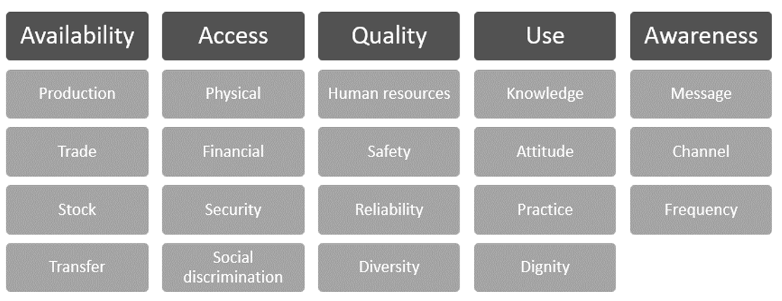
A list of standard definitions for each subcategory is proposed below. It is recommended to adapt the table and list for each context, using both sectoral and contextual knowledge.
Availability issues:
- Production: Lack of goods and services produced/built/delivered in the area (lack of water points, latrines, schools, health centres, etc.).
- Trade: Lack of goods and services brought into the area through market mechanisms due to disruption of supply chain.
- Stock: Lack or deficiency of goods or services held by traders or in government reserves (lack of medicines, ambulance, reconstruction materials, spare parts, fuel, etc.).
- Transfer: Lack of goods and services supplied by the government and/or aid agencies (lack of assistance, physicians, schoolteachers, health staff, subsidised bread, etc.).
Accessibility issues:
● Physical and logistical: Long distance, transport issues, fuel, lack of road maintenance, bridge destroyed, etc.).
● Security: Security constraints interrupting or preventing access or supply to/of goods and services (insecurity, checkpoints, attacks, etc.).
● Financial: Lack of income, resources or financial means (price inflation, loss of purchasing power, etc.) to purchase items or pay for services.
● Social discrimination: Difficulties in accessing or benefitting from services and goods due to discrimination or specific requirements (discrimination of minority groups, lack of documentation, etc.)
Quality issues:
● Human Resources: Number of people and possession of the required skills and knowledge to perform the service.
● Safety: Beneficiary of the good or service is free from danger, risk or doubt including physical safety, financial security and confidentiality, e.g. sterilisation of medical material, lightning around latrines at night, etc.
● Reliability: Ability to perform the anticipated service in a dependable and accurate manner, e.g. water quality, shelter standards, etc.
● Diversity: Ability to meet the variety of demands and needs expressed.
Use issues:
● Knowledge: Being not familiar with someone or something, which can include facts, information, descriptions, or skills acquired through experience or education. It can refer to the theoretical or practical understanding of a subject.
● Attitude/Belief: Refer to a person's general feelings about an issue, object, or person. Attitudes are interlinked with the person's knowledge, beliefs, emotions, and values, either positive or negative.
● Practices: The actual application or use of an idea, belief, or method as opposed to theories about such application or use.
● Dignity: Capacity of the service to be delivered in accordance and respect of local customs and culture
Awareness issues:
● Message: Ability to understand messages, e.g. language, literacy, etc.
● Channel: Possession of the appropriate channel to receive the information (radio, TV, etc.)
● Frequency: Frequency at which the message is repeated to ensure the largest audience is reached

Annex 6. Definitions (WORK IN PROGRESS)

Sector: The term sector refers to: a) policy area (e.g. economic, social, cultural, environmental sector); b) a distinct field or theme (e.g. agriculture, education, health, etc.);

Multi-sectoral: Approaches that consider impact in individual sectors. Linear model, each sector is equal to each other, linkages are not the objectives. E.g. MIRA, VAF (Jordan), Basic Needs Assessment.

Inter Sectoral / Cross-sectoral: Approaches that highlight the importance of system thinking and considering issues as a whole, across sectors, and the range of factors that collectively influences humanitarian conditions or how situations in one sector influence or impact upon one or more other sector. Focused on intersectoral interventions and coordination (SDGs 2030, health 2020). Objective is to build synergies across sectors so as to tackle complex issues using inter/cross sectors interventions and achieving inter-related humanitarian/development goals and targets, e.g. MPC.

HPC Reference module: https://www.humanitarianresponse.info/sites/www.humanitarianresponse.info/files/documents/files/hpc_reference_module_2015_final_.pdf
The JIAG is an interagency group with no barriers to entry that draws membership and expertise from specialist organizations, Clusters, UN Agencies and NGOs. It is governed by the JIAF Steering Committee which is comprised of leadership from the JIAG member entities. Leadership / facilitation of the JIAG is provided by OCHA.
The IPC has been since updated: IPC Manual Version 3
Essential to understanding what is to be done in the humanitarian response to include population sub-groups, by relevant age, gender and diversity characteristics.
In order to understand existing capacities, it is recommended to capture the main service providers, e.g. government or local authorities, organizations of persons with disabilities, communities, faith-based organizations, private entities, RCRC, national NGOs, international NGOs, etc.
To be noted that all indicators or information directly related to the existence, functioning, quality or coverage of a service should be placed under this subpillar, e.g. number/percentage of education facility destroyed, number/percentage of schools opened/closed, levels of health care and type of health services available, functional police stations and justice court, number/percentage of food markets functioning, availability of essential items on existing markets, etc. Measures of people’s access to those services should be considered under the Humanitarian Conditions/Living Standard subpillar.
Following global Clusters’ requests, some indicators normally belonging to the “impact on services” pillar were moved to the “Humanitarian Conditions” pillar as they are considered key to calculate the number of People in Need. In the Indicator Reference Table, those indicators are tagged with the letter E under column S. Eventually, what matters is to understand how potential damage or impairment of the functioning of essential services, and access to these, is affecting people’s survival and ability to meet their basic livelihood and protection needs.
It is important to agree at country level on the exact list of basic needs. A good starting point is the list of items included in the country Minimum Expenditure Basket. Based on context, additional important elements can be added, such as information / risk education, transport services, access to income generating land and resources, etc.
E.g. Problem trees, Fishbone diagram, key assumption checklist, reliability judgement
IASC Policy on Protection in Humanitarian Action, 2016
IASC Policy: Light Guidance on Collective Outcomes, 2020
A set of key indicators, with proposed thresholds put forward at global level is accessible Here. These can be adapted to local contexts as needed, using the severity scale definitions on page 13.
Country Clusters/Sectors, Inter Cluster Coordination Group (ICCG), Inter Sector Working Groups (ISWG), Cash Working Groups (CWG), Cluster Lead Agencies (CLAs), Cluster partners, NGOs, Academic institutions, Civil Society Organizations (CSOs), Organizations of Persons with Disabilities (OPDs), UN agencies, HC/HCT, National Government, Donors, Private Sector, Technical Agencies, etc.
The HPC Step-by-Step guides provide an overview of roles and responsibilities, how HNO and HRP link and the main steps to develop them: Insert Link (to be included shortly)
Alternatively, the team could be co-led dividing the task of facilitating the process and leading the analysis
Link HNO template (to be included shortly)
link missing, indicators should be merged with the IRT and tagged by pillars/sub pillars to avoid separate spreadsheets
Disaggregation by female and male and a disaggregation for children (ages 0-17 years inclusive) and adults (over 18 years) should always be included. For Nutrition, it is further recommended to disaggregate according to children aged 0-23 months and 24-59 months. For education, the following is recommended: 3-5, 6-12 and 13-17 and 15-24 years.
It is recommended to use the Washington Group Short Set of Questions on Disability for data collection on disability status.
Changes must be documented and communicated to the global cluster IMO for learning and further improvements purposes
In the longer term, the JIAF will seek to adopt a ‘universal’ severity scaling, where each indicator in the reference table is aligned with the JIAF scale, but this will take more time and study to be fully executed. The identification of Critical Indicators is a temporary solution as the JIAF develops towards this goal.
A common way to identify where a household is located is the recording of coordinates when the interview is conducted. However, in order to ensure that data protection standards are followed during handling of data, the exact coordinates may have been removed from the dataset made available for the JIAF analysis. This is ok, as long as the location of the household in terms of the overall area (e.g. District), exists in the dataset. This enables the creation of one household level dataset, including all available JIAF household level and area level indicators “linked” to each household.
During testing on 10,000 simulated datasets with different types of distributions (uniform distributions, normal distributions and poisson distributions), the Data Scenario B Aggregation /unlinked indicator approach yielded the same final result (overall area level severity class) as Data Scenario A aggregation /linked indicator approach in 83% of the 10,000 comparisons. This indicates that the approach to some extent is able to estimate co-occurrence / linkage between indicators, although the final results that can be obtained are less detailed (see Step 4 below). For further detail on the aggregation method testing please see here.
To avoid any duplication, when IPC/CH analysis is available, it should provide the basis for the food security component of the JIAF and one should thus refrain from using individual food security outcome level indicators, such as HHS, FCS, HDDS and rCSI.
CODs are an authoritative reference dataset of administrative boundaries and population statistics: https://data.humdata.org/dashboards/cod
UNHCR is the authoritative source for refugee population figures and confirms these with host Governments based on international refugee law.
See Annex 4: Organizing an Expert Judgement Elicitation in the JIAF
This set of aggregation methods were identified through testing on 10,000 simulated datasets, for further information about the testing please see here.
In the case of large geographical areas to cover, the workshop should be organized at the field level to maximise the presence of people knowledgeable of the area
The initial estimations are produced through the aggregation methodologies outlined in Annexes 1 and 2.
Compiling all indicator data into one location where the Analysis Team can view it will help facilitate the analysis process
Whereas for classes 2,3,4 & 5, the minimum # of people in the class or higher would be 25% of the total population, for class 1 it must be 100% of the total population since there are no classes below 1.
Note that for food security, IPC/CH projection should be utilized when available
Note that some indicators already include a projection dimension (see e.g. nutrition) that could be helpful when anticipating future conditions.
It is recommended to present both sets of priorities alongside with contextual characteristics and risk drivers identified during step 4.5.4.
After testing aggregation methods, it was concluded that arithmetic & geometric mean/median/weighted sums etc suffer from central tendency, meaning that overall severity scores are “pulled down” the more indicators that are included. In reality, a household may then have very severe needs outcomes on some indicators but will not be identified as severely in need, if it happens to have low severity scores on some indicators (the probability of this happening increases with the number of indicators that are available). This can be avoided by applying the mean/median etc using only the most severe indicators in each household. As long as an absolute scale has been used for all indicators (overall or within indicator group/sub-pillar), this should give an accurate estimation of the overall severity faced by the household. For further information about the aggregation testing, please see here.
“Critical” indicators were identified earlier in the JIAF process (see section XX above). These are indicators that signify a particularly worrying, “life-threatening”, situation and that should therefore override the aggregated score to avoid severe needs being “hidden” by the other indicators in the aggregation.
A key assumption here is that the household size is relatively homogeneous within each group in a given area, hence the % of households could be projected directly on to the total number of individuals. Not perfect but “good enough”.
25% was selected after testing thresholds of 10%,15%, 20%, 25% and 30% on 10,000 simulated datasets with different distributions (uniform distributions, normal distributions and poisson distributions). The 25% threshold was most likely to yield the same final result (overall area level severity class) as the ones obtained from the scenario A aggregation method (same in 83% of the 10,000 comparisons). This demonstrates that scenario B proposed aggregation method is able to estimate the co-occurence of needs to some extent. For further detail on the aggregation method testing please see here.
Based on the rule of >=25%
After testing aggregation methods, it was concluded that arithmetic & geometric mean/median/weighted sums etc suffer from central tendency, meaning that overall severity scores are “pulled down” the more indicators that are included. In reality, a household may then have very severe needs outcomes on some indicators but will not be identified as severely in need, if it happens to have low severity scores on some indicators (the probability of this happening increases with the number of indicators that are available). This can be avoided by applying the mean/median etc using only the most severe indicators in each household. As long as an absolute scale has been used for all indicators (overall or within indicator group/sub-pillar), this should give an accurate estimation of the overall severity faced by the household. For further information about the aggregation testing, please see here.
For further detail on the aggregation method testing please see here.
The overall class was 4, hence we know that the 25% does not include people in class 3 (threshold for inclusion in PIN), so the “true” PIN is likely higher than 2,500.
The overall class was 3, meaning the 25% could represent the “true” PIN, if exactly 25% were found in classes 3,4 and 5 overall. However, it is more likely that more than 25% were found in classes 3,4 & 5, hence the true PIN could also be higher than 12,500.
The overall class was 1, meaning less than 25% were found in classes 2,3,4& 5. Hence the “true” PIN is likely less than 7,500.
The overall class was 2, meaning less than 25% were found in classes 3,4 & 5. Hence the “true” PIN is likely less than 15,000.
Child abuse in England and Wales: March 2020
Age dependency ratio - Norway

