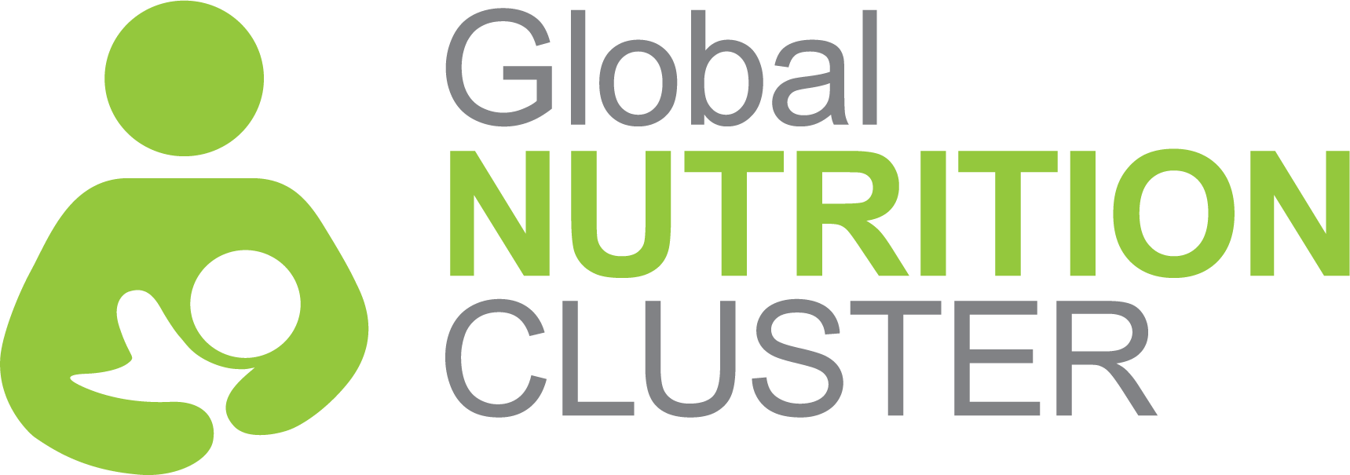
SUB-NATIONAL NUTRITION CLUSTER COORDINATION TRAINING
SUGGESTED COURSE LENGTH
- Two days starting at 8:30am on day one and finishing at 5:30pm on day two
- Adjustments can be made to timings to suit local customs
- Adjustments are also possible to timing overall such as shorter breaks etc. to manage local timing issues such as travel to the and from the venue or security considerations.
BACKGROUND

Coordinated humanitarian response rests on the notion that no one organization can meet large-scale humanitarian need so we must work collaboratively to achieve common goals for affected populations. The cluster approach helps ensure humanitarian action is effective, accountable, and transparent and founded on the principles of partnership.

In support of this, the Global Nutrition Cluster Strategy 2017-2020 commits the GNC to working sub-nationally, nationally, regionally and globally to strengthen the capacity of coordination platforms to deliver effective and people centered responses.
This training package is part of the GNCs suite of learning materials, focusing specifically on preparing participants for working at sub-national level nutrition coordination through strengthened understanding of coordination concepts, tools and processes and with greater confidence to lead through
strengthened inter-personal skills.
VENUE REQUIREMENTS MATERIAL & EQUIPMENT
- Seating for 25 people at round or rectangular tables.
- Table for facilitators
- Power boards and extension cables for computers
- Projector and cables (UVG or HDMI)
- Laptop and clicker (if possible)
- Microphone and batteries (if possible)
- Flipcharts for each group (stands if possible) and coloured marker pens.
- Post-it notes (large), coloured cards with pins/tape/tack if able to pin/tape/tack to walls.
- Access to a printer
- Name tags or stickers and cards for desk name tags

COURSE GOAL

To improve knowledge and skills of participants in coordination, their roles and responsibilities, approaches, tools and outputs through practical exploration of the Humanitarian Program Cycle and Core Functions of Clusters and, to develop knowledge and understanding of the interpersonal skills and skills needed for leading coordination platforms.
TRAINING OUTCOMES:

Expand knowledge of the Cluster Approach (origins, aims, and functions)

Explore the roles, responsibilities and accountabilities of Cluster/Sector coordinators, partners and stakeholders at national and sub-national levels

Expand knowledge of the attitude, skills and behaviors needed by Cluster/Sector Coordinators to support effective Cluster/Sector performance

Identify how to access and use Cluster specific tools, sources of information and lessons learned for each stage of the Humanitarian Programme Cycle

TARGET AUDIENCE

This course assumes a moderate level of existing experience and understanding of humanitarian concepts and nutrition (or other sector) programming.
Priority participant groups for this course at country level include:

Those currently serving as nutrition cluster/sector coordinators or information managers at sub-national levels, including representatives from Government bodies

Sub-national level nutrition sector program personnel working in a priority context who are likely to/wish to take on coordination functions within the coming year, or double-hatting as OIC for sub-national CCs
- Supervisors of the Sub-national Cluster Coordinators and IMOs, chiefs of field offices

Training Content DAY 1
FACILITATION TEAM
- The course requires a minimum of two facilitators to deliver sessions and support group work.
- Ideally the course would be run by a national coordination team members with the support of the GNC.
- There is a pool of vetted trainers available through the GNC who can co-facilitate the course.
- Whether run by the national coordination team or the GNC, or others, at least one person should have experience coordinating a nutrition cluster.
- One facilitator must also be experienced delivering leadership and or inter-personal skills training.
- Whenever possible, all facilitators should have experience delivering training/adult learning and/or be supported to complete a training of trainers.
- It can also be advantageous to have the humanitarian financing session and IM session delivered by local experts with support from facilitators to ensure content is relevant or at a minimum, to provide locally relevant content. If not available, at least one facilitator must feel confident delivering this material.

Day one of the SNCCT lays the foundation for the two-day course, building a common knowledge base among learners on sub-national and national humanitarian coordination functions, priorities, approaches and actors. Learners discuss nutrition coordination roles, responsibilities and structures with a focus on the core functions of clusters and accountability to affected populations at sub-national level. Participants are introduced to the good practices for working together in partnership for coordination and practice explaining the principles of partnership to cluster partners. In the afternoon participants explore the inter-personal competencies needed by coordination personnel to effectively lead a coordination platform. They are introduced to key concepts in leadership, consensus building and conflict management.

Training Content DAY 2
Day two shifts focus to the Humanitarian Program Cycle. Presentations provide up to date information on processes, tools and good practices and group work activities allow learners to apply this knowledge and explore how to use it real time, finding solutions to real life problems as they arise. The subjects covered on day 2 are: inter-cluster coordination, needs assessment and analysis, strategic planning, resource mobilization and monitoring and implementation.

TRAINING CONTENT DAY 3 (optional)
Day three is recommended to be added to the current training at country level, led by the country Nutrition Cluster Coordinator, and to be fully targeted to the local context. The content of the third day is flexible and should depend on the local needs. For example, it can include the following
- Development of the draft ToR for the sub-national clusters and defining roles and responsibilities of sub-national coordinators and partners, as well as linkages to national level
- Development of the work plan for the sub-national coordinators and discussion on how best to ensure linkages with national level
- In depth explanation of the needs analysis and planning process at national level and defining roles of the sub-national clusters in this
- Discussing main challenges faced by the sub-national coordinators and ways to address them,
- A session on in-depth caseload calculations and caseloads and calculation tool used in the country
- A session dedicated to improving inter-cluster coordination at sub-national level and support needed from national level
- Or other topics as identified relevant by the country coordination teams at national and sub-national level.

COURSE METHODOLOGY
The training uses a variety of interactive and participatory methods to support learners to explore new concepts, reflect on their confidence with them and explore their real life application. These include: group work; presentations, plenary discussions, role plays and cluster meeting simulation exercises based on a continuous case study. The delivery methods, focus and content can be adapted based on the experience level of the group and or particular needs in a delivery context with greater emphasis placed on any element as needed.

