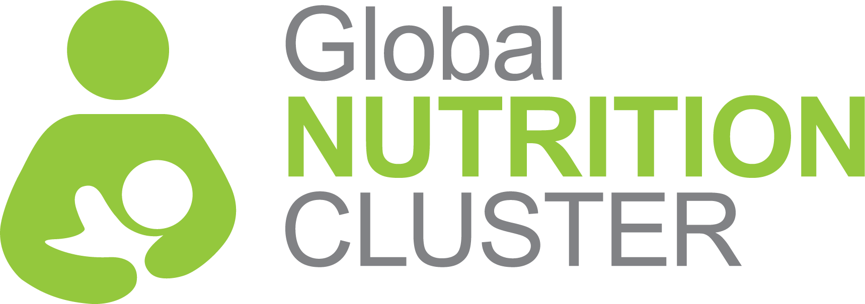
NUTRITION CLUSTER COORDINATION TRAINING
SUGGESTED COURSE LENGTH
- Five days starting at 8:30am on day one and finishing at 4:00pm on day five
- Adjustments can be made to timings to suit local customs
- Adjustments are also possible to timing overall such as shorter breaks etc. to manage local timing issues such as travel to the and from the venue or security considerations.
BACKGROUND

Coordinated humanitarian response rests on the notion that no one organization can meet large-scale humanitarian need so we must work collaboratively to achieve common goals for affected populations. The cluster approach helps ensure humanitarian action is effective, accountable, and transparent and founded on the principles of partnership.

In support of this, the Global Nutrition Cluster Strategy 2017-2020 commits the GNC to working nationally/regionally and globally to strengthen the capacity of national coordination platforms to deliver effective and people centered responses.
This training package is part of the GNCs suite of learning materials, focusing specifically on preparing participants for working in nutrition coordination through strengthened understanding of coordination concepts, tools and processes and with greater confidence to lead through strengthened inter-personal skills.
VENUE REQUIREMENTS MATERIAL & EQUIPMENT
- Seating for 25 people at round or rectangular tables.
- Table for facilitators
- Power boards and extension cables for computers
- Projector and cables (UVG or HDMI)
- Laptop and clicker (if possible)
- Microphone and batteries (if possible)
- Flipcharts for each group (stands if possible) and coloured marker pens.
- Post-it notes (large), coloured cards with pins/tape/tack if able to pin/tape/tack to walls.
- Access to a printer
- Name tags or stickers and cards for desk name tags

COURSE GOAL

To introduce participants to coordination roles, responsibilities, approaches, tools and outputs through practical exploration of the Humanitarian Program Cycle and Core Functions of Clusters and, to develop knowledge and understanding of the interpersonal skills needed skills for leading coordination platforms.
TRAINING OUTCOMES:

Expand knowledge of the Cluster Approach (origins, aims, and functions)

Explore the roles, responsibilities and accountabilities of Cluster/Sector coordinators, partners and stakeholders

Describe the attitude, skills and behaviors needed by Cluster/Sector partners to support effective Cluster/Sector performance

Identify how to access and use Cluster specific tools, sources of information and lessons learned for each stage of the Humanitarian Programme Cycle

Gain practical examples of Cluster/Sector performance management tools, processes and products
TARGET AUDIENCE

This is an introductory-level course which assumes a minimum level of experience and understanding of humanitarian concepts and nutrition (or other sector) programming.
Priority participant groups for this course include:

Those currently serving as nutrition cluster/sector coordinators or information managers at national, regional or sub-national levels, including representatives from Government bodies

National and or sub-national level nutrition sector program personnel working in a priority context who are likely to/wish to take on coordination functions within the coming year

When spaces are available, coordination and or program personnel preparing for coordination roles from other sectors in locations where the training is being run for the nutrition platform.

Standby Partner personnel with nutrition program and or nutrition coordination profiles

Training Content DAY 1
FACILITATION TEAM
- The course requires a minimum of two facilitators to deliver sessions and support group work.
- Ideally the course would be run by a national coordination team members with the support of the GNC.
- There is a pool of vetted trainers available through the GNC who can coordinate the course.
- Whether run by the national coordination team or global NC others, at least one person should have experience coordinating a nutrition cluster.
- One facilitator must also be experienced delivering leadership and or inter-personal skills training.
- Whenever possible, all facilitators should have experience delivering training/adult learning and/or be supported to complete a training of trainers.
- It can also be advantageous to have the humanitarian financing session and IM session delivered by local experts with support from facilitators to ensure content is relevant or at a minimum, to provide locally relevant content. If not available, at least one facilitator must feel confident delivering this material.

Day one of the NCCT lays the foundation for the five day course, building a common knowledge base among learners on global humanitarian coordination functions, priorities, approaches and actors. Learners discuss nutrition coordination roles, responsibilities and structures with a focus on the core functions of clusters and accountability to affected populations. Participants are introduced to the good practices for working together in partnership for coordination and practice explaining the principles of partnership to cluster partners.
Training Content DAY 2
On day two of the course participants explore the inter-personal competencies needed by coordination personnel to effectively lead a coordination platform. They are introduced to key concepts in leadership, consensus building and conflict management and practice identifying good practices in each. Participants are introduced to the course case study and begin group work that progresses through the rest of the course. On this day, the case study provides space for learners to explore meeting management, consensus building, conflict management and leadership in realistic settings and challenges them to apply new knowledge to an unfamiliar context.

Training Content DAY 3

Day three continues the case study exercises but shifts focus to the Humanitarian Program Cycle. Presentations provide up to date information on processes, tools and good practices and group work activities allow learners to apply this knowledge and explore how to use it real time, finding solutions to real life problems as they arise. The subjects covered on day 3 are: inter-cluster coordination, needs assessment planning and analysis, strategic planning and response planning.

Training Content DAY 4

Day four continues exploration of the program cycle and case study group work. Participants examine different components of resource mobilization including people, supplies and funding with a focus on local context funding structures. In group work participants apply information presented on caseload calculation and discuss nutrition-specific caseload considerations. Lastly, participants practice developing and delivering key nutrition coordination advocacy messages to a range of audiences.

Training Content DAY 5

Day five of the course completes the final elements of the program cycle and then shifts focus to the context of delivery and performance management of a coordination platform. The content of the day can be delivered through presentation and discussion or as group work exploring CCPM results where appropriate and can thus serve as a practical means of transferring what has been learnt in the course into the ongoing work of the platform in the country of delivery.

COURSE METHODOLOGY

The training uses a variety of interactive and participatory methods to support learners to explore new concepts, reflect on their confidence with them and explore their real life application. These include: group work; presentations, plenary discussions, role plays and cluster meeting simulation exercises based on a continuous case study. The delivery methods, focus and content can be adapted based on the experience level of the group and or particular needs in a delivery context with greater emphasis placed on any element as needed.

EVALUATION MATERIALS INCLUDED IN PACKAGE
- Level one evaluation: (participant reaction) done each day at the completion of sessions using varied methodology to garner feedback
- Level two questions based on session learning outcomes: (knowledge transfer): options include informal level 2 evaluation is conducted for 20min at the start of every day using learning outcomes from the previous day’s sessions to gauge comprehension, lateral thinking and identify gaps or errors.

