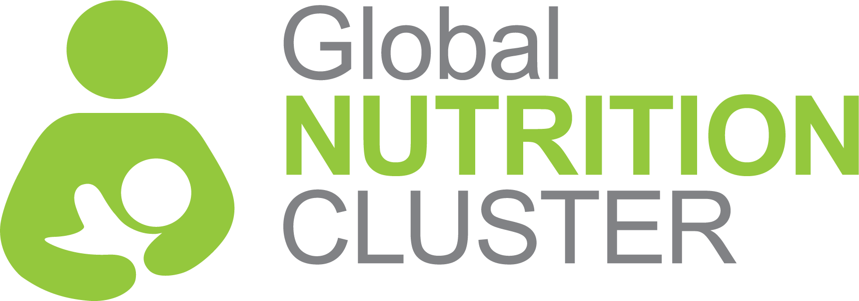
INTEGRATED INTER-CLUSTER TRAINING PACKAGE

FOR NUTRITION OUTCOMES

BACKGROUND

TRAINING DETAILS
- Date:
- Time:
- Venue:
The Inter-Cluster Nutrition Working Group (ICNWG) of the Global Food Security Cluster (gFSC) and the Global Nutrition Cluster (GNC) works towards improving coordination and collaboration between nutrition and food security clusters at country level. The ICNWG is also working with clusters, including WASH, Health, Education, Protection (including Gender-Based Violence (GBV) and child protection) at global and national levels to enhance emergency response effectiveness to address malnutrition.

The ICNWG has identified the limited capacities of humanitarian partners and clusters for multi-sectoral nutrition sensitive programming among the main barriers to effectively achieve nutrition outcomes in humanitarian settings.

To address this, the ICNWG developed a training package to support in-country cluster coordinators and partners in applying nutrition-sensitive approaches across sectors, with specific focus on: nutrition, food security, health, WASH, education, and protection.

This training package focuses specifically on preparing participants for working in an integrated manner to improve nutrition outcomes through strengthened understanding of integration concepts, tools, processes, and specific integrated activity examples. A strong emphasis is on the how of integration for nutrition outcomes.

TRAINING GOAL

The goal of the training is to strengthen the ability of country cluster/sector coordinators in programming the multi-sectoral integrated interventions for improved nutrition outcomes.

LEARNING OBJECTIVES

By the end of the training participants will be able to:
- Explain the consequences and drivers of malnutrition
- Explain how critical Food Security, WASH, Health and Protection are to achieving positive nutrition outcomes in emergencies.
- Describe what activities from their sectors can be integrated into nutrition programming
- List examples of what nutrition activities can be integrated into their sector programming and how this is done
- Understand how to plan and implement sectoral integrated programming in humanitarian responses
- Create an action plan on the next steps of integration

LEARNING OUTCOME

Cluster coordinators and cluster partners have the necessary knowledge and tools to plan and implement an integrated multi-sectoral response to improve nutrition outcomes based on the country context.

TARGET AUDIENCE
- Cluster coordinators of, at a minimum nutrition, health, WASH, education, protection (including GBV and child protection), and food security clusters.
- Government/local authorities, partners of at a minimum the nutrition, health, WASH, education, protection (including GBV and child protection), food security clusters ad OCHA focal points.

MINIMUM KNOWLEDGE AND EXPERTISE OF PARTICIPANTS IN THE INTEGRATED INTER-CLUSTER TRAINING PACKAGE FOR NUTRITION OUTCOMES
- The target audience the Integrated Inter-Cluster Training Package for Nutrition Outcomes are the government/local authorities focal points, cluster coordinators and cluster partners of nutrition, health, WASH, education, protection (including GBV and child protection), and food security clusters, as well as OCHA. Additional clusters/sectors can be added as long as the technical support from those clusters/sectors is provided for the development of PowerPoint presentations and case studies showcasing specific integration activities and outcomes.
- The main learning outcome from the training is that the cluster coordinators and cluster partners would have the necessary knowledge and tools to plan and implement an integrated multi-sectoral response to improve nutrition outcomes based on the country context. Therefore, participants in the training will need to have the technical skills and knowhow to contribute to the planning and implementation of an integrated approach, be able to influence and advocate for their agency to engage with donors and others to be able to implement and monitor such programs, and be committed (and their agency be committed) to having them dedicate the needed time and effort for this training.
- Participants need to be knowledgeable in their sector and have field experience in humanitarian emergencies and in the country if at all possible.

Training MODULES Content
The Integrated Inter-Cluster Training Package for Nutrition Outcomes consists of 3 days of sessions.
- Day 1 focuses on foundational knowledge around nutrition and integrated programming. It consists of three sessions.
- Day 2 focuses on integrated programming for nutrition outcomes from the perspective of the different sectors: WASH; Health; Food Security.
- Day 3 has the main focus of creating an action plan for integration in the country. The participants will work in group to map the integration efforts to date and identify actions needed.

