Hand-out: Finding and telling stories in the data
Steps |  | Instructions
Find the story hidden in the data |  | - Use inductive or deductive reasoning and undertake visual analysis to start interpretation/identification of potential data stories.  - Use comparisons: categorical and proportions, ranking, values, range and distribution, context, hierarchies, etc.  - Find trends: up and down vs. flat, linear vs. exponential, steady vs. fluctuating, seasonal vs. random, change rate vs. steepness, etc.  - Find patterns, or lack of: Exceptions, outliers, intersections, correlation, connection, clusters, associations, gaps, etc.  - Pick an indicator and ask: What is the level and the rate of change for the considered area? How do different subgroups/regions etc differ? What is driving the change? How much changes affect other aspects of life? How does this compare with other countries?  - Define the storyline that readers would value from the visualization and what stories you wish to tell with what you are showing.  - Finding stories is using visualization techniques to familiarise, learn about and discover insights from data.
Tell the story |  | - Scientists start with details and build to a conclusion. Journalists start with the conclusion, and then give supporting details. Be like a journalist!  - Identify and present only key results, not details.  - Focus on what the numbers really mean for your audience.  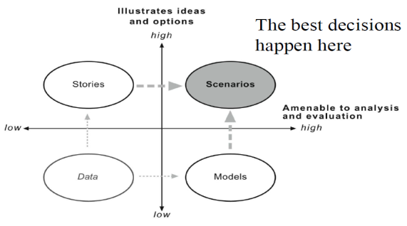  - Users need explanations, interpretation and comments. Reveal the unexpected, the relevant, the truth behind the data. Guide users along the journey to find their answers.  - Don’t confuse what’s countable with what really counts: Many of the most important things in life can’t be quantified, so don’t focus just on the numbers– they aren’t everything.  - Know the characteristics of message that stuck: Simple, unexpected, credible, concrete, emotional and story-based.  - Telling stories is identifying and caring for the reader, taking responsibility to maximise their potential insight. Effective statistical narratives are simple, seamless, informative, true, contextual, familiar, concrete, personal, emotional, actionable and sequential

Few 2009, Statistical Narrative. Telling Compelling Stories with Numbers
Jonathan G. Koomey. 2006. Best practices for understanding quantitative data
Jonathan G. Koomey. 2004. Practical problem solving: A beginner’s guide

