# Describing Patterns and trends

## Patterns

**Patterns are a repeating design or sequence and demonstrate recurring themes or categories, appearing in a predictable manner.** They are regularities, variations or exceptions which stand out above the typical noise evident in nature or in raw data.

Our perception of patterns in visual display (but also in qualitative data) is fundamental to the sense-making process. They lead to insights that might never occur if the data were examined in any other way. For example, certain health conditions may cluster in particular geographical areas or people from a particular group may apply similar coping mechanisms. These patterns may not be specifically what was looked for or anticipated, but they may be important in themselves and deserve increased attention, or they may shed light on new areas of interest or specific elements of the data.

Meaningful patterns in quantitative data fall into three general categories:

* Large-scale patterns (a.k.a. trends). These are patterns that reveal what is going on in general, that is, as a whole (i.e. cereal prices have trended downwards over the course of the year).
* Small-scale patterns. These are patterns that reveal what is going on in specific subsets of data. For example, high incidence of water borne diseases correlates exclusively among the people of a particular district.
* Exceptions or outliers. These are values that appear outside of what is normal, standard, expected, regular or acceptable. For example, out of all visited areas, only one particular village showed a complete lack of food product in the local market.

Most common patterns in data are presented in the following paragraphs.

**Repetitions:** Often, in data, series of numbers or values repeat themselves. In a repetition, one value might consistently follow another or, when a value occurs, it might repeat three or four times before shifting to another value.

Repetitions can indicate either that a process is stuck or that there is a relationship between one event and another. For example, a longer task completion time (i.e. firewood or water collection) might be followed consistently by task abandonment periods.

Repetitions are slightly, but significantly, different from cycles in that the entire sequence does not recur.

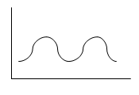**Cycles:** Cycles are easily recognisable because each segment of the data looks similar. In a cycle, there is a regularly recurring pulse reminiscent of a heartbeat or the ebb and flow of the tides. Cycles indicate an underlying rhythm to an event you are observing and measuring. Examples might include the rise and fall of cereal prices in an area with various harvests or the peak of admissions in nutritional centres during the hunger gap period.

Recognising the presence of a cycle and understanding the driving forces behind it can help you plan ahead and gain deeper insights into your information. Cycles can also highlight the presence of negative forces acting against growth. For example, the incidence of malaria or cholera cases can be correlated to temperature and climate, while prices rises can be associated to the rainy season leading to increased time of transport in remote areas.

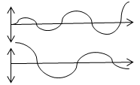**Feedback Systems:** Feedback systems are like cycles that get bigger and bigger, or smaller and smaller, because some influence gives the system a small kick each time around. Variations become more and more accentuated as one event exacerbates the next.

Feedback patterns can also indicate that a process is out of control. Small improvements in road infrastructures can lead to greatly increased traffic, resulting in the system becoming overwhelmed once more.

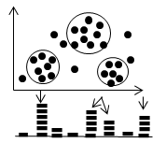**Clusters:** Knowing how many concentrations are present is just as important as knowing where they fall. When clustering occurs in data, it may appear as a concentration of objects in just one small area, or data might group in several areas, as shown in the drawing, depending on what you are testing or researching. A cluster might represent something as simple as the distinguishing characteristics of different livelihood groups or geographical areas (urban vs. rural).

Depending on the complexity of your research, approaches to identifying clusters will vary. In simple cases, when dealing with just one or two characteristics, you can use a two-dimensional visualisation to highlight each concentration. For more complex cases, identifying clusters may require statistical analysis. In this last case, it is important to use a technique that is flexible, in terms of the number of clusters it generates.

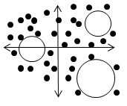**Gaps:** Gaps in the data represent the absence of any observable data, which can be just as informative as actual observations. Gaps in data are the opposite of clusters.

For example, looking through the demographic data gathered about the affected area may highlight an untapped population segment or reflect that targeted beneficiaries are not showing up at the distribution point or perhaps highlight that the health centre shows a significant drop in visit frequency during dry season. Whatever the scenario, gaps like those shown in the drawing tell us about issues and/or opportunities.

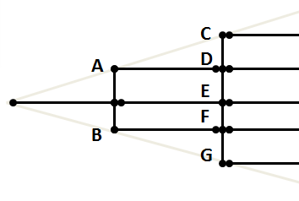**Pathways:** The aim in analysing pathways is to present the data’s branches and progression from node A to node C or D and so on. You can use sequential data (e.g. use of specific coping mechanisms) to identify major pathways. Higher-use paths receive a higher value, and you can use a thicker line or a different colour to identify the track most users are following. Analysing pathways isn’t really a case of seeing a pattern as much as it is about recording, manipulating, and visualising your data so that it clearly illustrates a pattern.

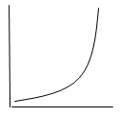**Exponential Growth:** A constantly increasing rate of growth characterises exponential growth, as illustrated in the drawing. Exponential growth rates are typical of early adoption stages in a technology lifecycle, the presence of network effects, or the viral spread of a vaccination campaign.

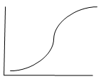**Diminishing Returns:** Following an initial period of rapid growth, diminishing returns occur when the growth curve flattens out—still rising, but at a much slower rate, as shown in the drawing enclosed. It is clear that the curve is reaching some limit, possibly because of increasing competition or market saturation. This pattern is typically associated with mature products or strategy (e.g. vaccinations or a hygiene promotion campaign). The presence of a diminishing-return pattern can serve as a trigger for a more creative approach to product or activity enhancement, i.e. you might pare away sub-activities to refocus your strategy rather than adding more and more features or you might completely re-evaluate the way a product (malaria treatment, therapeutic feeding product) addresses a problem.

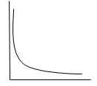**The Long-tail:** In a long-tail pattern like that illustrated in the drawing, the data rises steeply, then falls off sharply, and levels off over a large range of low values. The long-tail is an example of a power law distribution that is common in nature and works typically for sales or a new product. The presence of a long-tail pattern might simply indicate that things are working normally, but it can also highlight deviations from the expected patterns in your data.

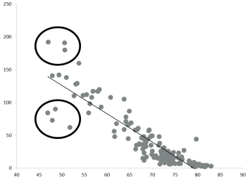**Exceptions:** Also called outliers or anomalies, exceptions refer to abnormal values in a set of data. They can be described as data elements that deviate from other observations by so much that they arouse suspicion of being produced by a mechanism different than that which generated the other observations. Every abnormal value can and ought to be explained. Three possible reasons can create outliers: Errors (caused by inaccurate data entry, measurement or bias), extraordinary events (storm, earthquake, etc.) or extraordinary entities (richest person in the village, etc.). Exceptions can be displayed in several ways (adapted from Stephen few):

Showing ranges of normal using reference lines or areas:

 

Showing (not) acceptable ranges using reference lines and fill colour:

 

We are so adept at recognising patterns that we sometimes detect ones that aren’t there. When one pattern is found, especially one that we were prepared to find, we stop looking and can miss others that are unfamiliar and unexpected.

It is important at times to disregard familiar patterns and view data with fresh eyes. New patterns can emerge if we let ourselves look without pre-conceptions and drill down to specifics as well as scanning the big picture. Examine details and see what might be there that you cannot anticipate. Let yourself get to know the trees before mapping the forest.

## Trends

**A trend is a general direction in which something is developing or changing.** They refer to the changes or movements in facts and figures over a period of time. They are usually used to describe the difference between two or more points on a graph, to compare two or more columns on a bar chart and to show the difference between information in a chart.

Basic trends can be categorised as:

* Upward (🡽) or downward (🡾) movements
* Stability (🡺 no change or movement)
* Change in direction ( or **,** ∩or **U**).

When data show a clear trend, all data progress in the same direction. In an upward trend, each subsequent piece of data is higher than the last. In a downward trend, each subsequent piece of data is lower than the last. Trends can appear in a variety of types of data such as site visits, price lists, transactions, time series, etc.

In a trend, the progression of data up or down is rarely completely smooth. Data will regularly dip down or shoot up against the general trend. When plotted as a graph, the lines representing the data will look jagged and rough.

Recognising trends is often a matter of looking at the data at the appropriate level of scale. If looked at too closely, data is simply a series of peaks and troughs lacking any real sense of direction. However, when one zooms out and views a greater range of data, the overall shape of the data becomes clearer.

Identifying trends, particularly when viewing data collected over a long period of time, can be difficult when the length of time each data point represents is short. Because data constantly shifts up and down, an upward trend can appear to be heading downward or vice versa. This is noticeable when looking at, for example, nutritional admissions in therapeutic feeding centres. Looking at only one or two days’ data makes it difficult to identify a trend. However, looking at admissions over months or years makes trends clearer.

The degree and the speed of change also need to be considered.

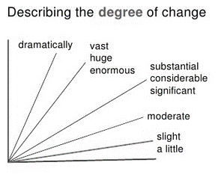 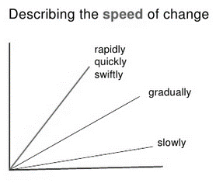

## Detecting patterns and trends

What makes some details in the material analysts are studying more worthy of attention than others? How do we know which parts to attend to? Here are three principles for identifying which details in the material are more worthy of attention than others:

* *What repeats? What goes with what?* Look for patterns of repetition or resemblance. In virtually all subjects, repetition is a sign of emphasis. Once apparent similarities have been located, analysts can refine their thinking by pursuing significant distinctions among the similar things (looking at differences within the similarity or similarities despite the difference).
* *What is opposed to what?* Look for binary oppositions. Sometimes patterns of repetition are significant because they are part of a contrast around which the subject matter is structured. One advantage of detecting repetition is that it will lead analysts to discover opposites which are central to locating issues and concerns.
* *What doesn’t fit?* Look for anomalies, outliers, and things that don’t fit. An anomaly is literally something that cannot be named, *a deviation from the normal order*. Anomalies help us revise stereotypical assumptions, and noticing them often leads to new and better ideas. Observations can fall outside the norms for three reasons: errors, extraordinary events or extraordinary people.

When looking for patterns, ask yourself:

* Which details seem to repeat? Why? What does the detail mean? What else might it mean? How do the details fit together? What do they have in common? What does this pattern of details mean? What else might this same pattern of details mean? How else could it be explained?
* What details don’t seem to fit? How might they be connected with other details to form a different pattern?
* What does this new pattern mean? How might it cause to read the meaning of individual details differently?

|  |  |
| --- | --- |
| Patterns and trends can reveal: | |
| The relative magnitude of separate sets of values | Which set of values is the higher or lower? |
| The general nature of change | Are the values going up, going down, or remaining relatively flat? |
| The rate of change or the comparative rate of change | Are numbers increasing at a progressively greater rate over time? Which of these two sets of values is decreasing at a greater rate? |
| Seasonal or cyclical events | Are there particular times of the year when the disease peaks? |
| A possible temporal co- variation between two sets of values | Are the costs of radio campaign a reliable leading indicator of hygiene practice increase? |
| When one set of values surpasses or falls below another | At what point during the year did the sale of livestock’s surpass the sale of cereals? |
| The stability or volatility of a set of values | Has the nutritional status remained stable over the year, or has it fluctuated significantly? |

The following sections (adapted from Stephen Few) outline the specific patterns or trends that can be detected when using graphs.

## Patterns in lines

By connecting points with a line, we can transform a display of individual values into a story of transition from one value to the next. Using a line to connect the points allows us to perceive an actual connection that exists between the values, making it easy for our eyes to trace the transition from one value to the next. This is especially useful when the values measure change through time, which can be seen in the up or down, dramatic or subtle slopes that encode temporal transitions.

|  |  |
| --- | --- |
| Pattern | Example |
| Unidirectional lines | A line that encodes monthly numbers of admissions in a therapeutic nutritional centre is heading down during the course of the year.  A line that encodes a country total number of security incidents has remained flat for the last five months, despite ups and downs in particular districts. |
| Curved lines | Curative effect of a new drug increased rapidly soon after its introduction but began to increase at a much slower rate after a few months and eventually began to decrease after a few years. |
| Repeating line patterns | The numbers of malaria cases are at their lowest in the first trimester of each year, rise somewhat in the second trimester, and hit their peak in the final trimester, then drop again at the beginning of the next trimester to begin the cycle again. |
| Co-variation among multiple lines | Budget expenses and number of reached beneficiaries went up and down together throughout the year.  Nutritional status always increased in relation to the number of days spent in therapeutic feeding centre, but didn’t register until ten days after the first admission day. |
| Intersecting lines | In June of the year, the decline in livestock sales and the increase in cereal sales intersected and changed positions in a ranking of sales by product. |
| Smooth vs. jagged lines | Expenses in the HR budget line tended to change slowly and smoothly compared to the IT budget lines, which exhibited large and rapid increases in expenses from time to time. |
| Exceptions | Number of malaria cases in the month of August decreased far below the norm. |

## Patterns in points

Small points in the simple shape of circles (dots), squares, triangles, etc., are ideal for pinpointing the precise location of individual values in a graph. Here is a partial list of meaningful patterns that can be found when points are used to encode values:

|  |  |
| --- | --- |
| Type | Pattern |
| Linear trends | Points are arranged in a way that forms a pattern that looks like a straight line |
| Non-linear trends | Points are arranged in a way that forms a pattern that looks like a curved line |
| Concentrations | Dense sets of points appear in particular areas of the graph |
| Clusters | Sets of points appear to be set apart from other points |
| Gaps | Area in the graph where no points appear in the midst of surrounding points |
| Randomness | Points are arranged randomly in the graph, without a discernible pattern |
| Exceptions | Points that stand out as different from the norm |

## Patterns for distribution

When we examine distributions, we focus primarily on three characteristics of the data:

* The full range across which the full set of values extends (spread),
* The central tendency of the values, which serves as a single-value summary of the full set (for example, the median), and
* The shape of the distribution, which informs us where items fall at various locations across the distribution.

|  |  |
| --- | --- |
| Pattern | Example |
| Symmetrical | Most refugees are between 40 and 49 years of age, followed by those in the 30 to 39 and 50 to 59 age groups, with only a small number in both the 20 to 29 and the 60 to 69 age groups. |
| Skewed | The median salary for employees is only $32,000, even though salaries begin at $20,000 and extend to $100,000. |
| Uniform | The number of visitors to the health centre is evenly distributed across all age groups. |
| Multi-modal (multiple peaks) | Percentage destruction after the hurricane was especially high among inhabitants in two distinct salary ranges: $20,000 - $30,000 and $70,000 - $80,000. |
| Gaps | The distribution of interviews per age group exhibited a strange gap in the 50-69 age group range. |
| Exceptions | All but one price fell within the range of $2,000 to $4,000 per metric ton, which was $7,000 in the northern region. |

## Patterns in bars

Bars are less versatile in their ability to form meaningful patterns, but they support one analytical task exceptionally well: comparisons of magnitudes. Because bars are so salient, they draw our eyes to individual values and make it as easy to compare the magnitudes as it is to compare the heights or lengths of two bars to one another. Consequently, in a bar graph, it is easy to rapidly find the lowest and the highest values in the bunch.

This is especially useful when you want to see how a collection of values are ranked from highest to lowest or vice versa. Nothing reveals a ranking relationship better than a series of sorted bars.

## Guideline to describe a chart

Describing a chart calls for an adequate use of words and phrases when depicting what happens. Before you start, underline key words, circle and highlight the graph, use arrows, make notes, circle the biggest, the smallest, stable or unchanging parts, sudden increases, etc. in order to identify and understand patterns or trends (the overall idea of the graph).

* What is happening/happened
* The main change over time
* The most noticeable thing about the graph
* The pattern over time
* The pattern for different places or groups or people.

Some graphs will have several patterns or trends, or there might be two graphs with a trend in each. You could tell about the two trends/patterns in two separate paragraphs. The total size of your description should be 100-150 words.

**Draft introduction:** In the first sentence, describe what the chart shows and be careful to give the full information, i.e. *The graph shows the price inflation from 1994 up to 2005 in 5 northern districts of Niger.* Don’t forget to paraphrase the title of the diagram in the introductory sentence.

In the second sentence, describe the general trend, *i.e. overall, the price index fluctuated a lot during this time.*

**Paragraph(s):** This is where you should provide more details on the patterns or trends, including:

* When did it **peak/reach a low?** Where or when is the maximum or minimum value?
* **Time**: In what period...? For how long ....? e.g. in the period between March and June 2005, in the first quarter of 2005, in the second half of 2005, for three consecutive months...
* How **intensive/quick** was the change? How big is the difference between values?

Start with a sentence with no number, i.e. *Population displacement increased sharply over the considered period; The most obvious trend in the graph is that displaced families are composed of significantly less adult males; Maize production has increased slightly in all the districts; The number of displaced in province X is twice bigger than the number of displaced in Province Y.*

Follow this sentence with an example (sentence with number) and perhaps another example (another sentence with number) describing the main features of the graph, including dates and figures. Describe significant or important differences and make comparisons where relevant. Don’t attempt to describe every detail. Contextualise the provided information (i.e. drop of prices due to drought) with underlying factors; however clearly distinguish facts from assumptions.

**Finish by** one or two sentences providing an overall summary of the main trends or features. Use different vocabulary. Do not use any numbers in the conclusion (you could use words like "most", "the majority" "a minority", "a small number"). Do not provide opinion either.

**Some Don’ts**

* Don’t describe the X and Y axis. Give the information.
* Don’t write about everything on the graph. Pick the biggest, the smallest, the main points, the main trends. Group similar things together.
* Don’t write about the line or the bar: “The line went up,” “The bar went down.” Instead, write about the idea. “The number of people using water from unprotected sources increased gradually.”
* Don’t use shorthand: “Men went up.” “Women went down.” Instead, write about the real data: “The number of men working in farms fell dramatically”, “The percentage of female students getting a degree rose suddenly.”
* Don’t use “I feel”, “as I have written,” “as you can see,” etc. Keep it academic.

There are a number of specific words and phrases used to describe and discuss graphs and charts. Much of the language relates to small or large movements or differences between various data points.

Both transitive[1] and intransitive[2] verbs can be used to describe trends (see also useful terms in annex 1):

**Upward movement:**

* Transitive: increase, raise, put/push/step up, extend, expand, improve, etc.
* Intransitive: increase, rise, go/be up, grow, expand, boom, rocket, soar, gain, improve advance, etc.

**Downward movement:**

* Transitive: decrease, drop, put/push down, cut, reduce, etc.
* Intransitive: decrease, fall, drop, go/be down, decline, collapse, slump, plummet, plunge, tumble, dip, slip, etc.

We can also describe a lack of movement using expressions such as ‘remain stable’ or ‘stay constant’. Other common expressions used to describe trends are as follows:

**To fluctuate:** We use this expression to describe when there has been a serious of changes both up and down, *i.e. prices have fluctuated wildly since the beginning of the year.*

**To stand at:** We use this expression to focus on a particular point, often before we talk about the trends of movement, *i.e. at the beginning of the year, malaria cases in India stood at 6,500.*

**To reach a peak:** We use this expression to talk about the highest point of a trend, *i.e. late last year, malaria cases reached a peak of 12,000 in province Beta.*

**To bottom out:** We use this expression to talk about the lowest point of a trend, *i.e. the bread price bottomed out at 1.50.*

**To level off:** We use this expression to talk about the point when a changing trend becomes stable, *i.e. after a long period of decline, the inflation rate finally levelled off at 2.3 per year.*

As shown, trends can be described by verbs, nouns, adjectives and adverbs. It is worth mentioning that the majority of the given verbs have a noun form:

* *Unemployment levels* ***fell****; or*
* *There was* ***a fall*** *in unemployment levels;*

It’s also important to remember that adjectives are used to modify nouns whereas adverbs are used to modify verbs, adjectives, other adverbs and clauses; besides that, the preposition "by" is used with the verbs, and "of" with the nouns:

* *It increased* ***by*** *20%;*
* *There was an increase* ***of*** *5%;*

**Example of chart description:**



*The line graph shows the upward trend of the sorghum price evolution (Kg/CFA) from 1995-2012 in the main markets of Niger.*

*The sorghum price went through significant fluctuation during the last 15 years, with dramatic increases caused by major droughts, food security crises and famine.*

*There was an abrupt pick in 2005/2006, when prices skyrocketed due to the famine that affected the country, reaching historical prices levels of 300 CFA/Kg. One notable exception is the recorded prices in the Diffa region which hit a low at the same period at 40 CFA/Kg.*

*After a drop back to 5 year average price levels in 2007/2008, prices started to steadily increase due to inflation (period 2008-2010) before dropping back again below the national average early 2011.*

*It is noticeable that when severe food insecurity periods are recorded (2001, 2002, 2005, 2010), there is little or no variation between prices recorded in all country markets, suggesting that the crisis affects all markets countrywide.*

*End 2012, prices started to take off again, probably due to the announced bad harvest by agronomists, pushing suppliers to stock cereals and wait for prices to increase to sell their production at a better rate. Sorghum prices at the end of 2011 are quite identical to those observed during the 2002/2003 food security crisis. However, the range of average prices end 2011 is quite spread (from 160 CFA/kg in Zinder up to 220 CFA/Kg in Niamey), suggesting a different pattern when compared to historical food security periods.*

*While it is clear that sorghum prices follow an upward trend at the end of 2011, it is difficult to compare the current crisis to historical data and to conclude to a national food insecurity crisis.*

## References

Now You See It, Stephen Few, 2008

Visual pattern recognition, Stephen few, 2006, <http://www.perceptualedge.com/articles/Whitepapers/Visual_Pattern_Rec.pdf>

<http://www.slideshare.net/meerisild/describing-graphs>

<http://esl.about.com/od/businessmeetings/a/Language-Of-Graphs-And-Charts.htm>

[www.admc.hct.ac.ae/hd1/english/graphs/DescribingGraphsscrambled.ppt](http://www.admc.hct.ac.ae/hd1/english/graphs/DescribingGraphsscrambled.ppt)

Baty, S. (2009). Patterns in UX Research.

<http://uxmatters.com/mt/archives/2009/02/patterns-in-ux-research.php>

## Annex 1 Patterns in visual display

This section, adapted from Stephen Few, provides a non-exhaustive list of most common patterns.

High, low and in between



Going up, going down, and remaining flat



Steep and gradual



Steady and fluctuating



Random and repeating



Leading and lagging



Straight and curved



Non intersecting and intersecting



Wide and narrow



Symmetrical and skewed



Clusters and gaps

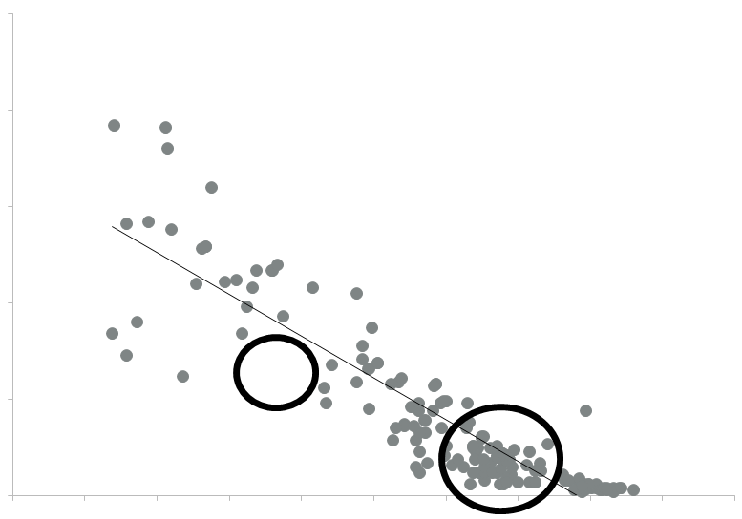

Tightly and loosely distributed

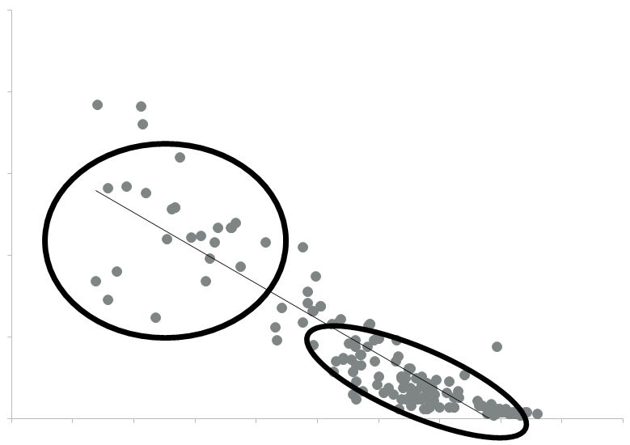

Normal and exceptions



## Annex 2 Sample description



Production grew dramatically in the first month, but then reached a plateau of about 70MT. Since then it has remained more or less stable.



The production started from 20MT and climbed sharply in January, but flattened off during February at a level of around 70MT. Since then, it has plummeted back to 20MT again towards the end of April.



Production grew more and more rapidly over the first three months and then reached a peak of 70 MT. Since then, it has quickly dropped to 22MT at the end of April.



Production started the year in a stable position of 70MT, but then plunged in March at 20MT. Since then it has flattened out at that level.



Starting the year at 70MT, production fell considerably over the first three month, reaching a low of 20MT. Since then it has staged a partial recovery by ending at 40MT in April.



Production held steady at the level of 70MT in the first three months, but fell sharply in April to reach a low of 35MT.



Production has been fluctuated from 30MT to 68MT all the considered period around.



Production showed a marginal rise of 10MT (from 50 to 60MT) in the first three months, but then suffered a sharp drop to 32MT in April.



After a considerable drop in the first month, production bottomed out at 30MT. Since then it has started to bounce back, reaching 70MT in April.



There was a rapid drop in production (from 70 to 30MT) in the first month, but it bottomed out at about 20MT in the remainder of the considered period.



Production peaked at 70MT in the first month, and then slid slowly but steadily over the considered period to 40MT.



Production has experienced a strong, steady growth over the whole considered period, climbing from 40MT in January to the peak of 70MT in April.

## Annex 3 Useful terms for describing graphs and charts

|  |  |  |
| --- | --- | --- |
| **Upward change (positive)** | **Downward change (negative)** | **Stability** |

|  |  |  |  |  |  |  |  |  |
| --- | --- | --- | --- | --- | --- | --- | --- | --- |
| * To raise; a rise * To increase; an increase * To go/be up, an upswing * To grow; a growth * To ascend; * To climb; * To boom; * To show / see an upward trend; * To jump * To skyrocket * To rocket; * To recover; * To improve; * To surge; * To shoot up; * To soar; * To take off; * To rally; * To put up; * To strengthen; * To bounce back; * To double; * To pick up; * To creep up; * To push/put/step up * To extend/expand * To reach a peak * To reach an all-time high   **Speed of change**     * Rapidly, quickly, very fast * Quickly, sharply * Suddenly, abruptly * Gradually * Steadily * Slowly | | * To fall; a fall * To decrease; * To decline; a decline * To dip; * To drop back; a drop * To slump; * To deteriorate; * To go down; a downswing * To reduce; * To lower; * To slip back; * To cut; a cut, a reduction * To shrink; * To halve; * To show / see a downward trend; * To weaken; * To slide; * To hit a low; * To plunge; a plunge * To plummet; * To collapse; a collapse * To crash; * To slump; a slump * To go bust * To bottom out; * To have a trough; * To worsen   **Degree of change**     * Dramatically, extremely, disastrous, very big * Considerably, massively * Significantly, perilous, heavily * Moderately * Slightly, insignificantly, evenly | | | * To level out / off (at); * Do not change; * To remained stable (at); * To remained steady (at); * To maintain at the same level; * To stay the same; * To stabilise; stability * To keep … stable * To hold … constant * To be / remain flat;   **Fluctuation**     * To fluctuate (around); * To vary; * To peaked (at); * To plateau (at); * To stand (at); * To be volatile;   **Change of direction**     * To level off; a levelling off * To flatten out * To stand at * To stop/start falling/rising * To remain steady | |  | |
| **Adjectives** | **Adverbs** | | | **Generalisations** | | **Approximations** | |
| * considerable; * dramatic; * drastic; * enormous; * gradual; * huge; * marked; * minimal; * moderate; * quick; * rapid; * sharp; * significant; * slight; * slow; * small; * steady; * steep substantial * sudden * swift; * temporary; * wild; | * considerably; * dramatically; * drastically; * enormously; * gradually; * markedly; * minimally; * moderately; * quickly; * rapidly; * sharply; * significantly; * slightly; * slowly; * steadily; * steeply; * substantially; * suddenly; * swiftly; * temporarily; * wildly; | | | * a great deal more than; * a way over; * about; * almost; * approximately * around; * far less than; * just over; * just short of; * just under; * nearly; * not quite; * nothing like as much as; * nowhere near; * roughly; * slightly more than; * somewhere in the region of; * well over; * well under; | | * About * Roughly * Approximately * Around * Nearly * Close to * Approaching   **Less than**   * Just, a little, slightly under… * Slightly, a little less, just less, a bit less than… * Just, slightly, marginally below…   **More than**   * Just, a little, slightly, not much over… * A little, a bit, slightly, barely more than… * Just, a little, barely, marginally above…   **Precision**   * Precisely * Exactly   **Connective words**   * However, * In contrast, * In comparison, * After, before, until * In sum, * To sum up, * In concluding, * In conclusion, * From the graph, it can be safely concluded that… * We are safe in concluding that …   **Predictive words**   * …… is projected to rise sharply * …… is forecast to drop slightly * …… is expected to fall dramatically * …… is predicted to decline steadily | |
| **Some useful phrases** | | | | | |
| * As can be seen from the chart, last year started on a positive note; * Initially; * At the beginning; * There was a sharp fall during March; * Over the summer … was flat; * In autumn the market remained more or less unchanged, failing to break through the spring’s highs; * Over the last few months the market has advanced again; * In March the consumer spending was up and close to reaching a high again; * This was followed by; * There was a; * In this year it started (to); * Show an upward trend; * Changed very little; * Diverged significantly; * Recovered slightly; * Continued an upward trend with some fluctuations; * Over the period from … to …; | | | * Despite an overall increase, the … figures were characterised by a number of peaks and troughs over the … years; * It then fluctuated around this level; * The data suggest / show that ... * The most significant fact is that ... * In spite of this increase / decrease, ... * This could well be due to ... * This is supported by the fact that ... * An important point to note is that ... * It is quite clear form this data that ... * The chart indicates that ... * This graph shows… * The diagram outlines… * This table lists… * This line chart depicts… * This chart breaks down… | | |

1. A transitive verb is an action verb. Second, it requires a direct object to complete its meaning in the sentence. In other words, the action of the verb is transferred to the object directly. To determine whether a verb is transitive, ask whether the action is done to someone or something.
2. An intransitive verb is an action verb, but it does not have a direct object. The action ends rather than being transferred to some person or object or is modified by an adverb or adverb phrase.