Yemen Scenario Update 2
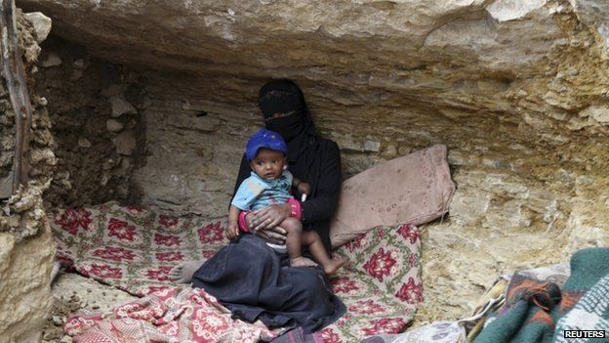
The situation in Yemen is becoming more unbearable. Every day there appears to be terrible news. Overnight, a wedding was hit by airstrikes, killing at least 50 people. The media has widely reported the story. There are also unconfirmed reports of an outbreak of measles in Dhamar governorate which has affected 100 children, including some fatalities. This information was provided by the Dhamar Governorate Health Ministry Office.
Seven boats carrying Somalis have arrived on the southern coast 100-200km from Aden in the last month. Many of these people had not heard of the conflict, or claim that people smugglers downplayed it. Many of the arrivals have disappeared into the community without being registered by agencies. Those who registered themselves said they had arrived for protection, to work, or to travel on to other countries. There are reports of bodies washing up on the Red Sea Coast. At the same time, people make the perilous journey from Yemen to Somalia and Djibouti.
The school term was scheduled to commence this week but 3,500 schools remain closed. Some schools are hosting IDPs and some are occupied by armed groups. 1.6 million children missed sitting their final exams earlier in the year. There are increasing reports of children being recruited into armed groups voluntarily as well as forcibly. Amnesty International reports that as fighting escalates, UXOs in urban areas are increasingly being reported. They also claimed that cluster munitions were being used by the Coalition, which they deny.
Planting season in several parts of the country has commenced. Three fishermen were killed when their boats were hit by rockets last week. Rubbish is piling up on the streets of cities and towns. Fuel queues are up to 3km long in Sana’a. There are reports that people are sleeping in their cars while waiting for several days. Life for ordinary people even in areas less affected by violence is increasingly difficult. Food prices have spiralled out of control, where food is at all available. Wheat flour is only available in half the country and has risen up to five times as much as before the crisis.
The fuel situation in the country is driving the crisis, the country coming to almost a complete standstill. Local water corporations report that they will soon run out of diesel. Medicines are running extremely low and more than 60 health facilities nationally have closed due to a combination of factors including lack of fuel, clean water, supplies or staff.
Field staff with several national and international cluster members have not been in contact for several weeks. In addition to concerns about their welfare, their activities go unreported.
Despite this, the ERC has regretfully revised his initial advice on the CERF allocation due to several simultaneous major emergencies. Subject to the application, $25m will be made available for urgent life-saving activities.
The ICCM is reminded that clusters will not make direct applications for CERF funding, but cluster members can partner with UN agencies to implement programs for which the agencies have received funding. Eligible recipient UN agencies are in discussion with implementing partners in a separate meeting taking place now.

