OCHA Information Management Guidance
Sudden Onset Emergencies
Original draft by Andrej Verity, Kristina Mackinnon & Yaelle Link, February 2014
Background
In the early phases of a sudden onset or rapidly changing complex emergency, performing the basic information management (IM) functions can be a challenge. Yet, these core services are imperative to an effective emergency response. Despite given its importance, OCHA has never completed draft guidance on information management for this early phase^{[1]}. At least one past attempt^{[2]} was made in conjunction with the UNDAC system, but it was made to vast, complicated and relied on volunteer contributions of on-UN staff. Given the history of such attempts and the authors’ experiences responding to Typhoon Haiyan^{[3]}, this guidance will be written as a practical “To Do” guidance and will remain a living document that can be continually updated by OCHA staff.
Importance of Information Management
During Haiyan, IM was described to one of the authors, by a senior OCHA official, as the part of the engine that makes the engine function and the car drive. This analogy means that IM drives coordination, must lead us to where are going and needs to tell us when we have reached our destination. When IM is not functioning well in an emergency, everyone knows. When it is functioning well, no one will know that “IM” is there. In the car analogy, everyone knows when the engine is not functioning well, but is complacent when everything is running well. In order to ensure that things proceed smoothly, it is highly recommended to develop an Information Management Strategy as early as possible. See the Typhoon Haiyan IM Strategy.
For IM Responders
The remainder of this document is intended for OCHA information management professionals responding to a crisis. It will not replace the experience, intuition, or logic of a strong IM professional. It is not written for nice evening read. It is intended to give concrete suggestions on actionable tasks and guidance on behaviour to our responders. It is not written in a style to be put into a fancy organizational guidance structure. It is written and structured to be practical.

The Checklist
- Get ready, set, go!
- IM Team Set-up
- Define required team (size and roles)
- Create a Staff Tracking Matrix
- Draft an IM Organigramme
- Plan for transition of IM staff
- Expand your team virtually
- The 3C’s: Coordination, Communication & Collaboration
- In-person Communication
- Be bilateral
- Engage in OCHA Internal Meetings
- Set up an IM Working Group
- Participate in Inter-Cluster Coordination Meetings
- Virtual Collaboration
- Set up Skype Groups
- OCHA IM Internal
- Community IM Responders
- Set up a dropbox for data collection and sharing
- OCHA IM Internal
- Community IM Responders
- Set up a Google Doc Folder for OCHA IM Team
- Coordination
- Agree on a reporting cycle
- Enhance standardization
- Data Strategy
- Review the CODs
- Review the FODs
- Identify datasets and sources
- List terms and Definitions
- Identify data flow
- Sharing data
- Storage locations
- HPC Support
- Support Assessment
- Support the SRP
- Support Monitoring
- Products
- Define core set of products to be delivered
- Deliver common products
- Contact List / Meeting Schedule
- 3W - Read, Print & Share 3W concept document / Define & Setup 3W collection, cleaning and product process / Create 3W Registration ‘one card’/ Create ‘How to Report’ Instructions
- Maps
- Severity Estimate Ranking
- Most Affected Areas
- Prioritization Ranking
- Gap Analysis
- Geographic Profiles
- Briefing Packs
- Comparisons
- Services
- Get HR.Info up and running
- Make use of the Assessment Registry
- Monitor and Contribute to the Virtual OSOCC
- Offer dynamic online charts
- Maintain the Humanitarian Kiosk (H.Kiosk)
- Have a physical kiosk
- Setup Social Media Monitoring
- Provide other services
- Printing, printing, printing
- OCHA’s Humanitarian symbol set
- Map in PPT template
- Operational Advocacy
- Set up a MailChimp Account
- Print Products
- Design briefing packages
- Define sites to monitor for new products
- Regularly update Wikipedia article on the emergency
- Transition
- Relay
- Adapt the frequency of products
- Turn off the light before you leave
- Continually update your IM Strategy
You still don’t have enough? See the annex…
- You & Your Behaviour
Beyond the regular personal preparedness^{[4]} you should have in place for any given mission, below are a few points that you need to consider during your work.
- Be proactive. You need to have regular discussions with your Head-of-Office (HoO), Inter-Cluster Coordination, cluster IMOs, government focal points and so on. You need to determine the crucial meetings for the emergency and attend with the purpose of looking for the problems that IM can solve.
- Build Personal Relationships. With a degree of certainty, it will be the personal relationships that result in increased collaboration, data sharing, and a better understanding of the IM needs in an emergency.
- Share what you have. Be willing to share your data, knowledge and products as widely and freely as possible. When you visit partners, make sure you go with data on a memory stick (or at least a list of data that you do have) and the latest maps/products. Simply offering can change a relationship drastically. And, people may surprise you with what data or information they want.
- IM Team & Staffing
Although general staff tracking should occur by administration or human resources, through several major IM responses, the authors have found that senior IM staff should be tracking IM staff (arrival, departure, R&R) to both ensure proper coverage, staff well-being, and support to senior management.
- Staff tracking: track staff in terms of their arrival, movement within country, R&R periods, and final departure. [Google Doc template]
- Staffing Levels (general):
- Determining the appropriate number of IM staff to include in an emergency (and thus cost plan) is not a simple formula. However, it is suggested that one reviewed the typical IM Team Roles and adjust according to overall office side. If the emergency encompasses multiple geographical hub locations, IM capacity should be added in each. Depending on the scale of the area this level could range from one person (e.g. Cebu) to several (e.g. Tacloban).
- Being able to outline the level of IM staff in an emergency can be of critical importance. Below is a simple graphing over time that was used in the Philippines to show the slow, planned decreasing of IM staff over time. Such graphics are quick to produce and help to show that senior IM staff are planning forward.
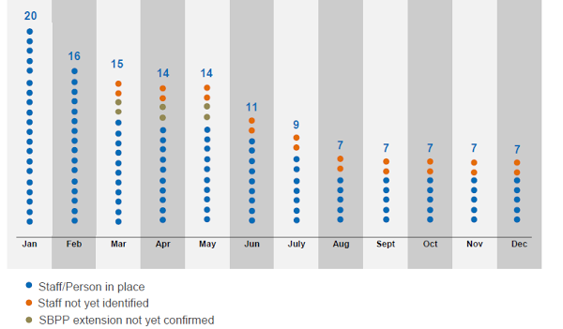
[DOC | PDF]^{[a][b]}
- Organigramme: although many organigrammes will be created for the office, senior IM officers should consider drafting an IM organigramme especially if the emergency covers multiple locations. The Philippines we found it quite invaluable to help track the recruitment of so many staff. When the staffing transition phase approaches, a transition organigramme should be considered to help management understand that IM capacity will be maintained or will suffer a gap.
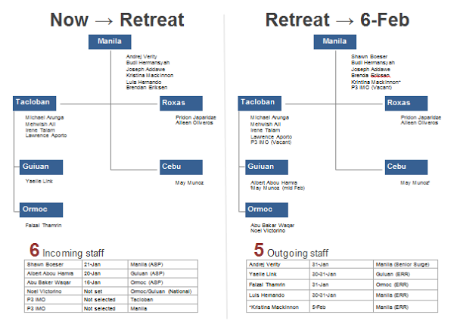
[DOC | PDF]^{[c][d][e][f]}
- Team roles: when putting together an IM team, the below roles should be considered. In major emergencies, you may have one or more for each role. In smaller emergencies, you will have one person taking on many (if not all) of these roles.
- Team Leader / IMWG Chair
- Data Coordinator
- GIS specialist/Cartographer
- Cluster Liaison
- Volunteers & Technical Communities (V&TCs) liaison^{[5]}
- Field Support focal point
- Visualization / Products
- Assessment & Monitoring Support
- HR.info & H.Kiosk management
- Government IM Liaison (should work/collaborate with OCHA government liaison focal point)
- Data Entry / Cleaning
- IMO Terms of Reference (TOR): the work that an IMO is expected to take on during an emergency will largely depend on the scale of the emergency, the number of IM staff deployed, and the capacity of other members in the office. As an IMO, you should consider that your work will cover some element(s) within the team roles. In large scale emergencies, some of these roles will generally be filled with specialized skill sets - e.g. V&TC liaison, data coordinator, visualization, etc.
Although we encourage IMOs to be team players within the office, you should not expect to take on work outside the roles above^{[g]}. For example, an IMO should not be leading the assessment and/or monitoring work. Rather, the IMO should be supporting their efforts with his/her technical skills.
During the early phases of an emergency, you will receive what feels like countless demands from internal and external^{[h][i]} audiences. Supporting the office for donor meetings, HQ requests, government meetings and so on will be continual. Demands from the clusters on data standards, new tools and reporting cycles will be recurrent. It would be ideal to have focal points for internal demands and for external product requests, but in reality this setup will not be feasible. The best approach would be to try to track the various requests and quickly establish a relevant procedure (e.g. reporting cycle, product development plan, product catalogue, etc).
Example TORs are available in the IM Toolbox^{[j][k][l]}.
- Expand your IM Team virtually: in today's world, technology can enable many people, remote to the emergency, to help your work. The OCHA IMO Community of Practice (Skype group) has proved invaluable countless times. In the Philippines we had OCHA IMOs from offices like Myanmar, Pakistan, ROWCA, and Mali helping us on a variety of tasks. Do not be afraid to ask for help, examples, or simple guidance.
You should also consider activating the Digital Humanitarian Network as they can provide support on a wide range of topics. Filtering useful information from social media, crowdsourcing, crisismapping, GIS production, statistical analysis, translation, website/Drupal expertise, and data analysis are just a few of their services. The DHNetwork is made up a range of Volunteer & Technical Communities who all have a proven track record. In the Philippines, we activated them to scour the internet to look for data that we used to augment our standard products and services (3W, assessments, events for the calendar, key documents/maps, in-country contacts, etc). They provided approximately 40% of the data for our first 3W product.^{[m][n]} By augmenting an existing product, we could easily give structured guidance and the product consumers did not need to interpret something new.
- The 3C’s: Coordination, Communication & Collaboration
Coordination and Communication both internally & with IM partners is critical to ensure an effective response during an emergency. With the increased use of modern collaboration tools, especially their regular use within OCHA on a day-to-day basis, the suggestions below include tools to improve collaboration and data flow within the emergency.
- In-person
- Bilateral meetings: having dedicated meetings with individuals can greatly help build up relationships and thus make data/information flow much easier during emergencies. Getting to know people is critical.
- In-person visits by Senior IM: Regardless of the tools used, it will be imperative for senior IM visits to all hubs early (within first month) in the emergency to help understand the responders’ needs, set direction, and show commitment to our partners.
- IM Reporting: when multiple locations are involved in an emergency, it will be critical to setup light internal IM reporting. Depending on the internet and phone connectivity, this could start in the form of a regular phone call and eventually progress into everyone reporting on a Google Doc [example]. Moving to something like a Google Doc also help with sharing between the various hubs as everyone can see what is being reported.
- Dedicated meetings with the IM focal points of the clusters: it can greatly improve the working relationship with the respective cluster and thus make future collaboration much better.
- Information Management Working Group: bringing together the IM focals from a variety of organizations is an extremely valuable activity in an emergency. To help move the conversation topics quickly into substantive matters, it is recommended that you quickly draft a IMWG TOR [^{[o][p]}example] and connect the frequency with the data reporting cycle.
Members: Although the initial focus should be to ensure that the clusters and government are invited, participation should also include: volunteer groups, private industry, world bank, NGO consortiums, UNDSS, and academia.
IM WG Meeting Minutes: After an IMWG meeting, the minutes should be uploaded to HR.info and shared with all IMOs in all of the hubs, highlighting key points in the email body, to ensure everyone is aware of happenings within the emergency. You should consider creating a IMWG meeting minute template (for all locations) that includes standing agenda items, clear “follow-up action” point area, participant list and topics discussed.
- Example: 03-Dec-2013 IMWG Manila Meeting Minutes^{[q][r]}
- Draft Template^{[s][t]}
- OCHA Internal Team Meetings: although many meetings will happen, the two key internal meetings are:
- General OCHA team meetings: the attending IM focal point should capture notes relevant to the IMOs. These notes should then be shared with all OCHA IMOs.
- IM Team meetings: when possible and appropriate, brief team should occur every morning to cover key topics of the day.
- Inter-Cluster Coordination (ICC) Meetings: when possible,^{[u][v]} an IM focal point should attend the ICC meetings in order to better understand the emergency overall and gather an understanding of the information needs of the group and responders.

b. Virtual Collaboration

i. Skype Groups
- OCHA IM Internal Skype group: set up a private Skype group for all OCHA IM Officers responding to the emergency. This group gives you the secure space to talk about the emergency, the challenges you are facing, and any plan to move forward.
- Community IM Responders Skype group: set up Skype group composed of for all IM Officers responding to the emergency. Although the focus should be to ensure that all of the cluster IMOs are present in the group, it should not exclusive to just clusters.
This group will help to build a “community” atmosphere within the IMOs and will complement the in-person IMWG meetings. It can help to bring a team attitude to much of the group. With proper fostering of the group, you should find that IMOs from different clusters and different locations start to help each other.
Depending on how the group is being used, you may want to consider outlining general Skype etiquette to help people feel more comfortable with its use (also see OCHA Skype Group Guidance).

ii. Community Data Collection
- OCHA IM Internal Dropbox (or cloud storage tool): if appropriate, the IM team can setup a private dropbox space to share internal files. As well, cloud storage should be considered for general office collaboration and business continuity planning. Thought should be given early in the emergency to procuring a cloud solution for the office over the longer term. (See annex 2 for example of folder structure)
- Community IM Responders Dropbox: ^{[w]}without a corporate solution in place (e.g. Egnyte) a well structured dropbox folder^{[x][y]} should be set up where all cluster IMOs were invited. Careful structuring ensures that partners know where they can place and/or edit content. You should not attempt to have shared working files.
Do not fear the occasional case of people deleting files. In the Philippines Haiyan response, we had shared our folder with nearly 100 people and only encountered two deletions. Both cases were rectified within minutes using the Dropbox.com interface [all deleted files are retained for 30 days].
iii. OCHA IM Internal Google Docs and/or Sky Drive: making use of these platforms can increase collaboration and sharing of information significantly. A couple examples from the Philippines Haiyan Response 2013/14.
- Google Docs for 3W raw data: although we did 3W heavy-lifting in Excel, we then made the data openly available by uploading it to Google documents. Without a tool to upload and share such data, Google Docs provided a quick and easy solution. This open data was then used by external groups (e.g. British Red Cross) to create products.
- Google Docs for OCHA IM staff tracking: by putting the spreadsheet online, all staff could update the information ensuring that it was always accurate and everyone could be aware of planned movements.
- SkyDrive for Emergency Figures: a SkyDrive based Excel file was created by Christian Cricboom (ROWCA) and later managed locally. Being able to massage and clean data an Excel file and then have it embedded into the HR.info (through SkyDrive) made providing authoritiative figures much easier.
c. Coordination

i. Reporting Cycle
In order to make OCHA’s Information Management activities predictable to our partners and clients as well as significantly reduce the ad-hoc craziness that often ensues in the IM world. OCHA IM should setup a standard IM reporting and product cycle in the form of by using this approach, we give the clusters space to do their work between reporting periods and allow them to be predictable with their cluster members (as they define a reporting cycle for their members). Having predictable output will also calms management’s demand for products as they always know when the next will be released.
The image below shows the 3W reporting cycle used in the Philippines Haiyan Response 2013/14 after about one month into the emergency. [Earlier in the emergency, the frequency was twice per week]
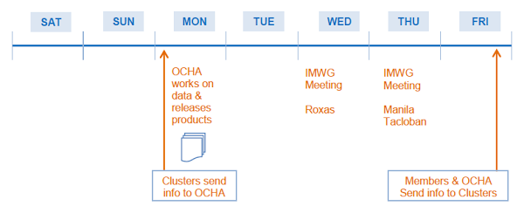
Information Management Reporting Cycle
[Week 1: DOC | PDF and End of Month 1: DOC | PDF]^{[z][aa]}
Given that there may be a geographical spread of the emergency and thus multiple coordination hubs, an IM data flow should be agreed upon early in the emergency. In order to provide clarity, it should be proactively decided (with the clusters) that the field clusters are responsible for collecting their own local data, sharing it with their clusters at national level who compile it, and then share the data with OCHA. With this approach, products can be generated anywhere along the chain of data movement. See the figure below for a visual depiction of the setup in the Philippines Haiyan Response 2013/14.
Of course, we know that OCHA will continue to receive data from partners who visit our offices (see OCHA Registration Card from Guiuan^{[ab][ac][ad]}), people who attend meetings, and by email. The agreed approach with the clusters should be that OCHA would happily accept this data with clear messaging that we will pass it along to the cluster (at the respective level) for incorporation into their 3W data. In this arrangement, OCHA becomes an extra conduit of information for the clusters.
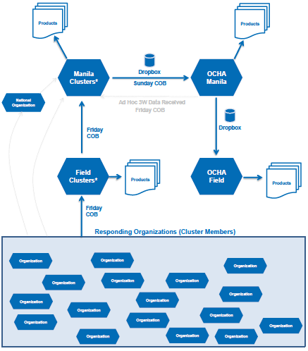
Information Management Data Flow [DOC | PDF]^{[ae][af]}

ii. Standardization

Over time and as cycles become more predictable OCHA IM should setup a standard IM reporting and product cycle in the form of a product catalogue and calendar. A product catalogue outlines the standard products, their data sources, their frequencies, their target audiences, etc will help to structure, streamline and prioritize your work. See the template Product Catalogue.^{[ag][ah][ai]}
- Examples from Typhoon Haiyan: catalogue | calendar^{[aj][ak]}
- Template Product Catalogue: to be drafted^{[al][am]}
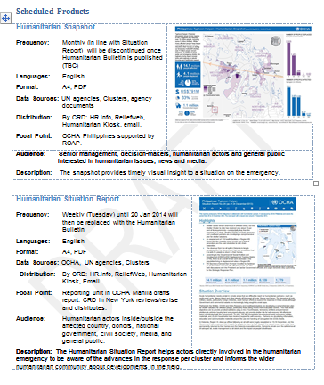 | 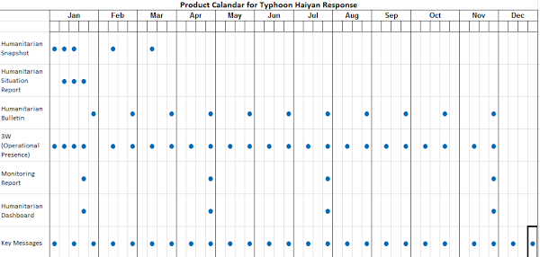
Example from Philippines catalogue^{[an]} | calendar^{[ao][ap]}

- Data Coordination^{[aq]}
Data coordination is critical to IM in all phases of an emergency to ensure that data is being shared as broadly as possible so all have a common understanding of the situation; to reduce duplicated efforts, to identify gaps in data, and to prioritize datasets that the humanitarian community needs. OCHA’s role is to coordinate data and the IMWG is a mechanism to 1) identify/improve CODs; 2) identify datasets (FODs) and data sources that are available; 3) create list of terms and provide definitions; 4) identify data gaps and develop strategy to collect these. For more tips and tricks see here
- Review the Common Operational Datasets (CODs)
The CODs should already be available on the COD FOD Registry and adhere to the quality guidance, promote the use of these as partners’ baseline data
- Promote use/adoption of Pcodes (enables standardization and harmonization of data)
- Check to make sure that Pcodes are in place and are usable
- Review locations on hr.info to make sure
- Prepare and promote the use of the pcode tool^{[ar][as]} among partners so their data can be pcoded (place it on the COD FOD Registry and in dropbox
- Discuss with IMWG if the population statistics COD is acceptable, if it does not have age/sex disaggregation, discuss if a national statistics can be applied? (See example on how SADD was calculated in the Philippines by using population growth rates. Also see Other Distribution on how to share datasets in environments with poor connectivity.)
- Decide how the Humanitarian Profile COD will be developed, include detailed metadata, (data source(s), methodology caveats) This should be discussed in the IMWG in country and shared with the IMWG at HQ and CRD.
- Review the Fundamental Operational Datasets (FODs)
Some Fundamental Operational Datasets (FODs) may already be available on the registry (e.g. education facilities, health facilities, etc) but others may become available only once an emergency has occurred (e.g. storm path, storm surge height, population density in affected areas). Ask partners, especially government what they have available.
- Identify datasets and sources:
Initial review of baseline and operational data available is required immediately to develop a data strategy and to coordinate data sharing. By identifying data that is available then gaps and data sources can be identified. On-going identification of operational data is required, so improvements to datasets can be made, missing datasets can be identified and found/created (data needs change over the course of an emergency). The IMWG (including Clusters/ Sectors/ NGOs/ Government/ V&TC etc)
The following are suggested steps:
- Share the metadata dump from the COD FOD Registry:
- log in (I am administrator role)
- in the address bar of your browser type the following: http://cod.humanitarianresponse.info/admin-list.csv
- a window pops up for you to save the CSV file
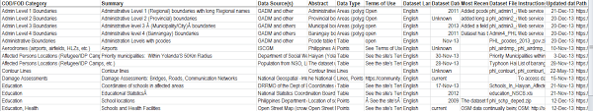
- Ask IMWG members to share data they have/have used
- data and metadata can be shared in Dropbox (ideally new data/metadata can be placed in the COD FOD Registry)
- Compile the new datasets metatdata with the COD FODs to the review what data is available and to identify gaps
- Review data in the IMWG (this should be a standing item in the meeting agenda).
- Wanted/Missing datasets can listed
- IMWG should prioritize the datasets that are needed.
- identify data sources (using the relationships that are already present)
- UNOSAT - Satellite Imagery Request
Email request To: emergencymapping@unosat.org, Lars.Bromley@uni
CC: mackinnonk@un.org (Kristina Mackinnon), ^{[at][au]}ocallaghan@un.org (Janet O’Callaghan)
Telephone hotline: +41 76 487 4998 (email with details should be sent first)
Details to provide in a request:
1. Geographic Bounds:
2. Temporal Bounds:
3. Operation it will support:
4. How will the data be used?
5. What do you need to see? What Questions are you trying to answer?
6. Which organization is requesting the data?
7. List partners that will use the data? What are their licenses for derived^{[av][aw][ax]} works? (e.g. OSM has creative commons license this can be disucsed)
8. Who will benefit? (e.g. HCT, affected population, UN agencies, NGOs, government etc)
Best practice: include partners in the request such as Open Street Map (OSM) , MapAction, REACH etc in the request so they can use the data and images
Space Charter | Charter Sequence of Events
- List of Terms and Definitions^{[ay]}
Create a list of common terms and definitions so there is a common understanding of the terms being used in the disaster and may come from different sources (e.g.government/clusters/etc). The list should be made in Google docs so all can access/update it. It should be publically available (somewhere on HR.info) and updated as needed (these terms would be used in publications). If the terms are part of a dataset, the definition should be included in the metadata. Example fromProtection Cluster. Example of terms that should be described:
Glide number
Affected
Targeted
Evacuee
Displaced
Partially destroyed home
number of people in a family/household
- Identify Data Flow
Identify how data flows in the different systems and focal points for data exchange/metadata/sharing/meetings. This is important to reduce redundant requests, optimize resources, understand different data that is available and when.
- Government
- Within a cluster
- Among clusters and with OCHA
- Sharing data
- CODs to GO^{[az]} - Zip all CODs into one zip file regularly to share with people going into the field (make it part of their briefing pack)
- Prepare product outlining the data available [good to take to meetings, share with Govt/partners, print & post, etc]
- Matrix listing the data that we do have so that we can share the entire matrix (COD FOD Registry Metadata dump)
- Illustrate the complexity and what can be done with a dataset (print it out so others can see it)
- Send links to the COD FOD registry/Dropbox location rather than zip files.
- Create a “data wanted” list that can be posted so people can easily see what data is needed
- Compile all satellite imagery links into a single FOD record
- Promote the use of Data Notification in the COD FOD Registry so people receive an email notification of
- Promote the sharing of data even it is incomplete, include information about the status in the metadata
- Storage locations
- Data stored on laptops/desktops does not promote data sharing, can be a security risk and there is an increased risk of data loss if there is no back-up elsewhere (preferably online)
- Data is best placed on the COD FOD Registry so all can access it and it is safe from deletion or corruption. to place it there all metadata is required.
- Create a dropbox folder [see suggested structure in the Annex] specifically for temporary data sharing among clusters (this allows for easy sharing and to “semi-private” data to be shared among the known people with access to dropbox. Metadata should be included and data that can be shared publically should be registered on the COD FOD Registry
- Announce new datasets in: the skype groups, the IMWG and in the IMWG minutes, general coordination meetings in the hubs
- In cases where internet connectivity is very poor, single files can temporarily be shared through the HR.info production server, downloadable through tools like FlashGet.
- Data security concerns.
- if data should not be made public but can be shared within the humanitarian community you could put in a generic office email address for requests. If this is not possible, place in a safe location (on-line if possible) inform the IMWG (partners) of the availability of data (email notification, skype group include metadata in the matrix of available data)
- consider on-line storage (or back-up online) in case something happens to the office/server/computer)
- Examine data elements prior to distribution to ensure there is no sensitive information (especially with IDP and Refugee data and in conflict situations)
- Humanitarian Programme Cycle Support
Assessment Support
OCHA IM support to the MIRA process should start with ensuring core data (e.g. CODs, and other identified data) is available in order to enable analysis^{[ba]}, other IM support may be required such as: making maps, compiling/processing data, formatting reports, responding to questions about baseline data, provide feedback on questionnaire design, development of a database.
The IM team should support the assessment by uploading available assessments in the Assessment Registry on HR.info (for secondary analysis) and ensure that it is kept up-to-date. Assessments added to Assessment Registry on HR.info rely on the pcodes in administrative boundaries and populated places CODs. Assessments with many locations (e.g. MIRA) can be uploaded from the back end by providing an excel spreadsheet with the names/pcodes in their appropriate hierarchy.
Strategic Response Plan (SRP) Support^{[bb]}
The OCHA IM team should provide support to the SRP process in the following areas:
- The Indicator Registry provide a set of cluster specific indicators approved by the global clusters. Make sure the IMWG and ICC are aware of this resource.
- The logframe created for the strategic level objectives for Typhoon Haiyan illustrates how the indicators are related to the outcomes and objectives
- Work on trying to develop some form of data-verifiable “in-need” number for the SRP. While official guidance is being developed by the Programme Support Branch, you can read through Examples on Ways to Calculate In-Need Numbers to help give you some direction.
- Mapping of planned projects and a simple infographic on funding requirements by cluster.
- Monitoring through the Strategic Response Plan (SRP) may prove to be too high level for responders especially in the sub-office. Therefore, it is strongly encouraged that you make use of the Most Affected Areas concept to ensure that the local offices can monitor changes on a more operational basis.
In a later stage efforts related to the SRP are going to be related to monitoring of the indicators defined by the clusters. This will affect the 3W product and needs to be taken into account.
Monitoring Support
Although the standard process and products are still be standardized for monitoring, a couple key things to keep in mind that as IMOs may be asked to : participate in the inter-cluster meetings (IMOs in all clusters should be encouraged to attend through the IMWG); advise/develop data collection template, processing the data and infographic creation for products. Consider that the template should be an effective tool for collecting and processing data.
Some based on experience in Typhoon Haiyan
- Involve IM as soon as possible in the process
o ICCM should involve IMOs when discussing data collection (Cluster coordinators should bring their IMO counterpart). Do not suggest holding separate meeting about this with only IM.
- Send out the data collection template ASAP to get input from IMOs
o Joseph and Jay are working on a better template. This should be discussed with IMOs first
- Introduce Monitoring Focal Point to IMWG
- Data collection process
o The data should be finalized before narrative is provided to avoid misalignment
o The infographics for the report should be created and then shared with the cluster IMOs to get input and ensure they are accurate
o The infographics should then be provided to the cluster coordinators for them to use to write the narrative
Examples from Typhoon Haiyan: Concept note | Monitoring Collection Tool | Infographic
- Products

a. Product standardization, localization & the discrepancy between operational and advocacy products
In any emergency there will be a huge demand for a wide variety of products and you will have a relatively high degree of freedom on many products that you create. Obviously, you should model as many products as you can in accordance with the OCHA Visual Style Guide^{[bc]} while customizing to meet the local, operational needs. If multiple hubs exist within the emergency, IMOs will need to proactively share what they are working on and the field focal point will need to provide regular, structured feedback on products.
You will need to distinguish the purpose of any product you plan to create thereby helping to define the amount of “polishing” time you need to spend on the given product. Operational products that are intended for in-country responders to make rapid decisions will not require the finesse that HQ, PI or Advocacy colleagues will demand in products like the snapshot or funding status.
Making sure that you understand the difference and noting it in the Product Catalogue will help the IM team function and management better understand the different visual quality/style of products.
Standardized tools
Humanitarian Icons for ArcGIS | Humanitarian Icons other formats
Templates: power points, maps

b. Standard / Common Products
Below is a set of products that you are expected to deliver or support^{[bd][be]}.
- Contact List / Meeting Schedule: these are core products that will take a lot of time to management. Going forward, we recommend that you make use of HR.info for the contact list (self managed profiles update the contact list which is automatically generated) and meeting schedule (online, mobile/computer syncs, and printable version)

Template for Contact Lists to import in HR.info I Standard Fields for Meeting Schedule
- 3W: As a very initial starting point, you need to read OCHA’s 3W - It’s Purpose, Target Audience, Scope and Products^{[bf]}. A few points about the 3W, beyond that document, relevant during an emergency:
- Set the standard fields that OCHA needs to collect complete with an explanation of what is needed/expected for each field.
Fight your urge to add a lot of fields at the beginning. You can add more as time goes on.
- Align the 3W with a standard schedule and data flow process.
- Define a data cleaning and product creation process and review said process (and any assumptions made about the data) with clusters in the IMWG.
- Define the standard 3W products you are expecting to create in the emergency. This effort will become part of the product catalogue.
- Interesting Facts product: you should strongly consider creating an “Interesting Facts” product from the 3W data to help show the potential of such data. [Example of Interesting Facts Product]
- After each round of the 3W, make sure to share the cleaned data back to the community and provide one-on-one feedback to clusters about cleaning process to reduce redundant cleaning.
- Pain Point: how do I submit my 3W data? OCHA needs to facilitate the submission process of an individual or organization. Think about how we we facilitate the organization’s submission of 3W data to the clusters. A couple considerations:
- Consider using a simple one page form that can be entered and shared with the clusters (see OCHA Registration Card from Guiuan^{[bg][bh][bi]})
- Provide a simple document that outlines how and when they can provide their 3W input to the various clusters cluster [template^{[bj]}].
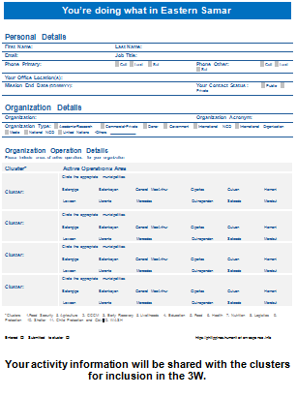
OCHA Registration Card from Guiuan^{[bk][bl][bm]}
- Explanation of the 3W data process in a simple graphic can be of great help when trying to explain where and how 3W data arrives at OCHA. Combing something like the graphic below with the Reporting Cycle graphics, responders can quickly understand how 3W data flows in an emergency.
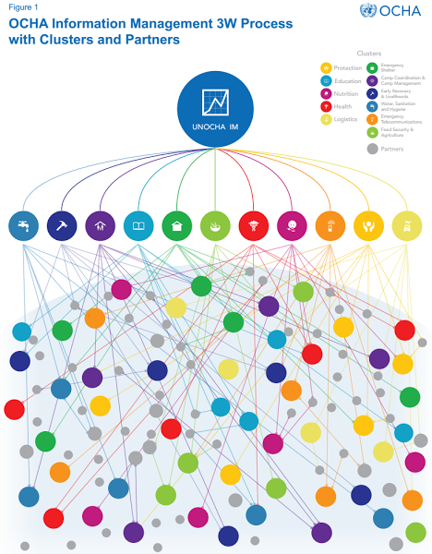
OCHA Philippines Information Management 3W Process
- Maps:^{[bn]} One of the biggest demands during an emergency will be maps. The demands will range from reference maps to standard 3W maps to completely custom maps. A few considerations:
- Create a printed Map Catalogue that can be shown to visitors when they enter the office. More often than not, they will find a map to fit their needs and you will simply have to print it. This approach is standard practice for MapAction.
- When creating the electronic version of a product, consider the resulting file size. Often maps can be too big to download over low bandwidth. Consider creating normal and low-bandwidth versions.
- If you need to activate the space charter, it is recommended that you contact UNOSAT.^{[bo][bp][bq]}
- Severity Estimate Ranking: trying to determine where the emergency may have had the most severe impact can be an extremely valuable exercise (and resulting product) if done immediately after the emergency happens. Such an estimate is only going to be good for the first few days when little “ground truth” information is available. It should be replaced by a Prioritization Ranking. The resulting products should be used to guide responders questions, investigations, and targeted assessments in the first days. Steps:
- Determine appropriate datasets^{[br]} for the composite indicator (population density, poverty incidence, population affected, distance to typhoon, storm surge height, etc). See the Severity Estimates from Typhoon Haiyan 2013.
- Determine appropriate graphics, matrixes and maps to create from the data. The below map was created by MapAction. Later, we overlayed the number of organizations responding in each area to get an idea if a proportionate number were responding.
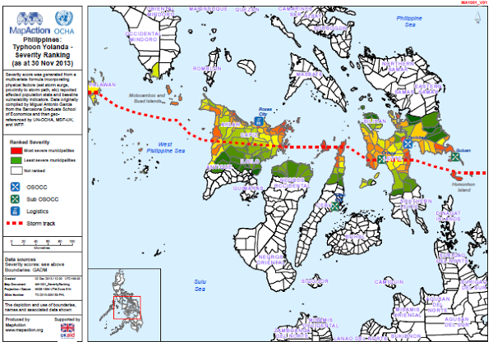
[PDF]^{[bs][bt]}
- Most Affected Areas matrix and graphs: One of the most posed question is ‘what is the most affected area?’. Yet often we try to develop sophisticated tools, undertake details assessments, implement burdensome processes, and weight different clusters aspects in order to answer this question. However, if we create a less sophisticated product simply trying to understand the severity of the situation, we can usually answer the common questions that responders have without causing major headaches and political conflict. Providing raw data in a simple matrix with the worst location per category highlighted, we provided a summarised picture while leaving the detailed analysis to each person
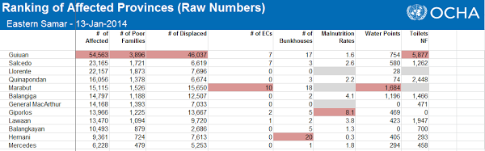
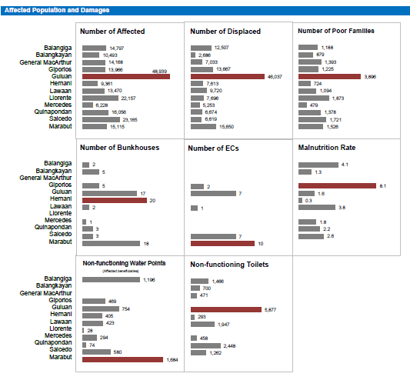
[Matrix and Charts: XLS; Full Product: DOC | PDF][bu][bv][bw][bx][by][bz][ca][cb][cc]
- Prioritization Ranking^{[cd][ce]}: after a few days, datasets should start to become available to develop an initial prioritization ranking composite indicator. Such ranking would be a replacement for the Severity Estimate ranking. The prioritization ranking should be valid for approximately the first month, but should align with assessment efforts. Read about how it was done in the Philippines in response to Typhoon Haiyan 2013^{[cf]}. Note that in large, geographically dispersed emergencies, zooming in to specific regions [vs the general overall picture] may be of great benefit for decision makers
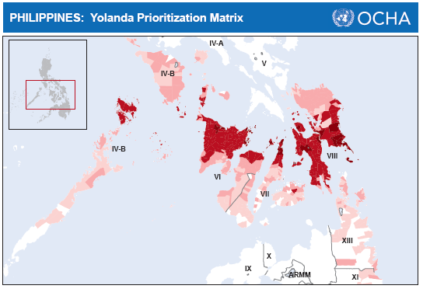
[PDF | XLS of Data]^{[cg]}
- GAP Analysis: generally you will hear people ask “What are the gaps?”. Although they generally mean gaps by cluster, you should know that there are many different types of gap analysis that can be performed in an emergency. It is not OCHA’s business to conduct cluster specific gap analysis (unless asked by the cluster). Rather our focus should be on inter-cluster, overall, and summary gap analysis. For a better understanding of the purpose of and different type of gap analysis, kindly read Humanitarian Gap Analysis - Its purpose, Definition, and Products. It is strongly encouraged that you share this document with the IMWG.
- Geographical profiles: a common, value added product that you should create is geographical (or admin-level) profiles. At what geographical level and the detail of^{[ch][ci]} data will be context specific. Over time, these profiles may help to guide discussions with and request to the government for core datasets.
- Briefing Packs: See Briefing Packages under Operational Advocacy.
- Snapshop:
- Funding Status graphic:^{[cj][ck][cl]}

c. Humanitarian Comparisons
In reports or visuals, you may find that making comparisons (size of population, geographical area, etc) to past emergencies or non-emergency related items can help amplify the impact of a given product. However, doing so in a humanitarian context not only requires access to data, but also an understanding of what is appropriate. To help, OCHA-FIS has drafted Appropriate & Impactful Comparisons in Humanitarian Crisis (Guidance)
- Services
Below are set of services that you are expected to deliver or support^{[cm][cn]}.
- HR.info: managing your HumanitarianResponse.info site is a crutial aspect to OCHA Information Management response. Keep in mind that HR.info is aimed at operational repsonders in-country and we want people to get on and off the site as quickly as possible. It is not intended for a global audience. A few common questions:
- Setup: if you meet the activation criteria, kindly see the checklist for setting up a site.
- Tools: an HR.info site has several tools including contact management, meeting schedule, assessment registry, document/map repository, automatic FTS charting, incident logging, information request tool, and humanitarian access. Some of these tools are not enabled by default and must be requested.
- When setting up features such as automatic FTS charting, it is strongly encouraged that you check with respective HQ sections to do a quick review. For example, by contacting the FTS team (team manager or fts@un.org), they can advise if there’s anything “special” about the data for your emergency that could impact the charts or graphs.
- Advocacy: make all efforts to ensure that your HR.info site is known. Email signatures, link on all products, posters, etc.
- Roles: the site is designed to have the following roles:
- Trusted: a person who can see content that is marked as “private”.
- Contributors: can upload content which needs to be approved before becoming visible to anyone.
- Editors: can add content and edit their content.
- Managers: can add/edit/delete content and manage the site (users, taxonomies, etc.).
- Training: since an HR.info site can have many editors (especially cluster IMOs), consider putting together a simple training package for responders not familiar with site’s management.
- Notifications: with user profile on the site, people can now subscribe to notifications (by email) of new content being added to the site (e.g. send me the new visuals added today)
- Assessment Registry: In the response to Typhoon Haiyan in the Philippines, we did not want yet another emergency to pass where very few assessments were captured. By leveraging the Assessment Registry on HR.info and collecting as many assessments as possible, including efforts by remote volunteers, we put together the most comprehensive list of assessments ever seen in emergency of this size^{[6]}.
- The assessment registry has an interactive map online and can be downloaded in CSV for offline mapping.
- Virtual OSOCC (link): the VO is a password protected space where early responders can register their potential response and can share operational information in semi-private discussions (e.g. procedures on how to clear customs, how to get approval to get a USAR team into the country). The VO is generally activated at the onset of major disasters that trigger international interest, in particular after orange or red GDACS alerts. A VO disaster discussion typically remains active until other coordination tools have been activated, or when the international (bilateral) response scales down. During the early phase of a disaster, IMOs are encouraged to access the site, monitor content, and contribute input where possible. User accounts can be requested on-line;
- Dynamic online charts: consider displaying your data (e.g. 3W data, displaced persons, damages houses, etc.).
Below an example of a dynamic 3W dashboard, kindly developed by Simon Johnson (Red Cross UK) with the 3W data shared by OCHA:
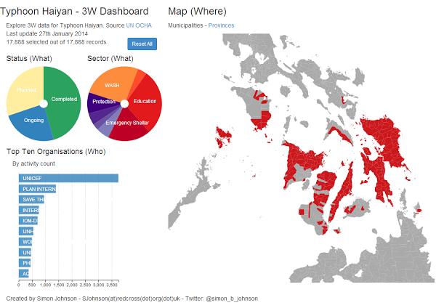
JPG screenshot of dashboard
Another example of displaying data, contributed by OCHA ROWCA using Tableau Software:
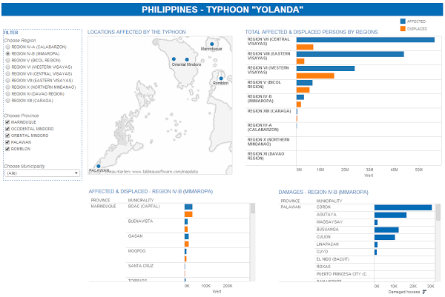
JPG screenshot of tableau
- Humanitarian Kiosk (H.Kiosk): as a way to share publicly available OCHA products on mobile devices, you should manage a small amount of advocacy and key fact content on an H.Kiosk for your emergency. If you need a new kiosk created, kindly request the Field Information Service (FIS) team to create one. Managing a kiosk is very simple as it is Dropbox based. See H.Kiosk Management Guidance.
- Physical Kiosks: you should consider setting up two different types of kiosks in an OCHA office.
- Electronic kiosk: set up a public laptop where you place the latest electronic files in a desktop folder. Visitors can then insert a flash drive and copy the files to their drive. You can include the latest sit rep, contact list, meeting schedule, list of data available, maps/visuals, SRP, etc.
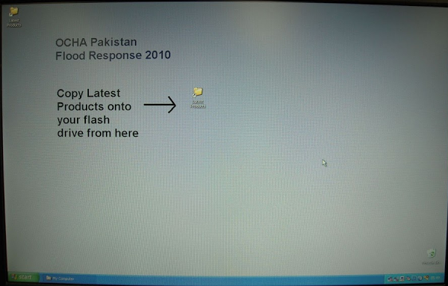
- Paper kiosk[co][cp][cq][cr][cs][ct][cu][cv][cw][cx]: making products available on paper copy is critical in emergencies. Setting up a kiosk-like space where visitors can take copies for themselves. You may need to make these paper copies available in multiple location (even if not for visitors to take in each place). Putting copies at the Reception-Departure Center, the OSOCC/OCHA office, the central meeting rooms, and other commons areas will be valuable to responders (see checklist for ‘situation / crisis rooms’ from Redhum in EN I SP).
Pakistan 2010 Floods - Map Wall, Map Catalogue & IM Reception
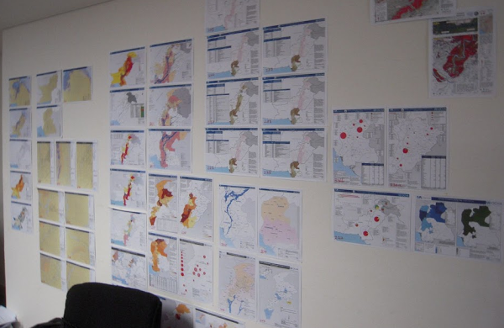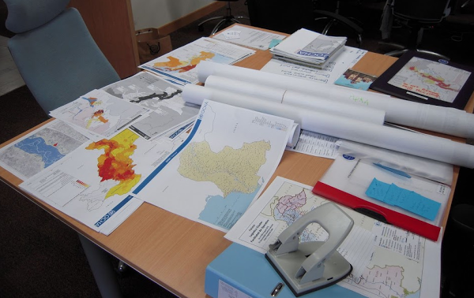
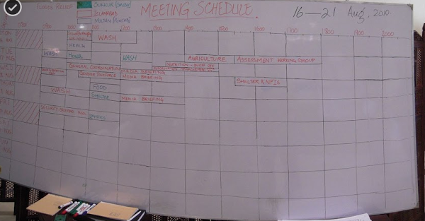

Haiti Earthquake 2010 - Reception Tent (Managed by IM) & Common Space (products posted on wall)
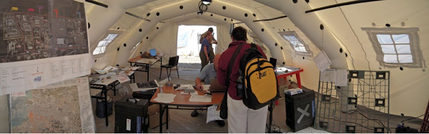
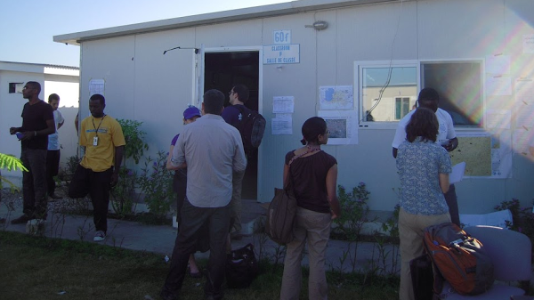

Philippines Typhoon Haiyan/Yolanda 2013 - OCHA Sub-Office Reception, Blackboard, Municipality Maps
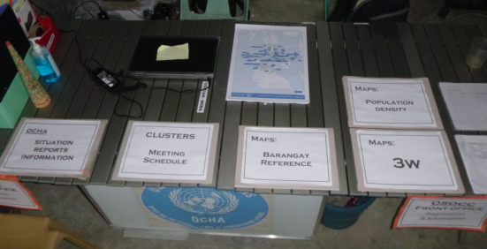
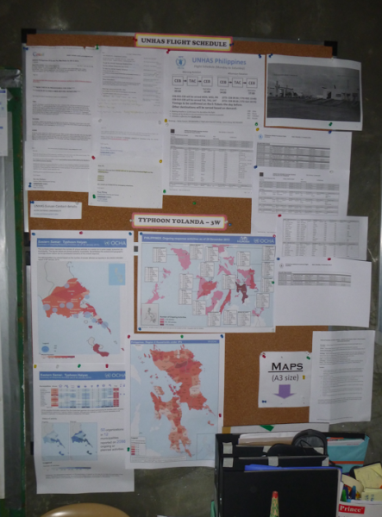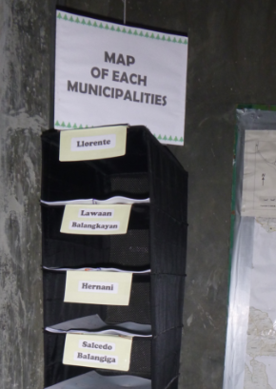
For all kiosks, you should develop a process to follow each day in order to ensure that you have the latest content available. For example, you may want to print all materials at 6AM and distribute to all kiosks before 7AM.
- Social Media Monitoring
Depending on the emergency, your capacity and the capacity of the PI/Reporting team, you may be asked to help set-up media monitoring for the emergency. In this context, we are referring to basic monitoring using tools like TweekDeck andHootSuite to look for major events or changes. You will want to monitor standard hash tags, official social media accounts of the government or local news, etc.
- Other Services
Given that many clusters and organizations have their own websites and post content exclusively on these sites, a big value added for OCHA IMOs is to regularly review a core set of sites and print new products for distribution
- Printing: See Printing Products under Operational Advocacy.
- OCHA’s Humanitarian Symbol Set: Download Symbolset^{[cy]}
- PPT Mapping: Provide .emf of shape files for non-GIS IMOs to use in PPT
- Operational Advocacy
In order to ensure that a wide audience is exposed to the content being produced by OCHA’s IM Unit or cluster members, it is recommended to undertake strategic “operational advocacy” efforts through powerful tools as MailChimp as well as conventional methods such as printing or briefing packages.
- MailChimp
- Tools, data and materials shared on HR.info (e.g. maps, assessment registry, check-in/out, meeting schedule, etc) can be highlighted though a daily MailChimp blast. By including all people operationally relevant to the emergency, you can ensure that many in-country responders, local and global donors and OCHA HQ will receive the latest updates on IM tools, services and products. Such advocacy helps to make everyone aware what is being done by IM in the emergency.
- Offering this distribution channel, it is likely that humanitarian partners would like to share their products through MailChimp as well. It is the perfect ground for collaboration and highlighting other organizations’ work while at the same time encouraging them to use HR.info.
- Each MailChimp distribution is crafted using engaging language and includes a clever sign-off. It should be noted that several people have noted on the refreshing writing style and reading to the end to see what the sign-off would be.
- See Annex 3 for the MailChimp blasts from the first three months after Typhoon Haiyan in the Philippines.
What is Operational Advocacy important? Often after an emergency, criticism of IM (especially from HQ) is experienced. However, by actively sharing the IM tools, services, and products, everyone will know what type of work the IM team is busy working on. Awareness is key. As well, if such information is being actively shared, others cannot attempt to blame IM for their shortcomings^{[cz]}.
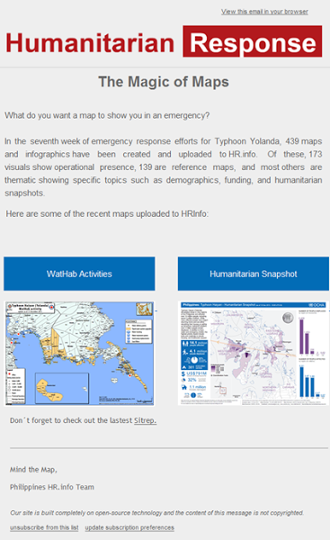
Shortened example of a MailChimp newsletter used for operational advocacy in the Philippines.
- Printing products
- At first sight, printing products might seem redundant when everybody can access them on HR.info or has them in their mailbox through the MailChimp. However, printing remains the best word-to-mouth method and should not be underestimated.
- Print the latest products for every meeting you attend and distribute the material widely. Make sure that the products have a footer with a reference to their digital homes.
- Be it at the country office or in a field hub, the OSOCC and later on the OCHA office will remain the first point of contact for many responders entering the country. Therefore it is of crucial importance to always update a physical kiosk (table, blackboard, etc.) each morning with new products and a stack of basic reference maps.
- Briefing Packages
- In addition to the physical kiosk it is helpful to always have an up-to-date briefing package on hand for incoming delegations/donors who will only stop by shortly.
- The briefing package should include:
- Latest 3W products
- Security map (if applicable)
- Meeting schedule^{[da][db][dc]} and contact list of cluster coordinators
- Latest OCHA situation report
- Reference maps of the area and specific maps
- Prioritization ranking / Most Affected Area
- The briefing package should be ready in hard-copy but, if possible, also on USB keys.
- Other Distribution
- With an increased IM capacity within the clusters, more great products are coming from the clusters themselves. OCHA’s role should also be to track down the clusters’ information and to distribute this information widely.
- In locations with poor connectivity, it is helpful to share datasets through orthodox methods (flash drive), while of course always promoting the COD/FOD registry. This can happen through announcing the existence of datasets during general coordination meetings or putting up posters in the OSOCC/OCHA Office highlighting the availability of data sets, such as sex and age disaggregated data.
- Wikipedia
- Review the Wikipedia entry of the emergency for details (esp numbers) and update to reflect accurate numbers and information. Ensure that you cite various official sources when you add/update information. Wikipedia is source that Google (and others) crawl and search regularly so we can have a great value add by making sure the details are correct and updated.
- Transition
From an IM perspective, there are three elements of transition that you need to take into consideration: transition of shorter-term surge staff (both OCHA and partner), frequency of product, and the longer term transition of OCHA from the emergency.
- Staff Transition
- In major emergencies, there will be two major IM staff transitions that you need to consider: from UNDAC to OCHA short-term surge and from OCHA short-term surge to OCHA long term staff (international and national)
- As highlighted in the Staffing Level section, preparing a staff tracking matrix early will greatly aid in the transition planning of staff and help to reduce any staffing gaps. Being able to share this matrix with management and HQ can really make it clear where you need staff or why you are outlining a certain staffing-related point.
- International: make sure that you request replacement IM staff very early. It will be much early than you think is required. Trust us, recruitment procedures will take longer than you expect.
- National: getting national staff on-board as quickly as possible will really help interaction with local counterparts (e.g. government) and with transitioning out of high number of international. Make sure that you identify the appropriate skill sets for national IMOs. Some UNDP offices may only advertise a generic IM vacancy or a very technical GIS vacancy. Make sure you find the right balance and possibly advertise multiple different TORs to find the right candidates.
- Frequency of Products
When developing your product catalogue and related calendar, you need to consider the staffing levels (both OCHA and partner) that will be present in the emergency over time. Try to balance the frequency of your products between their demand, their usefulness, and the capacity that both you and the clusters have. As seen in the staffing level graphic below, clearly understanding how many staff you will have is imperative. You may also want to break it down by roll and or location to get a more detailed understanding.
[DOC | PDF]^{[dd][de]}
- OCHA Transition
OCHA does have a general package related to transition and the office will begin planning as a whole. However, transition may happen at different times and in different locations within the same emergency. As an IMO, you need to start thinking early about who might be able to take over your IM activities - the government, UNDP, NGO, etc. A working and sustainable IMWG is essential to ensure the transition and continuation of IM activities into the recovery and development phases. If you do not expect that you will find an entity to take over the work, you should plan to wrap-up your work, according to the transition date, and package all the work (including data) for hand-over to in-country entities, your respective regional office, and OCHA’s record management / archiving focal points.

Annex 1: Info Flow Impediments & Action/Interaction Strategies
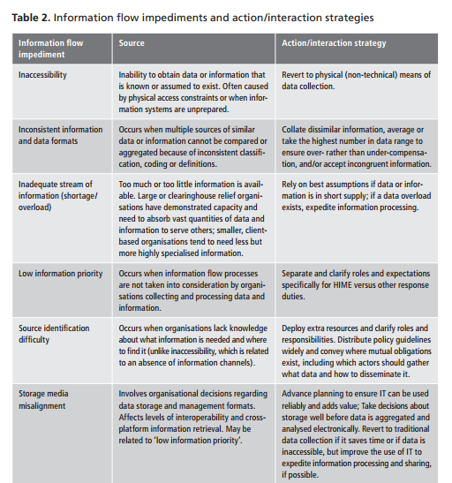
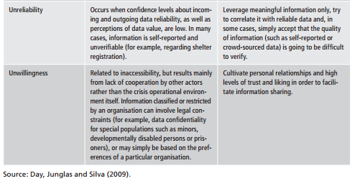
Source: http://www.odi.org.uk/sites/odi.org.uk/files/odi-assets/publications-opinion-files/8782.pdf

Annex 2: Dropbox Folder Structure
<Disaster Name>_IM
· Assessment
MIRA-1
…
· 3W
§ CASH
§ CCCM
§ Early Recovery
§ Education
§ Emergency Shelter
§ Emergency Telecoms
§ Food
§ Health
§ Nutrition
§ Protection
§ Other Sources
§ OCHA_Working Files
§ Templates
§ …
· Datasets
· New Data To Review
§ Agriculture
§ CCCM
§ Civil Military
§ Damage Assessments
§ Demographics
§ Early Recovery
§ Education
§ ETC
§ Food
§ Government
§ Health
§ Humanitarian Profile
§ Logistics
§ Nutrition
§ Protection
§ Shelter
§ WASH
· CODs and FODs to Go (possibly place zip file here)
· Pictures
· Maps_ Infographics
· Monitoring
§ Data submitted by Clusters
§ Compiled and Working Docs
§ Templates
· Tools
§ PPT Mapping
§ AgeSex Data_Template
§ AgeSex Affecetd Template
§ Pcode Tool
§ Training Material
§ Resources_Templates
§ Icons (Humanitarian Icons in various formats: ARCGIS (v9.3 and v10))
§ Prioritization Model
§ Vulnerability Index

Annex 3: Operational Advocay - MailChimp HR.info Blast (Phils)
Listed in reverse chronological order..
- Quantifying a website - 29 January 2014 - http://eepurl.com/Ni-yH
- Radyo Bakdaw – Helping you to help each other - 15 January 2014 - http://eepurl.com/MkRAX
- Cash Transfer Programming and Market Assessments - 3 January 2014 - http://eepurl.com/LL3w1
- A Field Perspective of Information (Guiuan) - 31 December 2013 - http://eepurl.com/LzH3v
- Where do Infographs come from - 24 December 2013 - http://eepurl.com/LmGzX
- The Magic of Maps - 20 December 2013 - http://eepurl.com/K_iSf
- What do 200 elephants, 230 balls and 40,000 football fields have to do with humanitarian response? - 18 December 2013 - http://eepurl.com/KYZXL
- The IM grease - 16-Dec-2013 - http://eepurl.com/KOrwr
- Staying and leaving - 13-Dec-2013 - http://eepurl.com/KHgA5
- Meeting minutes - 12-Dec-2013 - http://eepurl.com/KBujL
- Be in the right place at the right time - 11-Dec-2013 - http://eepurl.com/KwMnL
- Strategic Response Plan - 10-Dec-2013 - http://eepurl.com/KrHMj
- Humanitarian Kiosk (Information in your pocket) - 9-Dec-2013 - http://eepurl.com/Kl-CD
- Connecting Digital Humanitarians to in-country operations - 7-Dec-2013 - http://eepurl.com/Kh0KT
- From All Angles - 6-Dec-2013 - http://eepurl.com/Kdi8b
- Opening Assessment Data - 5-Dec-2013 - http://eepurl.com/J_83D
- Harmonization with a press of a button - 4-Dec-2013 - http://eepurl.com/J5Lf1
- Severity Ranking - 2-Dec-2013 - http://eepurl.com/JUt_L
- Get Custom Content from HR.info - 1-Dec-2013 - http://eepurl.com/JRtjv
- Gender Marker - 30-Nov-2013 - http://eepurl.com/JPSoD
- MIRA Report Released - 29-Nov-2013 - http://eepurl.com/JMb2v
- Who is doing What Where? - 28-Nov-2013
- Where Have Assessments Happened? - 27-Nov-2013 - http://eepurl.com/JDuWj
- Localized Content - 26-Nov-2013 - http://eepurl.com/Jxp19
- OCHA 3W - 25-Nov-2013 - http://eepurl.com/JsBXf
- Disaggregated Population Stats - 24-Nov-2013 - http://eepurl.com/JpCx5
- Make Your Own Maps - in PPT - 23-Nov-2013 - http://eepurl.com/JnQFH
- Humanitarian Community Capacity - 22-Nov-2013 - http://eepurl.com/JkIfL
- More Infographics - 21-Nov-2013 - http://eepurl.com/JfCmj
- Cool Infographics - 20-Nov-2013 - http://eepurl.com/I_xnz
- Figures and Charts (19-Nov) - 19-Nov-2013 - http://eepurl.com/I7Voz
- Philippines HR.info - 18-Nov Update - 18-Nov-2014 - http://eepurl.com/I1qK1
- Philippines HR.info - 17-Nov Update - 17-Nov-2014 - http://eepurl.com/IZVe1
- Philippines HR.info - 16-Nov Update - 16-Nov-2014 - http://eepurl.com/IX9or
- Philippines HR.info site available - 14-Nov-2014 - http://eepurl.com/IRKQT

Page

[1] OCHA did produce general IM Guidance in 2004 and started, but never completed, IM in Sudden OnSet Emergencies in 2009
[2] Materials started for IM Guidance in Sudden Onset Emergencies: https://drive.google.com/folderview?id=0B90Y9gPUymOmM2Y0MGVhMzItYmE5ZC00NTAzLThjNTAtZDQ1ZTJiNzU4MmZl&usp=sharing
[3] Typhoon Haiyan: struck the Philippines on 8-Nov-2013. Known as Yolanda locally. Glide Number: TC-2013-000139-PHL
[4] This guidance is not in place to explain what medical precautions (eg vaccinations) you should take or what material you should carry with you.
[5] For an introductory understanding of the V&TCs, see the Digital Humanitarian Network
[6] Statement made by DFID locally after about 3 weeks of the emergency.
[a]Need permanent links in Toolbox
[b]added content, will update links in one final step
[c]Need permanent links in Toolbox
[d]_Marked as resolved_
[e]_Re-opened_
[f]Added content, will update links in one final step.
[g]It would be nice to get some more clarity of what an IMO is NOT suppose to do or be expected to do
[h]Is there any way to make this more clear for our IMOs? Could material be drafted highlighting what our services are and WHERE we will usually prioritize - community vs OCHA?
[i]We need to make sure the HoO is involved in the prioritization process - depending of course on the HoO.
[j]Insert link here when Toolbox is ready
[k]+kristinamackinnon@gmail.com can you add the OCHANet link here for now?
[l]contacted service desk to get the files restored
[m]Has this point been shared with DHN?
[n]Don't think so. I just calculated it the other day in order to highlight here.
[o]more examples to be added to toolbox
https://ochanet.unocha.org/CA/Information_Management/IM%20CoP/default.aspx?RootFolder=%2FCA%2FInformation%5FManagement%2FIM%20CoP%2FDocuments%20from%20IMO%20Skype%20group%2FToR%5FIMWG&FolderCTID=0x01200038976F43CA780C4796D79334B5A0DCC4&View={AE74A90C-5DEC-46C5-9E85-7619C11C1906}
[p]I've selected several illustrative examples gathered from the survey, and placed the rest in a zip archive, all available on the Toolbox. Will add the links to this document as a final step.
[q]Need permanent link in Toolbox
[r]Added, links later
[s]Need permanent link in Toolbox
[t]added, links later
[u]Know that there are competing priorities I would suggest that this be rather high on the senior IM task list.
[v]Fully agree - however, it'll also always be the Inter-Cluster Coordinator's decision to ask for support... so 'when possible' might be read in this way as well. Though, I wouldn't mind taking it out. Any more thoughts?
[w]SOP for dropbox (how to leave a folder etc) - sent landon skype msg
[x]can we insert a link to the empty file structure? Should be included in the new toolbox as well.
[y]Added the file structure in annex 2 to the toolbox under File Structure
[z]Need permanent links to Toolbox
[aa]Added content - links as a final step
[ab]need permanent link to Toolbox
[ac]This comment is linked to two other text instances later in the doc so make sure to update their links as well before resolving comment
[ad]Thanks, noted - Registration card is added in the 3Ws section of the toolbox. Will make link changes as a final step.
[ae]Need permanent links to Toolbox
[af]Graphics/template added links later.
[ag]+andrejverity@gmail.com and +addawe@un.org let's discuss how to differentiate the preparedness product catalogue now under construction from the from this product schedule catalogue.
Ideas on renaming to differentiate? For now adding to the toolbox as Product Standardization to differentiate from Joseph's preparedness product catalogue.
[ah]The way I see it is the schedule catalogue is a by product of the IM product catalogue where after identifying the IM products, in collaboration with the country office, they can now produce a schedule that they can present to partners.
[ai]Thanks Joseph, that sounds good let's differentiate by naming the two items
'Product Schedule Catalogue' and 'Product Catalogue'. We can change later
if necessary.

*Mark Slezak*

mobile: +1 540 454 4228 skype:
markslezak

e-mail: mzslezak@gmail.com web:
linkedin.com/in/markslezak <http://linkedin.com/in/markslezak>
[aj]Need permanent link in Toolbox [currently in Kristina's dropbox]
[ak]Note: the same comment is below the included image (comment connected to two pieces of text)
[al]FIS will work with VIU to create a template product catalogue relevant for early days of an emergency.
[am]great, let me know when complete.
[an]Please refresh this link or send the file location
[ao]Need permanent link in Toolbox [currently in Kristina's dropbox]
[ap]Note: the same comment is below the included image (comment connected to two pieces of text)
[aq]Should we add a section/point about promoting data standards? [we could point to different parts of this doc and sites like Glide Number, terms.humanitarianresponse.info, etc]
+kristinamackinnon@gmail.com
[ar]check with Myanmar/Nepal status of redesign and need hard link
[as]followed up with email
[at]+kristinamackinnon@gmail.com What generic email address can we use so that this section is relevant well into the future (not that I ever expect you to leave OCHA or change your role :-)
Perhaps fis-ocha@un.org?
[au]Support section to decide
[av]We are alos sometimes requesting support from UNOSAT for images, I was just wondering if there is a common place where organisation or working group will leave there AOI for the Image and the dates, it will avoid to ask several time to UNOSAT... (it is for them and us) ?
[aw]@Kristina/Andreon this we made a quick fact sheet maybe it could be sahred with you for info
[ax]@Yann - please sahre teh fact sheet! There is the GDACS summary (see http://portal.gdacs.org/Portals/1/GDACS_SatMapOverview_08_01Apr2014.pdf) perhaps we can discuss with UNOSAT about this
[ay]+kristinamackinnon@gmail.com Two things:
1) Wondering about providing the list in an Annex. Or separate Google Doc of our own.
2) Any ideas if there are other sites that we could point to for standard definitions? (e.g. UN TERMS) These sources would then need to be listed in the Annex/Doc
[az]case added to attirum - will be examine after HR.info V2.0
[ba]When appropriate IM capacity for the activity does not exist. Supporting the entire MIRA process requires dedicated resources (including IM). If those dedicated resources are not present, then the limited IM resources must become enabling.
With appropriate IM dedicated capacity, IM should be heavily involved in the Assessment process, MIRA drafting, etc.
Exact role, # of staff, required skills will need to be defined in discussions between OCHA IM (FIS Geneva) and OCHA's Programme Support Branch
[bb]An understanding of how the HPC process works and the elements involved will be important here. In particular the time lines, as there are multiple steps, and each has a date set for it and the specific tasks for different actors (e.g. cluster lead, HQ reviewers), which are discussed and agreed upon during coordination meetings. So setting up a specific calendar with these milestones and actors is recommended here. And of course to keep it updated.
When the different docs are published, then also making sure the IMO is in charge of uploading it and making it available.
[bc]Need permanent, external link
[bd]Still need to add in Snapshot, Funding graphic, etc. (What others?)
Should we include which ones would be ideally produced outside the emergency if data can be fed out (e.g. Snapshot)?
[be]Yes...alongwith 1.Coordination capacity infographic 2.Implementation/response capacity infographic and 3.Dashboard
[bf]May eventually want to get a permanent link
[bg]need permanent link to Toolbox
[bh]This comment is linked to two other text instances later in the doc so make sure to update their links as well before resolving comment
[bi]Thanks, noted - Registration card is added in the 3Ws section of the toolbox. Will make link changes as a final step.
[bj]already in FIS -> Products -> 3W folder. Perma link required?
[bk]need permanent link to Toolbox
[bl]This comment is linked to two other text instances later in the doc so make sure to update their links as well before resolving comment
[bm]Thanks, noted - Registration card is added in the 3Ws section of the toolbox. Will make link changes as a final step.
[bn]Need to link to OCHA Graphic Style Guide
[bo]Wondering +kristinamackinnon@gmail.com what OCHA Map production guidance we could point to.
Also wondering if MapAction could recommend resources to point to?
+lhughes@mapaction.org +jdouch@mapaction.org +alspach@un.org
[bp]The old OCHA Map production guide... https://www.humanitarianresponse.info/sites/www.humanitarianresponse.info/files/toolbox/files/Guidelines%20Field%20Map%20Production%20and%20Dissemination_Final_Version_29_June_2009.pdf
[bq]VIU should provide information on this - they produce the document that Joseph shared above
[br]More work will be done in the future to provide a long list of possible datasets to include in such an indicator
[bs]will need permanent link in IM toolbox
[bt]added to toolbox, will update link in final stage
[bu]Need permanent links in IM toolbox
[bv]Andrej please refresh these links or advise on the location of the original material.
[bw]I re-activated the PDF link. It was something that Dropbox did.
The XLS and DOC seemed to have been working fine for me.
[bx]I'm still getting a dropbox error when I click through these links. could you please send the docs via email?
[by]I made a big mistake! I started archiving things into OneDrive and I move this folder - awh!!!
[bz]I just restored that folder and the links seem to be working well again.
[ca]Awesome, thanks. One item off the list for tomorrow's chat!

Can you also set the permission so that I can redirect the links to the
toolbox?

*Mark Slezak*

mobile: +1 540 454 4228 skype:
markslezak

e-mail: mzslezak@gmail.com web:
linkedin.com/in/markslezak <http://linkedin.com/in/markslezak>
[cb](make that Friday's chat, not tomorrow).

*Mark Slezak*

mobile: +1 540 454 4228 skype:
markslezak

e-mail: mzslezak@gmail.com web:
linkedin.com/in/markslezak <http://linkedin.com/in/markslezak>

On Wed, Jun 18, 2014 at 4:31 PM, Mark Slezak <mzslezak@gmail.com> wrote:

> Awesome, thanks. One item off the list for tomorrow's chat!
>
> Can you also set the permission so that I can redirect the links to the
> toolbox?
>
> *Mark Slezak*
>
> mobile: +1 540 454 4228 skype:
> markslezak
>
> e-mail: mzslezak@gmail.com web:
> linkedin.com/in/markslezak <http://linkedin.com/in/markslezak>
>
>
>
> On Wed, Jun 18, 2014 at 4:24 PM, Andrej Verity (Google Docs) <
[cc]Done - you have Edit rights to this document.
[cd]I would suggest to have here included the revision of the composite measure and the severity ranking. There are several very valid lessons learned on how to improve the severity ranking.
[ce]Thanks for the input - we'll do that, also linking it with our IM Toolbox https://www.humanitarianresponse.info/applications/tools
[cf]Need permanent link in IM toolbox
[cg]Need permanent links in Toolbox
[ch]I think it will be related to the COD fod Available if you want to be consistent? and the notion over the time as well is alying important role
[ci]COD FOD can help but also other data/information can be used which may be more relevant. CODs that should be used for constancy - population statistics; pcodes and names from admin boundaries and Populated places. Any FODs available (especially demographic information should also be used.
[cj]Still to-be-written
[ck]We would be happy to provide input/feedback on the funding status graphic. It seemed that there was some duplication of efforts/products related to funding for the Philippines.
[cl]That would be very helpful Julie! Perhaps something that VIU should be brought into the discussion?
[cm]Need to add in a piece about Virtual OSOCC
[cn]Need to add a piece about setting up Social Media monitoring (general, trusted accounts, etc)
[co]Redhum has developed a checklist for Situation Rooms (for the process and products before, during and after managing a "Paper Kiosk"). But is in spanish. Is somebody there with enough time to translate in to English?
[cp]That would be awesome to have! Unfortunately I don't speak Spanish but would be great to have a volunteer to translate. How long is the checklist?
[cq]I suspect that we could find someone to translate. Would you be able to send us a copy?
[cr]For sure!
[cs]_Marked as resolved_
[ct]_Re-opened_
Is it in English finally? :)
[cu]Yaelle: we need to link both Spanish and English.
[cv]Ok, done.
[cw]_Marked as resolved_
[cx]_Re-opened_
(y)
[cy]Permanent Link
[cz]good for for he ICRC map ;-)! based on that we realised that in terms of coordination one of the task of IM manager working group is not only to provide support for exposition of documents but to crosscheck the Information, on the case of hayan for instance the ICRC has activities in Sammar, but in other maps Samar is still "empty" with no activity or humanitarian ( I do not see the exact date, of the Wahab map but when you have a look on this map http://reliefweb.int/map/philippines/philippines-usg-humanitarian-assistance-typhoon-yolandahaiyan-last-updated-18112013 you do not see any ICRC Water and Habitat activities, So teh work done is not visible for other humanitarian actors. (the same issue within the red cross movement) occurs
[da]Is the Meeting Schedule a common calendar?
In order to track meetings, in LAC we are promoting a Meetings Matrix (excel) that includes added columns for:
1) Name of meeting (or type of cluster)
2) Venue and date
3) Attendance (name of institucions, at least)
4) Agreements (briefly)
5) Next meeting (venue and date)
We think this matrix is very useful for two reasons, mainly:
1) Saving time.- If somebody need to know how the coordination is being developed, just have to read the matrix.
2) To monitor properly and get a "big picture" of the coordinations.
I know that IMO should not be monitoring work, but this matrix could be useful if every cluster (HCT, UNETT, RCO, etc. ) report their agreements after each meeting.
[db]Hi there, we've been promoting the online feature of HR.info (https://philippines.humanitarianresponse.info/calendar) in the Philippines, which has the neat addition that you can also ad minutes and agendas to the events. Having this said, we struggled a bit with a good format of a fancy offline version. Is there an example you can share?
[dc]What we use is just an excel sheet with columns referred. It's as simple as I said but very useful. I'll look for an example ;)
[dd]Need permanent links in Toolbox
[de]added content, will update links in one final step

