Leadership can come in many forms and shapes. One way of looking at leadership styles is to place them with three styles: directive, participative and delegative. We all have a natural leadership style, but effective nutrition cluster coordination requires an adaptive leadership style, meaning we can adapt our natural leadership style to the situation.

The table below provides a description of Leadership Styles and the types of situations where they are best suited. What is your leadership style and how could you adapt to different situations you come across in your work in the cluster?

Leadership Styles and When to Use Them

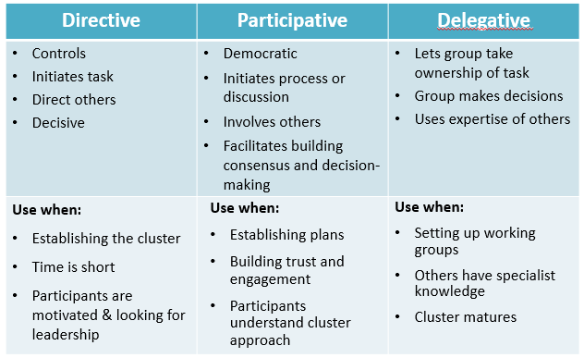

Leadership in the SNCC
- Having NGO work collaboratively across projects through the cluster system is better for beneficiaries than having them in competition with each other.
- It can be difficult for NGOs and UN agencies to work together for a number of reasons including competition for funds, clash of organisational cultures and mandates as well as because of personal egos.
- Effective leadership requires effective "follow-ship" - in other words, when agreeing to be part of a cluster, partners also have a responsibility to accept and support cluster leadership (coordinators, HCT, etc.) and collectively agreed ways of working, etc.
- Partners also have a leadership role within their own organisations, advocating for and promoting the positions and decisions of the cluster
- Regardless of the leadership style used in a cluster, ALL leaders require good information and evidence in order to guide decision-making - including evidence of what affected people want and need, and how they view the quality of assistance and the relationship with aid providers.
- No single person has all the right knowledge or understanding of the situation to make unilateral decisions - information sharing and joint analysis is critical for an effective response.
- Keeping the focus on affected people at all times can help leaders in whatever role or capacity to achieve the best results for them

