global Food Security Cluster
Inter-Cluster Nutrition Working Group
terms of reference
May 2012

Purpose
The purpose of the gFSC Inter-Cluster Nutrition Working Group is to provide technical direction to the gFSC on key areas of synergy between the Nutrition Cluster and Food Security Cluster in humanitarian food security responses.

Representation

Chair: IMC, Caroline Abla, cabla@internationalmedicalcorps.org

Co-Chair: IFRC, Hilary Motsiry, hilary.motsiri@ifrc.org

Members include:

- ACF France, Julien Morel –- jmorel@actioncontrelafaim.org
- ACT Alliance, Lisa Henry –- LIH@dca.dk
- CARE, Mohamed Daw, (dmohamed@care.org)
- Concern, Amanda McClelland –- Amanda.mcclelland@concern.net
- FAO, Neil Marsland–– Neil.Marsland@fao.org
- FAO, Florence Egal–– Florence.Egal@fao.org
- IFRC, Kiflemariam Amdemariam – kiflemariam.amdemariam@ifrc.org
- IFRC, Hilary Motsiri, hilary.motsiri@ifrc.org
- International Medical Corps, Caroline Abla –– cabla@internationalmedicalcorps.org
- International Rescue Commette, Frances Kimmins – Frances.Kimmins@rescue-uk.org
- Mercy Corps, Gregory Scarborough – gscarborough@bos.mercycorps.org
- Oxfam, Laura Phelps – lphelps@oxfam.org.uk
- Save the Children Jessica Saulle, J.Saulle@savethechildren.org.uk
- Solidarité Internationale, Peggy Pascal, ppascal@solidarites.org
- World Vision International, Douglas Brown – douglas_brown@wvi.org
- OC HA, Belinda Holdsworth –– Holdsworth@un.org
- UNICEF Josephine Ippe – jippe@unicef.org

The purpose of the Working Group is to provide Operational/Coordination/Technical direction/Guidance to the gFSC on key areas of synergy between the Nutrition and Food Security Clusters in humanitarian responses.

The rationale for developing the Working Group is to:
- Provide a holistic approach to integrating food security and nutrition responses in a humanitarian context.
- Reinforce the critical linkages between food security and nutrition.
- Understand complementarities

Objectives and Activities:

The objective of the Working Group is to develop Standard Operating Procedures between the gFSC and the GNC through:

- Identification of present coordination field practices between the Food Security and Nutrition Clusters.
        - Identify synergies and complementarities
        - Identify gaps and limitations
        - Identify Best Practices
- Field Survey:
        - Develop, analyze, write-up and disseminate findings

Deliverables:

Joint Guidance Note with:
- Synergies
- Complementarities
- Gaps
- Lessons learned

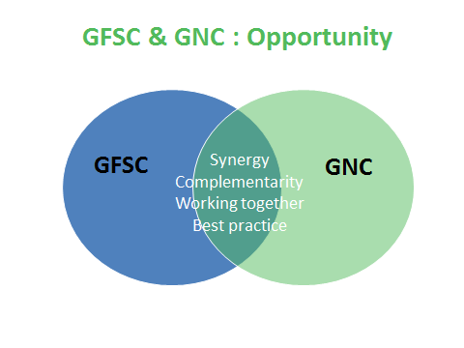
Decisions concerning budget availability and allocation will remain with the Global Food Security Cluster Coordinator according to prevailing resources.

Method of work:

The gFSC support team will act as the secretariat for the Working Group and will manage and ensure the communications through:
- Regular email correspondence
- Conduct regular telephone conferences (the initial recommendation is for monthly meetings)
- The first face-to-face meeting is scheduled for the 16 April 2012, in Geneva (the day prior to the gFSC bi-annual meeting in Geneva, 17-18 April 2012).
- The gFSC WG on Assessments will report high;ights to the gFSC partners during the monthly teleconferences and in more detail during the bi-annual meetings of partners).
- Final meeting minutes will be circulated to all gFSC partners as information.

